

**School of Computing and Mathematical Sciences**

**CO7201 Individual Project**

**Final Report**

**AN AUTOMATED SYSTEM FOR LOCAL GPS**

**[SHREEYA DINESH DESAI]**

**[sdd13@student.le.ac.uk]**

**[239038636]**

**Project Supervisor: [DR. YAKUN JU]**

**Principal Marker: [DR. STANLEY FUNG]**

**Word Count: [13,410]**

**[16/05/2025]**

**DECLARATION**

All sentences or passages quoted in this report, or computer code of any form whatsoever used and/or submitted at any stages, which are taken from other people’s work have been specifically acknowledged by clear citation of the source, specifying author, work, date and page(s). Any part of my own written work, or software coding, which is substantially based upon other people’s work, is duly accompanied by clear citation of the source, specifying author, work, date and page(s). I understand that failure to do this amounts to plagiarism and will be considered grounds for failure in this module and the degree examination as a whole.

Name: [Shreeya Dinesh Desai]

Date: [16/05/2025]

Table of Contents

1. Introduction 6

1.1 Aim. 6

1.2 Objective. 6

1.3 Requirements. 7

1.3.1 Essential Requirements. 7

1.3.2 Recommended Requirements. 7

1.3.3 Optional Requirements. 7

1.4 Tools and Technology used. 8

1.5 Structure Overview. 9

2. Background Research 10

2.1 Literature Review 10

2.2 Existing GP Web Applications. 12

3. System Design & Functionalities. 13

3.1 Backend 13

3.1.1 ER-Diagrams. 13

3.1.2 Class Diagram. 14

3.1.3 Use- Case Diagram. 15

3.1.4 Service Description. 15

3.2 Frontend. 18

3.2.1 UI Design (Wireframes and High-Fidelity Prototype). 18

3.2.2 Core Functionalities of UI. 18

3.3 Design challenges. 21

4. Development Process. 22

4.1 Database Development 22

4.2 Backend Development 23

4.2.1 Patient Routes/ API endpoints. 23

4.2.1.1 Authentication (auth.py) 24

4.2.1.2 Book Appointments 25

4.2.1.3 Prescriptions 25

4.2.1.4 Buy Prescriptions 26

4.2.2 Staff Routes/ API endpoints. 26

4.2.2.1 Admin Routes 26

4.2.2.2 Doctor Manage Appointments 27

4.2.2.3 Prescription 28

4.2.2.4 Staff Authentication 28

4.2.2.5 Staff Availability 29

4.3 Medical records. 29

4.4 Frontend Development. 31

4.4.1 Development Process 31

5. Testing. 37

5.1 Unit testing 37

5.1.1 Patient Features - Unit testing 37

5.1.2 Staff Features – Unit testing 38

5.1.3 Admin Features - Unit testing 40

6. Deployment. 42

6.1 Architecture. 42

6.2 Azure Services Used. 43

6.3 Deployment Process. 44

7. Results. 47

7.1 Achievements. 47

7.2 Lesson Learned. 47

7.3 Own Piece of Code. 48

7.4 Limitations 49

8. Conclusion. 50

8.1 Future Scope. 50

References 51

Appendix 53

A. Background Research 53

B. Existing GP Websites 57

C. Utility Functions. 58

D. Booking Appointment code snippet 60

E. Buy Prescriptions code snippet 64

F. Admin Routes code snippet 65

G. Doctor Manage Appointments code snippet 68

H. Prescription code snippet 70

I. Staff Authentication code snippet 72

J. Staff Availability code snippet 75

K. Medical Records code snippets. 77

L. Register code snippets 80

M. Own Piece of Code snippets 80

N. Diagrams. 81

O. Deployment Snippets 84

P. Application Snippets. 93

# Introduction

The National Health Service (NHS) in UK are facing countless problems today, out of which two primary problems are lack of staff and insufficient funds to improve the existing digital infrastructure of the healthcare sector. According to the (Medical staffing in the NHS, 2025) report, a large percentage of General Practitioners / Doctors are resigning from their job due to lack of work life balance and degrading personal health. Therefore, most of workload of the senior staffs is now handed over to beginner level or early age Practitioners which lack experiences.

In the year 2024, approximately 42.19% of the staff experienced workload-stress. While 30.24% of the staff felt burnt out as an outcome of their work. Additionally, the healthcare workers felt unappreciated and unhappy with their salaries (Medical staffing in the NHS, 2025).

Due to these challenges, there was an impact on the services provided to the patients. For instance, “Unfortunately, we don’t have any appointments available for today” is the most common phrase used by the receptionists due to the shortage of availability of GP (MacConnachie, 2024).The General Practitioner and NHS staff are facing numerous challenges such as shortage of staff, limited availability of appointments, adolescents not opting to study in the healthcare industry, lack of skilled Doctors. Due to these issues, patients have been suffering from adequate treatment and care. (Khan, 2023).

## 1.1 Aim.

This paper mainly aims to develop An Automated System for Local GP’s, which would be less stressful and user friendly for both healthcare staff and Patients. The Web App would help the staff to set their availability smoothly and cancel their scheduled appointment with an ease. Also allowing Patients to manage their appointments, pay for their Prescriptions, all these with a user-friendly interface of the applications for the Admin, Staff and Patients allowing all the users of the web-app to feel supported and less stressed while performing any task on the system. It is essential to understand that this Web App has been developed considering a specific GP.

## 1.2 Objective.

The objective for this project would be to design a secure and user-friendly web application considering different demography of users, short appointment booking forms to patients with read through articles for minor injuries. Additionally, patients should be able to pay for prescriptions from anywhere in the UK.

On the other hand, the General Practitioner will have a simplified dashboard which would help the doctors to set their availability, view the booked appointment, cancel their availability, view the patient previous medical history and prescribe the medicine.

Lastly, the entire application would be deployed on the Microsoft Azure cloud considering the CAP (Consistency, Availability and Partition Tolerance) theorem.

## 1.3 Requirements.

### 1.3.1 Essential Requirements.

**Registration – Accomplished**

The patient will be able to register themselves to the web-app using secure login credentials.

Registration of Doctors and Nurses will be performed by Admin.

**Availability - Accomplished**

The Doctor and Nurses will be allowed to set their availability two months prior.

**Book appointment - Accomplished**

According to the patient’s requirement, they can book the appointment with the available Doctor.

**Provide prescription - Accomplished**

The Doctor will be able to access medical history of patients and provide a digital prescription on the web app.

**Admin Dashboard - Accomplished**

The Admin Dashboard will allow administrators to add, remove healthcare staff and will also allow administrators to book appointments for aged patients, view the list of patients and the staff.

**Staff Dashboard - Accomplished**

The Dashboard will help staff to set their availability, view booked appointments, provide prescriptions, view patients medical history and send prescription to pharmacy.

**Patient Dashboard - Accomplished**

The Dashboard will help patients to book appointment, view prescriptions, upload the prior medical history, previous booked appointments records.

### 1.3.2 Recommended Requirements.

**Deployment on the cloud - Accomplished**

**Articles for minor injuries & awareness - Accomplished**

**View prescription - Accomplished**

**Buy and Pay prescriptions - Accomplished**

For the prescribed medicine the patient can buy and pay for the prescription online.

### 1.3.3 Optional Requirements.

**Responsive Web Application - Accomplished**

**One to one chat** - Not Implemented

Due shortage of Doctor/Nurse, if in case there's a follow-up required for a specific patient, or a patient requires immediate attention the chat feature can be leveraged.

**Video Consultation -** Not Implemented

## 1.4 Tools and Technology used.

The below mentioned details are the tool and technologies used in this project.

|  |  |  |
| --- | --- | --- |
| **Component** | **Name** | **Summary** |
| Database | Azure SQL and Cosmos DB, Blob Storage | Storing and managing the data either in structured or unstructured format. |
| Backend | Python, Flask, Azure Container Apps | Develop business logic. |
| Frontend | React JS, HTML, CSS, JS, Azure App service | Design a dynamic and responsive web application. |
| API | REST | Used to communicate with the database. |
| Authentication | JWT | Used for Secure authentication (What Is a JWT & How It Works, 2024). |
| Cloud Deployment | Azure | Hosting the application, considering availability and consistency from CAP principles. |
| Version control | GitLab | Version controls the project. |
| IDE | Visual Studio Code | Tool for editing code. |
| Testing | Manual testing, User Feedback(frontend), Test Cases, Postman (API) | Tests the robustness and security of the application. |
| Designing | Figma, Sketch (paper & pen), Draw.io | Designed a low-fidelity design, wireframes, ER Diagram, Use case diagram and Class diagram. |
| Documentation | MS Word |  |
| Operating System | Windows |  |
| Docker Image | Docker | Used to build docker images of the applications. |

## 1.5 Structure Overview.

1. **Introduction**: Provides a brief idea about the project including the aim, objective, requirements and tool and technologies used.
2. **Background Research**: This section tells us about the research that has been conducted during these three months of the dissertation. Moreover, this section is divided into two parts Literature review and existing applications.
3. **System architecture and Design**: This section is divided into two parts: Backend architecture which would have the designs of ER- diagrams, Class diagram and Use-case diagram. Frontend architecture: Display the High-Fidelity designs prototypes and the wireframes plus the core functionalities of the project.
4. **Development process**: This section will give us an idea about the entire development process from the scratch to the integration. The entire system has been tested manually considering different test case scenarios.
5. **Deployment**: This section will speak about the detailed deployment process.
6. **Results**: Learning outcomes, conclusion and Future scope of this project would be discussed in this project.

# Background Research

This paper involves ample number of background research with reference to problems faced by the General Practitioner and Patients. In this section, questions like how the existing Web-Apps or Mobile applications helped the patients to monitor their health and access GP services, how impactful will the cloud technologies be in the healthcare sector, how the security of user data should be handled with regards to the confidentiality. Research has been conducted with the help of google scholar, IEEE, articles, PubMed, BBC news (for the most updated news about General Practitioner), Oxford academic and Springer.

## Literature Review

Security has been considered as a major part of any Web-App development, primarily for the healthcare sector, where the confidentiality and integrity of the data needs to be maintained. Inorder to maintain the confidentiality and integrity of the data there are various approaches of developing a secure application or software. According to (Shuaibu & Ruqayyat Ahmad Ibrahim, 2017) the three known approaches used even today are Microsoft Security Development Life Cycle (SDLC), Software Security Touchpoint (SST) and Comprehensive Lightweight Application Security Process (CLASP). Since their approaches are different, but the crucial details would always be around developing a secure application. (Refer Appendix

Literature 0.A.1: Approaches key point. Image is taken from the literature survey.).

Additional attention should be given to various types of cyber-attacks taking place every second, the goal of these attacks is not just to damage the application servers, but they also intend to steal Users data and sell it on Dark Web. Data stealing is a new norm today, where one can detect or conduct cross-site scripting (XSS) across your web apps and can steal your user data in some hours. The authors (Shuaibu & Ruqayyat Ahmad Ibrahim, 2017) have proposed their own methodology that tries and helps to avoid any sorts of attacks: first was the selection of the framework and designing of the UI for the development, and the second phase was the evaluation. This research paper in specific, exclaims the methodology which the authors seem to rely on. Additionally giving an idea of how important it is to choose appropriate development methodology. (Refer Appendixs*Literature 0.C* A.3: Web application Development Model with security Concerns ).

In the previous decades, the manual health records system had various cons such as inconsistent data, missing required files, limited storage and misdiagnosed cases. Thanks to the Electronic Healthcare Record system (EHRC) where one could get the patients record fingertip. This technology has helped the doctors to improve the results of any disease accuracy as well as the communication with the patient. But the storage of patient history has always been a concern. Not only due to the size & scale of patient data, but also due to concern around data privacy. Yes, there are various norms and standards around data compliance and protection. But cybercrime still exists and is carried out on dark web even today.

Back in 2015, there was an increase in patients demand for the medical services, where healthcare system might not have been advanced in countries such as Iraq, India, Yemen, Myanmar. A handful of hospitals and private clinics may have computer-based systems that would enable them to maintain data, but there was no mechanism for sharing the information. Inorder to implement an advanced e-healthcare system there are significant components that need to be considered: Personal Health Record (PDR), Medical Health Record (MDR) and Electronic Health Record (EHR).

This research paper (Rasha Talal Hameed, 2015)written by Rasha Talal Hameed informs us about the healthcare system of Iraq and the model that has been designed by them, which is based on the service-orientated architecture and cloud computing. One of the most efficient solutions to tackle the digital problems is with the help of cloud computing. In other words, provision of services over the internet (Mohammad Mehrtak, 2021) Currently, the technologies of the cloud are being used in the healthcare industry in order to maintain the electronic records, which would help the patients to easily access their respective information. However, the cloud's storage, real-time information exchange, infrastructure and operating costs, and security are its most worrisome aspects. On the contrary, perks include scalability, flexibility, speed enhancement, cost reduction, and user cooperation ease (Mohammad Mehrtak, 2021) The proposed system management system makes use of computing with REST (Representational State Transfer), Amazon Relational Database Service (RDS), the cloud, SOA and services for web patients (Refer to Appendix, *Literature 0.F* A.6: Proposed System Architecture..). The use-case diagram for this project has users’ doctors, pharmacists, laboratory admins, employees, administration and radiologists, where each of them has various functions (Refer to Appendix, *Literature 0.G* A.7: Use Case Diagram).

The rapid evolvement of technology has supported and will support in solving problems which the modern world faces, however none of this would even be possible without regular feedback and thorough checks of the existing services provided in the healthcare domain. Authors (Nasaruddin & Izzatdin Abdul Aziz, 2018) thought of developing a web-based application where one could provide a feedback based on the service provided by the healthcare provider. The main motive behind this was to gather the feedback from patients and improve the services and facilities provided by the staff and healthcare. For example, an e-commerce website has various type of products where there’s a section of feedback that has been provided by the customers which therefore help the other customer to decide on that product. Similarly, if a patient provides feedback for that healthcare staff and facilities provided, this will help the other patients decision making.

The authors (Nasaruddin & Izzatdin Abdul Aziz, 2018) have conducted research on websites and review systems, including Doctor2U E-commerce, Australian digital My Health Record, Rating, review, chat box, and feedback techniques, as well as gaps discovered in related work on the trust factor, which have given them a better understanding of the methodology used to obtain the feedback. Their research paper explains the development of their system considering different Use cases for Patient (Refer Appendix,*Literature 0.E* A.5: Use Case diagram for patient.), Doctor (Refer Appendix, *Literature 0.D* A.4:Use Case Diagram for Doctor Admin.), Admin (Refer Appendix, *Literature 0.B* A.2:Use Case Diagram for Staff Admin.). Furthermore, the testing of their application was done using methodologies like Unit testing and integration testing. Initially, this research paper considers use cases which could be used as reference for this paper of Automated GP System.

## Existing GP Web Applications.

In the United Kingdom, general practitioners have their official website which conveys information to patients regarding the services they provide. The common services provided by most of the websites were registration, articles related to injuries, prescription-related queries, scheduling appointments and many more. During this period of research, multiple GP websites were analysed considering the user interface, user experience and functionalities.

During the process of analysing the website, one of the website's named Queens Road Surgery (<http://stpetershealthcentre.com/>) system link was not even accessible and displayed an error message ( Appendix Existing Websites ). This resulted a negative impression towards the GP Service, hence reducing the trust in the services provided by that GP service. On the contrary, most of the websites were accessible, which displayed the landing page. The landing page had both essential and advanced functionalities, but the flaws were around the UI (user interface) and UX (user experience). The UI and UX are an important aspect for the website, as it helps the user to access, navigate and traverse the website with ease.

The website Leicester Holistic GP had an awful user interface, and it was difficult to go through the text (Appendix Existing Websites ). This was mainly due to the colour and the typography chosen. Conversely, the website Highfield Surgery displayed a lot of information, which resulted in a packed look ( Appendix Existing Websites , **Error! Reference source not found.**).

Furthermore, designing healthcare website must be done considering the key aspects of colour, typography, tag names and not much redirection.

# System Design & Functionalities.

## Backend

### ER-Diagrams.

The entity relationship diagram is a frequently used diagram for structured analysis and conceptual modelling (Song, Mary Evans , & E.K. Park, 1995). Numerous entities, attributes, and relationships between them are used in the ER model (Begum & C. P. Indumathi, 2016). As a foundational step towards the designing, the ER model is the initial step in the project that aids in modelling the database (Begum & C. P. Indumathi, 2016; Daniela Berardi, 2005). The ER model is easy to understand, helps to solve the issue related to the real world, and can be easily translated to a relational database structure (Song, Mary Evans , & E.K. Park, 1995).

To design a self-efficient and automated GP system, it was necessary to develop an ER diagram which not only helps understand essential entities of the system but also will support us during the database modelling phase. Entities like admin, patients, doctors and nurses are the primary tables or objects for the GP system. Furthermore, entities like doctor specialisations, nurse specialisations, doctor availability, nurse availability, medicine, disease, pharmacy, slots and payments are created to support the overall idea of the automated GP system.

The connection / relationship between these entities helps us recognize the foreign key relationships between tables in the database. The relationships also give us a high-level brief idea of how the system would work in a real-world scenario. The ER diagram developed for automated gp system could be referred below.

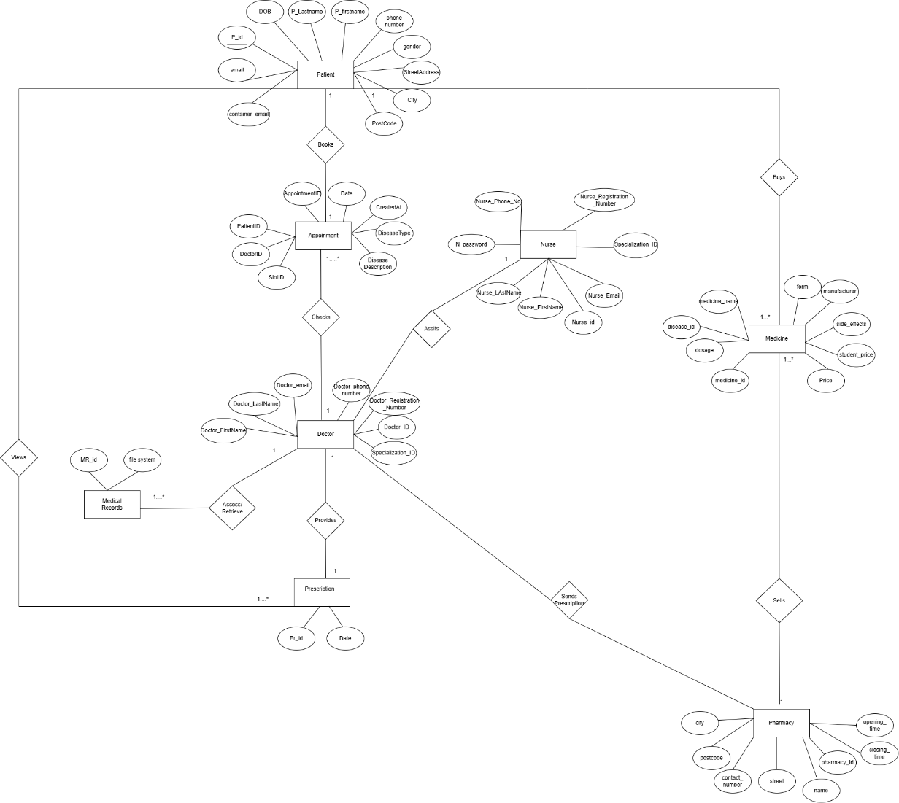

Figure : ER Diagram

### Class Diagram.

The class diagram basically helps in development process by describes the structure of the system to be designed. A class diagram is a combination of multiple classes that describe the system, and the connections between two classes are defined by relationships( (Daniela Berardi, 2005) (Lee, 2004).

Now, considering the automated GP system the most important classes are Patient, Doctor, Nurse and Admin. These classes build the foundation of the entire web app, furthermore attributes and operations allowed by each of these individual classes are depicted in the class diagram provided in the Appendix Diagram N.1: Class Diagram.

For instance, the doctor class is allowed to perform the operations such as cancel appointment, login, profile and delete doctor. For these operations to be carried out successfully, the attributes of the doctor class will be of high importance. A class diagram ideally is the main foundation of the entire GP system, as it was mostly used while database creation and tremendously helped in implementing advanced features like upload medical records and provide prescriptions.

Normalization process for these classes have been performed at the very beginning of the development phase, as the goal was to develop a highly scalable, secure, sophisticated and simple infrastructure for the web-app. Database Normalization is an important aspect while developing any dynamic architecture, this process ensure data integrity and reduces duplicate records to exist in the database.

### Use- Case Diagram.

The use case diagram is a diagram which provides high level idea about the system to be designed. Use case diagram are basically leveraged or are developed during the requirement gathering phase, this diagram helps software engineer understand the entire working of the system to be developed (Refer Appendix Diagram N.3: Use Case Diagram., Diagram N.4: Use case Diagram for admin.).

In the context of the paper” The Role of “Roles” in Use Case Diagrams” (Genilloud, 2001), the use case diagram helps to represent the functional requirements of the webapp. The human being like characters is called actors. These actors are basically the actual users of the web-app and anything inside the big rectangle are the features which the web-app will have.

With regards to the Automated GP System, actors for the use-case diagram are admin, doctor, nurse and patient. These actors are basically connected to the features they can use from the automated GP system. For instance, from the designed UI diagram, the actor Doctor can provide prescriptions, set their availability and access medical records.

### Service Description.

1. **Users Account**

This section describes essential functionalities related to users, including registration and login. It enables the patient, nurse, doctor and admin to login with their credentials, and according to the user role, which is assigned after login, the user would be navigated to their respective dashboard. Additionally, the admin has the privileges to manage the staff, either to add or delete staff members. This ensures that the users are appropriately managed across the system.

**API endpoints**

POST/patient/register: Register a patient.

POST/patient/login: Authenticate patient and generates a token.

POST/staff/login: Authenticate staff and generates a token.

POST/staff/registration: Admin Registers staff.

POST/gp-patient/registration: Admin registers the patient.

The associated entity relationship diagram includes tables such as patient, doctor and nurse. The password for each of the users has been encrypted with the help of SHA hashing. The login sessions are being maintained, with the help of JWT tokens. The JWT Tokens are generated in a way that they should expire within an hour, each user is assigned a unique JWT and CSRF token upon login. These tokens are required to access protected routes, if these tokens are missing, the user cannot access any protected route. JWT token has been implemented inorder to reduce the risk of unauthorised access. To maintain integrity and safety, the tokens are generated based on the email of the users, and these tokens are sent to the browser of the user via cookies.

1. **Availability Service**

This service mainly aims to set and cancel the availability set by the staff. With the help of the endpoints mentioned below, the staff (either doctor or nurse) would be able to set their availability. Conversely, due to uncertain circumstances, the staff has the right to cancel the availability. This ensures that the staff can access this service without any difficulties.

**API Endpoints**

POST/set_doctor_availability : Sets the doctor's availability.

DELETE/cancel_doctor_availability/<int:doctor_id>/<string:date>/<int:slot_id>: Deletes the doctor's availability for a specific date.

POST/set_nurse_availability: Sets the nurse availability.

DELETE /cancel_nurse_availability/<int:nurse_id>/<string:date>/<int:slot_id>: Deletes the nurse availability for a specific date.

The entity relationship diagram associated with this service uses tables named as doctor availability and nurse availability. In this, the availability set by the doctor and nurse would be stored. The doctor's availability will then be displayed to the patient while they are booking the appointment.

1. **Appointment Service**

This service handles the key functionality of the website, which is appointment booking. The patient books the appointment by selecting the type of disease. According to the disease type selected by the patient, the specialized doctor list would be displayed for the selected date and the slots available will also be displayed. The patient then selects the convenient slot and books the appointment. Additionally, the patient can cancel the appointment if required.

On the doctor’s side, the scheduled appointment could be viewed and cancelled under uncertain circumstances. If the appointment has been cancelled by doctor, an email will be sent to specific patient who has booked that specific appointment. This ensures clear communication and flexibility between the patient and doctor.

**API endpoint**

GET/ get_diseases: Retrieves the list of disease.

POST/get_doctors_list: Displays the list of doctors.

GET/ get_doctor_availability/<int:doctor_id>/<string:date>: Retrieves the availability of the doctor on a specific date.

POST/book_appointment: Books an appointment with the doctor.

GET/my_appointment: Displays the appointment booked for patient.

DELETE /cancel_appointment/<int:appointment_id>: Delete the booked appointment.

GET/ get_patient_bookings/<string:date>: Retrieves the patient booking on a specific date.

DELETE/cancel_doctor_appointment/<int:appointment_id>: Doctor cancels the appointment.

This service has the most complicated entity relationship diagram that uses tables such as appointment, availability, and slots. These tables are interlinked to each other as they share relationship between them. For instance, the doctor must set their availability with the help of slots. Upon adding the availability, if incase the doctor or nurse wants to cancel the availability, they can cancel their availability only if no patient has booked appointment for the same date. The available slots are then displayed to the patient inorder to book the appointment. This process needs to be handled with utmost care, since the details displayed on the patient and doctor dashboard need to be accurate and up to date, without any misinformation.

1. **Medical Records Service**

This service aims to mainly upload and view the medical-related documents like X-Rays, Prescriptions and other documents. The patient will be able to upload the medical records, and the same records could be viewed by the doctor as and when needed.

**API Endpoints**

POST/upload/<patient_id>: This endpoint helps the patient to upload the documents.

GET/patient/files: The patient is able to view uploaded files.

POST/patient/medical records: The doctor only has the right to access medical records of the patient.

1. **Prescription Service**

This service helps the doctor to provide digital prescription to the patient. The doctor verifies the patient, then prescribes the medicine to the patient which includes fields such as medicine name, dosage and instruction. The doctor then verifies if the patient is student or general inorder to apply any applicable discount on the medicine. Furthermore, the doctor sends the prescription to the pharmacy and selects the type of delivery based on patients’ preference.

On the patient dashboard, the system helps the patient to view the prescription provided by the doctor including all the details. If incase, the patients have been provided a prescription, he/she gets an option to buy the prescription, where the payment is done online and the medicine is delivered to their home or could also be collected from the pharmacy they mentioned to doctor while the medicine was prescribed.

**API endpoint.**

GET/prescription: Receives the prescription provided by the doctor.

GET/medicines: Retrieves the medicine.

GET/pharmacies: Retrieves the pharmacies.

GET/patients/verify: Verifies the patient.

POST/providePrescription: Doctor provides the prescription to the patient.

The associated entities involved in this service are the pharmacy, patient and payments. The backend uses the structed SQL to store the data of the pharmacy, patients and payments. However, the prescription data is being stored in NOSQL, specifically the Azure Cosmos DB. For instance, the doctor prescribes the medicine to the patient and sends it to the pharmacy.

The entities involved in this service are the doctor, patient, payment, medicine, pharmacy making the structing of the database much more complicated.

Additionally, this service assures secure payment using STRIPE and seamless transfer of prescription between the patient and pharmacy, making this as the crucial functionalities of the system.

## Frontend.

### UI Design (Wireframes and High-Fidelity Prototype).

Upon successful completion of the necessary diagrams like ER, Class and Use case diagram in previous section. This was the immediate next section which was considered while the development process. This section of UI design mainly exclaims the process involved in designing an interactive user interface.

The process begins with drawing the basic wireframes, where the layouts of the web app are designed with the help of pen and paper. The main objective behind designing the wireframe were to identify and understand the placement of components like Navigation bar, left Navbar panel and the main body. Additionally, there was a need to design essential features of the web app with in-depth knowledge and background research of the user demography, user journey mapping, especially for features like appointment form, upload medical history forms and view prescription table.

Followed by the wireframes were the high-fidelity prototypes, basically high-fidelity prototypes are an iteration over the wireframes. In simple terms, High fidelity means the look and feel of the final version of the website is designed in detail, considering the layout, image, font size and even typography and presented in the form of prototypes (Staff, 2024) (Pernice, 2016). The high-fidelity prototypes are designed with the help of Figma, the designed prototype helped while designing the actual UI of the web-app (Refer Appendix Diagram N.5: High Fidelity Prototype 1.,Diagram N.6: High Fidelity Prototype 2.,Diagram N.7: High Fidelity Prototype 3.).

### 3.2.2 Core Functionalities of UI.

Before diving into the challenges faced, it is necessary to outline the core functionalities of this web-app. As mentioned prior, this Web App mainly focuses to improve the user experience and provide a user-friendly interface for the staff, admin and patient.

The following are the three key dashboards developed along with their respective function in this project:

**Patient dashboard**: Designing the dashboard specially for the patient was a challenging task. However, with the help from the high-fidelity prototypes the developed dashboard provides features such as appointment booking, managing medical records and purchasing prescriptions.

**Admin Dashboard**: This dashboard was another crucial aspect of UI design, as the admin is allowed to add, view and remove the patient and staff. Admins are also allowed to book the appointment for the old-aged patients.

**Staff Dashboard:** This developed dashboard would be accessed by the doctor as well as the nurse staff of the specific GP, wherein the nurse are only allowed to set their availability. On the contrary, the doctor is allowed to set availability, cancel availability, view the previous medical history of the patients and provide prescriptions to the patients.

The Table 1, Table 2, Table 3 and Table 4 details design description for each of the dashboards

s

|  |  |
| --- | --- |
| **Screen** | **Design** |
| Login Screen (Refer Appendix thehealme P.1: Landing/Login page., thehealme P.3: Staff login Page. ) | Displays an input field along with icons for email addresses and passwords. The login button is implemented to submit the form and navigate to the dashboard. Further, the staff login button and register button are displayed. |
| Register Screen  (Refer Appendix thehealme P.2: Register Page.) | Displays input fields along with icons for first name, last name, email address, date of birth, gender, address, password and contact number. The register button is implemented to submit the form. |
| Patient Dashboard  (Refer Appendix thehealme P.4: Patient Dashboard.) | Displays a logout button at the top navigation bar.  The booking appointment, prescriptions, medical records and Profile are buttons displayed on the left side/navigation panel.  By default, the dashboard displays the appointment details that are already scheduled and a cancel button. |
| Staff Dashboard  (ReferAppendixthehealme P.8: Staff Dashboard (Doctor), thehealme P.13: Staff Dashboard (Nurse) ) | Displays a logout button at the top navigation bar.  The set availability, get patient bookings, prescriptions, medical records and Profile are buttons displayed on the left side/navigation panel. |
| Admin Dashboard  (Refer Appendix thehealme P.15: Admin dashboard) | Displays a logout button at the top navigation bar.  The Add Patient, Add Staff, Book Appointment, Patient List and Staff List buttons are displayed on the left side/navigation panel. |
| Profile  (ReferAppendixthehealme P.7: Profile(Patient).thehealme P.12: Profile (doctor).thehealme P.14: Profile(Nurse) ) | Displays the details of specific user. |

Table 1: Essential Screens along with brief design description.

|  |  |
| --- | --- |
| **Patient Dashboard** | |
| **Screen** | **Design** |
| Booking Appointment Screen  (Refer Appendix thehealme P.4: Patient Dashboard.) | Form 1: Displays an input field for disease description and selection of disease from a drop-down.  Form 2: Displays a calendar to select the date.  Form 3: Displays a list of available doctors for the selected date.  Form 4: Displays the available time slot of the doctor. |
| Medical Records Screen  (Refer Appendix thehealme P.6: Uplaod Medical Histroy Screen(Patient).) | Displays a drop-down where the type of file needs to be selected. The Select File button helps to select the file from the device/system and upload the same with an Upload button. |
| Prescription Screen  (Refer Appendix thehealme P.5: Prescriptions Screen (Patient).) | Displays the prescribed medicine along with details inside the React Card visual. The details displayed include the medicine name, quantity, instructions, pharmacy name, collection method and total cost. The buy now button is displayed along with the total cost. |

Table 2: Patient Dashboard screens along with brief design description.

|  |  |
| --- | --- |
| **Staff Dashboard** | |
| **Screen** | **Design** |
| Set Availability Screen  (Refer Appendix thehealme P.8: Staff Dashboard (Doctor).) | Display the Select Date button along with the time slots and the option Select all.  The already-available set, along with a cancel button, is displayed. |
| Get Patient Booking Screen (Refer Appendix thehealme P.9: Get Patient booking (Doctor)) | Displays the select date button. Upon selecting, it displays the details of patients booked along with a cancel button. |
| Prescription Screen  (Refer Appendix thehealme P.10: Provide Prescription.) | Form 1: Displays the verify patient form with input fields.  Form 2: Displays the details of the patient upon clicking the verify button along with the provide prescription button.  Form 3: Displays the header named Provide Prescription along with the patient's essential details. Further, the select medicine, quantity, instruction, patient type and collection method fields are displayed along with the add medicine and pharmacy buttons.  Form 4: Display the Add Pharmacy form along with fields such as select pharmacy, street, city, and postcode. Further, the back button and send to pharmacy button are displayed. |
| Medical records Screen  (Refer Appendix thehealme P.11: View Medical Records.) | Form 1: Displays the verify patient form with input fields and a verify button.  Form 2: Displays the list of files along with name and link. |

Table 3: Staff Dashboard screen along with brief design description

|  |  |
| --- | --- |
| **Admin Dashboard** | |
| **Screen** | **Design** |
| Add Patient Screen  ( Refer Appendix thehealme P.16: Add Patient.) | Displays an input field such as first name, last name, date of birth, gender, password, contact number, email address, street address, postcode and city, along with an Add Patient button. |
| Add Staff Screen  ( Refer Appendix thehealme P.17: Add Staff. ) | Displays input fields such as staff type, first name, last name , date of birth, password, contact number, email address, registration number and specialisation along with the Add Staff Button. |
| Get Patients List  ( Refer Appendix thehealme P.19: Patient List. ) | Displays a search bar. Displays the list of patients registered along with view details and remove buttons. |
| Get Staff List ( Refer Appendix thehealme P.20: Staff List(Doctor), thehealme P.21: Staff List(Nurse) ) | Display a search field and select a role field. |
| Booking Appointment Screen  (Refer Appendix thehealme P.18: Book Appointments. ) | Displays the same form as one for Patient Dashboard, with only one additional input field in form 1 that’s Select the patient id. |

Table 4: Admin dashboard screens along with brief design descriptions.

## 3.3 Design challenges.

During the design phase of this project, there were several challenges encountered that required thoughtful consideration and evaluation. The challenges faced were both technical and non-technical.

Starting with the technical design challenges, Entity relationship diagram was the first step towards designing the database model. It was necessary to design database model first, as database first approach was considered for overall app development. Designing an ER diagram which caters to implement health sector app was a tedious task and implementing the same model in the SQL database was another hurdle to overcome.

Followed by database modelling, the second most time consuming and challenging task faced was to implement and use cookie based JWT and CSRF tokens. In previous projects, I had familiarity of developing secure applications in JWT and storing JWT in local storage. However, for this paper cookie based JWT token implementation was undertaken. After a few hurdles, this security measure was successfully tested and implemented.   
 Finally, the task which challenged the implementation of the Automated GP system was CORS, CORS stands for cross origin resource sharing. This feature is basically implemented to secure your application from unwanted request from unknown origins. This functionality helps web app to be more secure. After spending more than two weeks, challenges around CORS were resolved, and the developed web app has CORS features built in it.

Non – technical challenges faced were around the designing of the individual pages of admin, staff (doctor and nurse) and the patient. The major point to be considered while designing the application was the look and feel of the application and the designing the User interface such that it should be simple yet professionally appealing as different age group people would be accessing the website. Also choosing the colour combination and typography was also a tricky part. The colours do have their own psychology as calm, emergency, growth, nature, trust and many more.

Since the website was being designed for medical purpose, the colour psychology plays an important role, and the chosen colour were blue, white and off-white. These colours were opted as they resembled calmness and trust.

Additionally, easy navigation through the website with the required information was a key feature to be provided to the users of the web-app.

# Development Process.

## Database Development

The development process was initiated with database development. The sole reason behind adoption of this methodology was around the database first approach considered for the development of business logic of the web-app. During database development, the majority of informative support was taken from the ER and class diagrams designed in the initial requirements gathering phase.

Initially there was only a vision to use Structured Relational databases. However, after understanding that the developed system would be read-heavy, thoughts were given to indulge Non-Relational database as well. Furthermore, to implement advanced feature of medical records storing BLOB Storage mechanism was also configured to be used.

Tool like SQL SERVER a relational database specifically used for Development environments was leveraged to store the data and edited using SSMS (rwestMSFT, 2025). Specifically speaking about the database structure, only on Database ‘GP’ was configured which furthermore consisted of multiple tables. List of tables within the GP database is as mentioned below:

Followed by Structured Database, the Non-Relation Database was implemented using Azure Cosmos DB Emulator a NoSQL database. Primarily used to store the prescription details provided by the doctors to individual patients. The prescriptions were stored in the Cosmos DB in the form of partitions. The key column for Partitioning the Cosmos DB was the patient Id column. Using the patient Id column, prescriptions assigned to that patient in the past could easily be retrieved, as the prescriptions are stored based on the patient Id. Hence, it was understood during the designing that this feature of the web-app needs to be read-heavy as well write-efficient contributed the idea to opt for Cosmos DB.

Finally, highlighting the last but not the least storage or database implementation the BLOB storage. After going through various articles, research papers and discussion with senior alumni the decision to implement medical record feature seemed feasible. The thorough research through Microsoft’s documentation and additional articles, the medical record feature was implemented with the help of Azure Storage account. A in-cloud service to store files, blobs and much more. The configuration was not the hard part, as there was only a need to place the connection string into the env file of Backend API. The challenge faced was across segregating the files as X-rays, Reports and Prescriptions. The business logic to implement a simple but effective file structure for each patient is discussed in the backend development section.

## Backend Development

The backend was developed in Flask API, Python, ensuring maintainability and scalability. The services were designed as a self-standing endpoint, having its associated serviceability and business logic.

The database-first approach was employed where designing the database for each of the entity was done, followed by the endpoints. Each of the endpoints were built according to the features and later were tested in Postman to confirm the desired output.

The folder structure (Figure 2: Folder structure.) of the backend was organized considering the best practices, ensuring scalability, maintainability, understandability, and readability of the application. Under the application folder, sub-folders were created for models, routes, and utils. The model’s folder holds the admin.py file which basically is used to register new admin, the routes folder was subdivided into patient routes and staff routes, each of them having their respective endpoints and functionalities, and lastly, the utils had the helper functions.

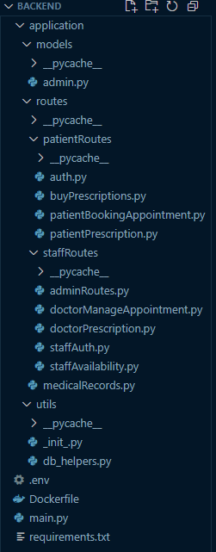

Figure 2: Folder structure.

Additionally, a Docker file, environment file, and main file were also created, which would handle the configuration, development and deployment of the application. In order ensure security and handle cross-origin request, CORS and JWT tokens have been implemented which ensures that data is allowed only from the authorized domain.

### Patient Routes/ API endpoints.

This section provides thorough information about the endpoints that are used for the functionalities of the patient, which are authentication, booking appointments, prescriptions, and buying prescriptions.

### Authentication (auth.py)

For the Authentication module to be implemented, which must only allow access to authorised user. The patient register endpoint (Figure 3) is developed which is a POST method that includes the required parameters. In case any of the fields missing in the post request, a 400 Bad request error message would be sent in response to this API call.

This API endpoint also checks in the database if the patient is already registered based on the email or phone number. Accordingly displays another error message stating that user already exist. In this module itself, when a patient is registered successfully a blob storage is assigned to the respective patient. This blob storage has been used to upload the medical records of patients.

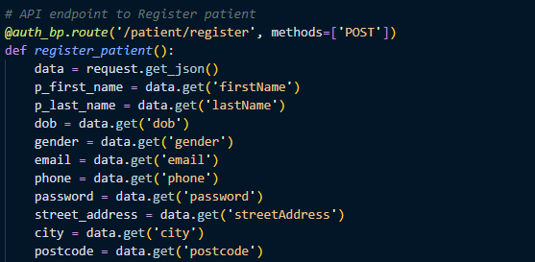

Figure 3: Patient Register Endpoint.

The patient login endpoint (Figure 4) is a POST method that validates the entered credentials against SQL database. In case any of the fields are missing or invalid credentials are entered, error messages 400 and 401 are sent in response. Upon successful login, the cookies and refresh cookies are produced, wherein JWT and CSRF tokens are stored in these cookies and are sent to the user’s browser.

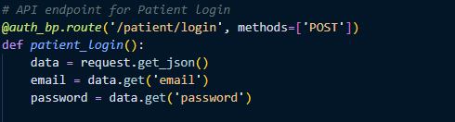

Figure 4: Patient Login endpoint

The patient profile API (Figure 5) is implemented to get the current patients details which is a protected route with a JWT token. This endpoint is a GET method where the patient details are retrieved from the patient email ID and maps the details of the patient from the database to the dictionary. If, in case the patient is not found with the email ID, it responds with an error message.

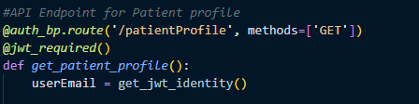

Figure 5: Patient Profile.

Additionally, for all the endpoints, if there’s any database connection failure or any exception error 500 error message is displayed.

The utility functions(Function C.1: Container Access.) used in this section are the password hashing function done in the SHA256 algorithm, get database connection from db helpers and the blob storage access rights provision is done using the utility functions, making the code more modular.

### Book Appointments

This module will basically allow patients to book appointments with an ease. To implement this, feature a set of APIs are used in sequence to allow patient to have a user-friendly experience(Refer Appendix N.2 for detailed flowchart). All the APIs which will be used are protected routes hence they will be secured with a JWT token required flag.

Starting with the get disease endpoint (Refer Appendix Code snippet D.1: Get Diseases.), which is a GET method used to retrieve the list of disease from which patients can select their disease.

The get doctor list endpoint (Refer Appendix Code snippet D.2: Get Doctor List )is the next API call, which is a POST method, where a list of specialized doctors for the selected disease is provided when the post methods is called. In this endpoint the slots table, appointment table, availability table and disease table are accessed using the SQL query, which in response returns with list of doctors.

Followed by the get doctor's availability endpoint (Refer Appendix Code snippet D.3: Get doctors availability) which is a GET method. This endpoint executes the availability of the selected doctor for a particular date. In other words, the endpoint displays the slots available for the doctor for the specific date.

The book appointment (Refer Appendix Code snippet D.4: Book Appointments.) is a post method mainly used to schedule the appointment for the patient. The endpoint fetches the details sent by the patient and checks if the slot selected by the patient is already booked. If booked, it responds with an error message Slot is already booked. If the slot is available, the appointment is booked for that specific patient for the decided datetime and slot with the respective doctor.

Finally, my_appointment endpoint (Refer Appendix Code snippet D.5: My Appointments. )is a GET method that will be used by patient to view the details of the appointment like the appointment ID, doctor's name, specialization ID, date, time, and status.

The delete appointment endpoint (Refer Appendix Code snippet D.6: Delete Appointments. ) manages to delete the appointment based on the appointment ID. This endpoint can only be used by patients to cancel their appointment.

### Prescriptions

The get prescription (Figure 6 )is a GET method that fetches the prescription of a specific patient. For this endpoint, the patient ID has been passed as an argument, and the endpoint is secured with JWT authentication, which ensures that only the authorized users can access the prescribed medicine.

The endpoint retrieves the prescription data from the Azure Cosmos DB, which is a NoSQL database. To retrieve the data from Cosmos DB, the setup of the database includes the Cosmos endpoint, Cosmos key, database name, and container name. In the database, the prescriptions are segregated based on the patient id.

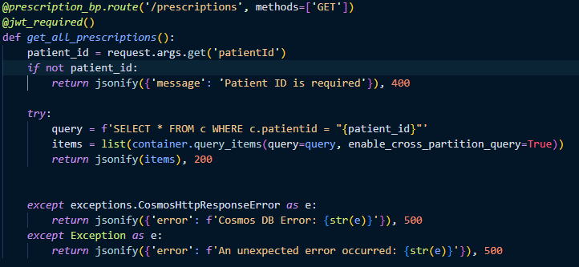

Figure : Prescriptions Endpoint.

### Buy Prescriptions

The buying of prescriptions was one of the crucial endpoints, as it included the Stripe integration. Firstly, the payment sessions (create-payment-session) (Refer Appendix Code snippet E.2: Create Payment Session., Code snippet E.3: Create payment session continuation.) endpoint checked whether the patient had done the payment or not with the help payment table. If the payment was not done, a Stripe checkout session was created, including the total amount. By default, session ID (stripe_payment_intent_id) and payment status as ‘pending’ are stored in the payment table.

Upon successful payment, Stripe provides secure webhooks (Refer Appendix Code snippet E.1: Stripe Webhooks )that confirm the payment status. If the payment is successful, the webhook sends a message that includes the session ID, prescription ID, stripe_payment_intent_id and updates the payment status to ‘succeeded’. The update payment status (Refer Appendix Function C.2: Update Payment Session.) is a helper function that updates the payment table when the webhook sends the response; until that time, the payment status is displayed as pending. This ensures that the transactions made are secure using the JWT authentication and the Stripe signatures.

### Staff Routes/ API endpoints.

This section outlines the endpoints developed for the staff functionalities, including registration of staff and patients, prescribing medicine prescriptions, availability setting, and managing the booking appointment.

### Admin Routes

The admin registers the GP staff which are nurse and doctor with the help of the staff registration endpoint (Refer Appendix Code Snippet F.4: Staff Registration.). In this process, the admin ID is first verified. Upon successful verification of the admin, the helper functions are invoked: register_doctor and register_nurse (Refer Appendix Function C.3: Register doctor and Register nurse.). The admin then sends the details of the staff to the database and stores it. On the contrary, if the admin ID is missing or invalid, the backend API for staff and patient registrations will not be allowed or executed.

Moreover, the admin has the right to register the patients (Refer Appendix Code Snippet F.5: Patient Registration.). During this process, the register patient API is being called. Like the staff registration endpoint, the admin is verified based on the admin ID. Upon successful validation, the admin enters the data and sends it to the database. However, if the admin ID is not verified or validated, the backend API will not be executed. While registering Patients an additional feature has been implemented with Azure blob storage library. This library is basically used during registering a new patient. This library of Azure mainly creates a unique blob container for every patient. Wherein the patient can upload their medical records in the blob container for doctor’s use.

The API endpoints getPatient(Refer Appendix Code Snippet F.3: Get patients.), getDoctor(Refer Appendix Code Snippet F.2: Get Doctors ), and getNurse(Refer Appendix Code Snippet F.1: Get Nurses ) are developed to retrieve a list of patients, doctors, and staff. These endpoints could only be accessed by the admin when the admin email had been verified. Upon successful verification, the details are being fetched from the respective database: Get patients from the patient table, get doctors from the doctors table, and get nurses from the nurse table.

Furthermore, the admin has the authority to delete the patient and staff. During this stage, the admin is verified based on the email address, and the endpoints involved in this are deletePatient( Code snippet 2), deleteNurse (Code snippet 3), and deleteDoctor(Code snippet 1). The deletion logic is carried out based on their respective email addresses. Additionally, if the email address doesn't exist, the status code 404 which stands for Not found is responded.

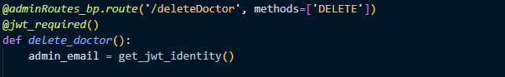

Code snippet delete doctor API

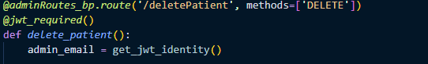

Code snippet : Delete patient API

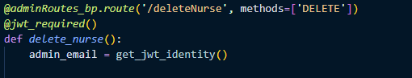

Code snippet : Delete nurse API

### Doctor Manage Appointments

The endpoint get patient booking (Refer Appendix Code snippet G.1: Get patient Booking.) was developed for the doctor to check the appointment scheduled for a particular date. In this endpoint, the doctor is verified based on the email address (included in the JWT token). Upon successful verification, the appointments were retrieved from the database based on the doctor's ID with the date.

In addition, if the doctor wants to cancel a specific appointment due to uncertain circumstances, the cancel doctor appointment endpoint (Refer Appendix Code snippet G.2: Cancel Appointment by doctors. would be triggered. During this, the endpoint fetches the appointment details from the database, displays them to the doctor, and then the doctor selects the appointment to be canceled. Upon cancellation of the appointment, send_cancellation_email will be initiated. The send_cancellation_email helper function (Refer Appendix **Error! Reference source not found.**) sends a structured email to the patient's email address. This ensures clear communication between the doctor and patient, where, if required, the patient could reschedule the appointment. For this feature to be implemented, Communication service from azure was leveraged. This service helps implement email communication, for our case when a doctor cancels an appointment it becomes necessary for the system to inform the patient that their appointment has been cancelled. This not only increases the transparency between the two parties using the system but also keeps data consistent and well communicated across the system.

### Prescription

The doctor provides the prescription to the patient, which includes the medicine details, collection method, prescription date and doctor's email. As an initial step of this process, the doctor must verify the patient by entering the first name, last name and date of birth. To ascertain the patient's identity, the verify patient endpoint would be triggered (Refer Appendix Code snippet H.3: Verify Patient.), which validates the provided data against the patient's database. Upon successful verification, the doctor proceeds to issue the prescription.

During the process of prescribing the medicine, the medicine details along with their prices are extracted from the medicine table. The price of the medicine is mainly based on the type of patient: student/normal. If the patient is a student, each medicine price is calculated with a 10% discount.

The finalised prescription(Refer Appendix Code snippet H.4: Provide Prescription, Code snippet H.5: Provide Prescription Continuation.) is then stored in Azure Cosmos DB which is a NoSQL database. To retrieve the pharmacy and medicine details, the get_pharmacy (Refer Appendix Code snippet H.2: Get Pharmacies.) and get_medicine(Refer Appendix Code snippet H.1: Get medicines.) endpoints are created, which helps us dynamically retrieve all additional information about medicines and pharmacies.

### Staff Authentication

The staff login endpoint (Refer Appendix Code snippet I.2: Staff Login, Code snippet I.3: Staff Login continuation.) is activated when the staff type is doctor, nurse, or admin. The credentials entered would be the password and email address. The email addresses are created for staffs in such a way that it adds an additional layer of security to the system. For instance, doctor email basically contains ‘. doctor’ in the ‘username.doctor@thehealme.com’ email needed to login.

During the verification process, the verify_staff helper function (Refer Appendix Function C.5.: Staff Verification.) will be invoked. This function will check the email first and confirm that it does hold the ‘. doctor’ or ‘. nurse’ or ‘. admin’ in the email. Upon verification of the credentials, the cookies are generated which hold the JWT and CSRF token. Conversely, if any email address or password is invalid, the backend will signal a status code 401 which says unauthorized.

The get staff profile endpoint (Refer Appendix Code snippet I.4: Staff Profile , Code snippet I.5: Staff profile Continuation. ) is a GET method where the staff is verified based on the email address. After the verification has been completed, the endpoint executes the details of the staff irrespective of their type (nurse/doctor), including the name, email address, registration number, specialization, and phone number.

The get specialization endpoint (Refer Appendix Code snippet I.1: Get Specialization.) extracted the specialization of doctor/nurse. This was retrieved with the help of specialization and the nurse specialization table.

### Staff Availability

For the doctor to set their availability, the set_doctor_availability endpoint (Refer Appendix Code snippet J.1: Set Doctor Availability. ) is called. This endpoint sets the doctors' slots selected for a particular date and inserts them into the doctor availability database table. In case any of the selected slots is already set in the table, a status code 400 will be returned.

Likewise, the nurse can set the availability with the help of the set_nurse_availability endpoint (Refer Appendix Code *snippet* J.3: Set Nurse Availability. ). This endpoint initially examines if the selected slot already exists in the nurse availability table, and if so, displays a status code 400. Conversely, the selected slots are sent to the database along with the nurse_id and the date. As a result, the message is returned as "Nurse Availability set successfully."

The staff (either nurse or doctor) has the option to cancel the availability (Refer Appendix Code *snippet* J.2: Cancel Doctor Availability. , Code snippet J.4: Cancel Nurse Availability. ) that is previously set in the set_availability endpoint.

To retrieve the availability set by nurse/doctor, the get availability endpoint (Refer Appendix Code snippet J.5: Get the Availability.) is handled. This endpoint utilises the staff type and staff ID to fetch the availability from the doctor availability or nurse availability database table.

### Medical records.

The medical record endpoint allows the authorised patient to upload the medical files (prescriptions, X-rays and reports) and allows the doctor to view the uploaded files. The upload endpoint (Refer Appendix Code snippet K.1: Upload the medical records.) allows patients to upload their documents to the containers assigned to them during the registration. The files are securely uploaded in the Azure Blob Storage, where each of the containers is linked with patient_id. Additionally, the connection string for the Azure Blob Storage has been configured, as it's necessary for secure communication.

The patients' records are protected with the JWT token, where each of the patients must be authenticated via JWT. Each patient is assigned a unique container along with an ID in blob storage. The files can only be accessed once the patient is verified. The upload medical record (/upload/<patient_id>) endpoint is secured with JWT. In this process, the API queries the patient table with patient_id to retrieve the Azure container name assigned to that patient. The patient then uploads the files based on the selected category and returns a success message.

The patient can view the uploaded medical documents with the get/patient/files endpoint (Refer Appendix Code snippet K.2: Get patients file). Like the /upload/<patient_id> endpoint, the API queries the patient_id to fetch the container_name. The response received presents the file name along with the URL published by the blob to access the files.

The doctors are only restricted to accessing the medical records of the patient with the post/patient/medical records endpoint (Refer Appendix Code snippet K.3: Doctors views the medical records., Code snippet k.4: Doctors view the medical record continuation.). During this process, the patient must be validated first with first name, last name and date of birth and If the patient is a valid user, only then the container name is fetched, which retrieves a list of files along with the URL. This helps the doctor to view the records without any complications.

## Frontend Development.

The main aim is to design a user-friendly interface considering the diverse age groups. This section provides a detailed frontend development process. The application is built using React JS and Bootstrap Library, which helps to reuse the components and minimise the code redundancy across the web app (Describing the UI, n.d.).

A modular folder structure (Refer Figure 7) was developed where the main folders were components, pages and app.js. To make the code easy to understand, each of the components was named based on the feature/functionality that was later imported to the respective folders.

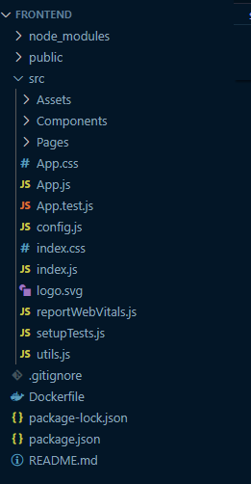

Figure : Folder Structure.

### Development Process

The table conveys the features that are implemented for each of the users (patient, staff and admin) along with the actual name tags used for the dashboard. The functionalities and user journey of each of the dashboards will be explained module-wise, starting with the appointment module, prescription module, medical documents module, profile module, register staff and patient’s module, list of registered patients and staff and lastly the set availability module. Below provided are the feature allowed for different users.

|  |  |  |  |
| --- | --- | --- | --- |
| **Module Name** | **Patient** | **Staff (Doctor/Nurse)** | **Admin** |
| **Appointment Module** | Booking appointments | Get Patients Bookings | Booking appointments |
| **Prescription Module** | Prescription. | Prescription. | N/A |
| **Medical documents module** | Medical Records. | Medical records. | N/A |
| **Profile module** | Profile. | Profile. | N/A |
| **Register module.** | Register. | N/A | Add staff.  Add patients. |
| **List of registered patients and staff module.** | N/A | N/A | Staff list.  Patients list. |
| **Set availability module.** | N/A | Set Availability. | N/A |

1. **Appointment module**

**Patients**:

Upon successful login, the patient is displayed the patient dashboard where the default page viewed is booking appointments. The previously booked appointment details, such as appointment ID, doctor, date , time and status, along with the cancel button, are displayed with the help of the fetchAppointments function(Refer Appendix Code snippet D.7: Fetch Appointment function.). The fetchAppointments function call the my-appointment API that will trigger once the patient is logged in. Due to uncertain circumstances, if the patient wants to cancel the appointment, the cancel button can be clicked where a modal is displayed allowing user to cancel the appointment. Upon successful confirmation, the handleCancelAppointment function (Refer Appendix Code snippet D.8: Cancel Appointment Function.) triggers the cancel_appointment API.

When the Book Appointment button is clicked, the booking form is displayed, whereupon selecting minor injuries displays an article. The patient has the option to read the article and take precautions at the very first stage of the disease. If, in case, the patient still requires a consultation from the GP, the date is selected from the calendar, and the function handleDateChange (Refer Appendix Code snippet D.9: Handle date change function.) is invoked. Further, the specialised doctor for that specific disease is displayed with the get_doctors_list API. Upon selecting the doctor, the available time slots are displayed where the get_doctor_availability endpoint is triggered, and the book button invokes the handleBookDoctor function (Refer Appendix Code snippet D.10: Handle book doctor function.).

Additionally, in this entire process, the components that were imported to the Patient Dashboard page were BookingAppointment, bookappointmentbutton and AppointmentCard. Furthermore, the BookingAppointmentForm, CancelAppointmentButton, CancelAppointmentButtonModal, Abdominal Page, Fever Page and Cough Page were the components utilised during this entire process of booking appointments and viewing the same.

**Doctor**:

The doctor can view the scheduled appointment with the help of the handleDateChange function (Refer Appendix Code snippet G.3: Handle date change function.). Firstly, the doctor needs to select the date and hit next to get_patient_bookings and then the patient bookings are displayed in the form of a table.

Due to uncertain circumstances, the doctor wants to cancel a specific appointment. The cancel button is clicked where the handleCancelAppointment (Refer Appendix Code snippet G.4: Handle cancel appointment.) function is invoked and the email is sent to the patient. sssss(Please Refer Email: 1 as an example for email cancellation).

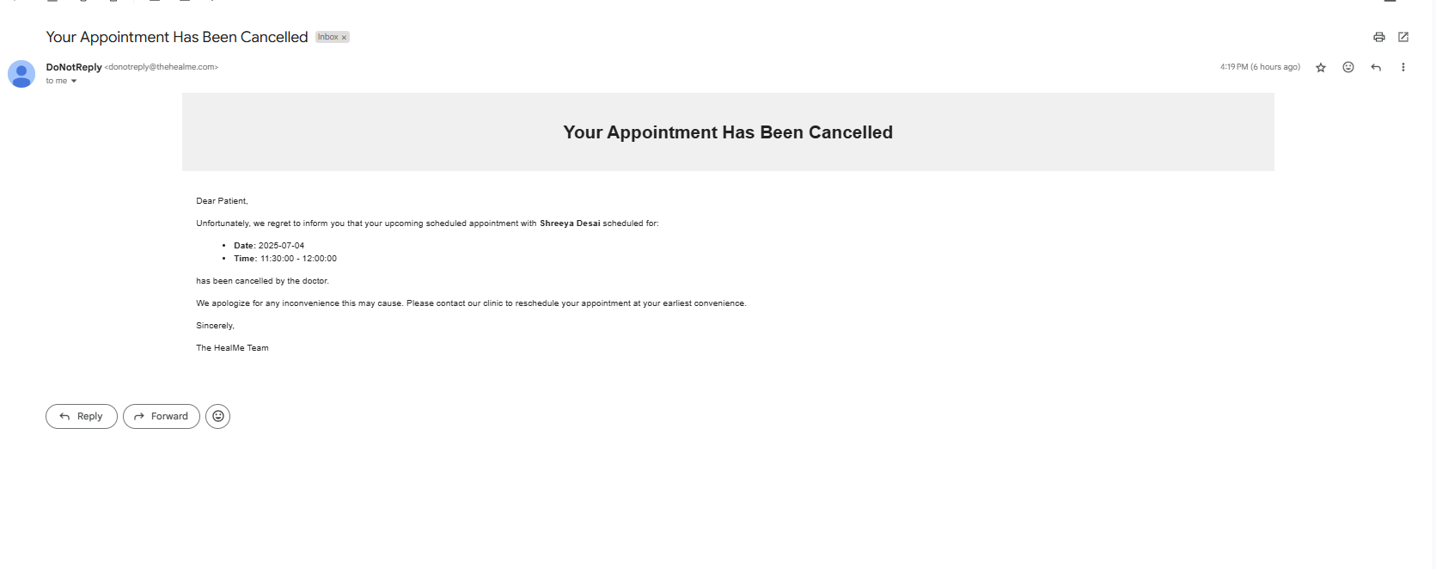

Email: :Cancellation Email.

**Admin:**

The admin can also book the appointment on behalf on old aged patients.

The entire process is same as for the patients, but the only difference is that if the staff types is admin, only then the patient ID input field is displayed in the BookingAppointmentForm. The patient ID is retrieved from the patient list component. This ensures that the patient receives the appointment booked on their dashboard.

1. **Prescription Module.**

The prescription module aims to prescribe the medicine to the patient and send it to the pharmacy and the patients.

The ViewPrescription.jsx component is designed, which includes the fetch prescription function along with the get prescription endpoint. This helps the patient to view the prescription. The prescription form, pharmacy form, provide prescription, payment already done modal, payment success and payment cancel components are used to develop the provide prescription.

**Patient:**

During the process of viewing the prescription, the patient must click on the prescription option which is on the left sidebar. The system then displays the prescription details, including the patient's name, doctor's email address, and the prescribed medicine details along with the type of delivery. Additionally, the patient can pay for the prescriptions, and this can be achieved by clicking on the Pay now button.

**Doctor:**

The doctor firstly needs to verify the patient by entering the first name, last name and DOB. Upon successful verification, the doctor can move to the next step, which is the prescription form. The prescription form displays the input fields, such as the selection of the medicine from the drop-down, quantity and instructions. Furthermore, the type of patients and the type of delivery is selected based on the patient preferences.

The next step is to select the pharmacy and send the prescription to the pharmacy and patient.

1. **Register module.**

**Patient:**

Firstly, the landing page is displayed, which has a Register here button. Upon clicking, the register form is displayed, which is divided into two parts: the first page displays the name and address fields, and the second page displays the contact number, email address and password.

Once all the inputs are filled, the register button is clicked, which then triggers the handleRegister function (Refer Appendix Code snippet L.1: Handle Register.). The function triggers the /patient/register API, which then saves the patient's details to the database.

**Admin:**

The add staff and add patient component files are developed separately and are imported to the admin dashboard.

Only the admin has the right to add the staff, either doctor or nurse. During this process, the admin is verified based on the email address. Once the admin is verified, the Add Patient tag is displayed on the left side panel/navigation bar.

Upon clicking the button, a form is displayed where the admin enters the data in input fields. Once the details are entered, the add staff button is clicked, which triggers the handle function logic which has the registration endpoint.

Conversely, to add the staff, the Add Staff option from left side bar is clicked. Like the Add patients, the Add staff follows the same process. Once the add staff button is clicked, a form is displayed where the details are entered, and upon entering the details, the register button is clicked. This page triggers two functions: firstly, the fetchSpecializations(Refer Appendix Code snippet L.2: Fetch Specialization function.) and secondly, the handleSubmit.

1. **Medical Records.**

This module aims to upload and view the medical records.

**Patient:**

The patient firstly clicks on the Medical Records option that's on the left side of the dashboard. Further, the patient selects the type of file from the dropdown. Then the patient selects the file from their device and clicks on the upload now button.

During this process, the handleFinalUpload function (Refer Appendix Code snippetK.5: Handle final upload function. in the UploadMedicalHistory.jsx component handles the main logic of the system where the API call is invoked. The uploaded files are then displayed to the patient, who can view them.

**Staff (Doctor):**

To view the medical records of the patient, the doctor firstly has o verify the patient by entering their name and date of birth. Upon successful verification, the doctor is able to view the files that were uploaded by the patient. A link is provided to access the same and can also download if required. The component file utilized for designing the logic and frontend is ViewPrescription.jsx

1. **Set Availability Module – Staff Specific**

This module mainly focuses to set the availability for doctors and nurses.

The SetAvailabilityModal.jsx and SetDoctorAvailability.jsx components are imported to the staff dashboard pages. The functions used for this module were fetchAvailability, handleAddAvailability, and confirmAddAvailability, where the endpoints are triggered for adding the availability, and lastly, handleRemoveAvailability was implemented to remove the availability set.

The process to set availability is as follows: Once the staff is verified, the staff is navigated to the dashboard, which displays a left panel that has a tag named "Set Availability". During the process of setting the availability, the staff firstly needs to click on the set availability button, which further provides the option to select the date to which the slots will be added. The slots are then set by clicking the add button, which displays a confirmation modal. The slots confirmed are then displayed along with the cancel button on the dashboard.

1. **List of registered patients and staff module – Admin Specific**

The admin only has the authority to view the list of registered patients and staff (doctor/nurse). During this process, the admin is firstly verified based on the email address. Upon successful verification, the admin is redirected to the dashboard, which has a top navbar and left sidebar. The left navigation bar displays the tags "Patients List" or "Staff List".

To view the list of registered patients, the admin clicks on the "Patient List" option from the left sidebar. The system then displays the list of registered patients, which is retrieved from the getPatients API that's in the PatientList function.

On the contrary, to view the list of registered staff, the admin should click on "Staff List" option in the left sidebar. The application then displays the field where the staff role needs to be selected. Upon selecting the staff role, the list of either nurse or doctor is displayed based on the selection. This has been achieved with the help of API getDoctor/getNurse that's in StaffList function.

Additionally, for both the staff and patient, the admin only has the right to remove/delete them.The component files linked with this module are StaffList.jsx and PatientList.jsx, and both are imported in the respective Patient and Admin dashboards.

1. **Profile module**

The profile section displays the details of the user, who is either a patient, doctor or nurse. The details that are commonly displayed across all the users are first name, last name, email address, and contact number.

The component files that handle the patient profile and staff profile are named Profile.jsx and StaffProfile.jsx.

The patient's profile is displayed when the user clicks on the Patients option from the sidebar, which is on the left navigation/sidebar panel. When clicked, the patientProfile API is triggered and displays the details. The details can only be read and can't be edited. Similarly, the staff (doctor/nurse) can view the details in the Profile section, which, when clicked, triggers the staffProfile API and displays the details.

# Testing.

## Unit testing

This Section will showcase unit tests conducted around different modules of web app.

### Patient Features - Unit testing

1. **Book Appointment**



1. **Prescription**



1. **Medical Records**



1. **Profile**



### Staff Features – Unit testing

1. **Set Availability**



1. **Get Patient Booking**



1. **Prescription**



1. **Medical Records**



### Admin Features - Unit testing

1. **Add Patient**



1. **Add Staff**



1. **Manage Bookings**



1. **Get Staff and Patients list**



# Deployment.

This section provides an in-depth description of the deployment done on Microsoft Azure leveraging Azure resources.

## Architecture.

A simple cloud-based architecture is designed to ensure security, maintainability and scalability across the services. The big three cloud providers currently in the market are Microsoft Azure, Amazon Web Services, and Google Cloud Platform, along with IBM Cloud, Oracle Cloud, Salesforce, DigitalOcean and many more. Thus, Microsoft Azure was the selected cloud provider for this project.

The figure illustrates (Figure 8) the system components, such as frontend, backend, and databases (SQL and NoSQL), which are interconnected with the services. In this deployment process, the frontend is deployed within the Azure App Service, as it helps to run the application without the burden of managing the underlying architecture. Similarly, the backend is deployed in Azure Container Apps since it provides reduced infrastructure maintenance and saves cost for containerised applications.

Additionally, the backend communicates with Azure SQL, Azure Cosmos DB, Blob Storage and Azure Communication Services for email, which is achieved with the help of the connection string provided by Azure services that is then set in the environment file of the backend.

In terms of security, cross-origin resource sharing is implemented to ensure that the server accepts and responds to the authorised frontend application. This methodology ensures that only authenticated and authorised requests are accepted, which would prevent malicious cyber-attacks. Additionally, along with CORS, the JWT and CSRF tokens were generated for a secure communication between the backend server and frontend application. The CORS would only accept the request sent by *thehealme.com*; this domain is purchased from GoDaddy.

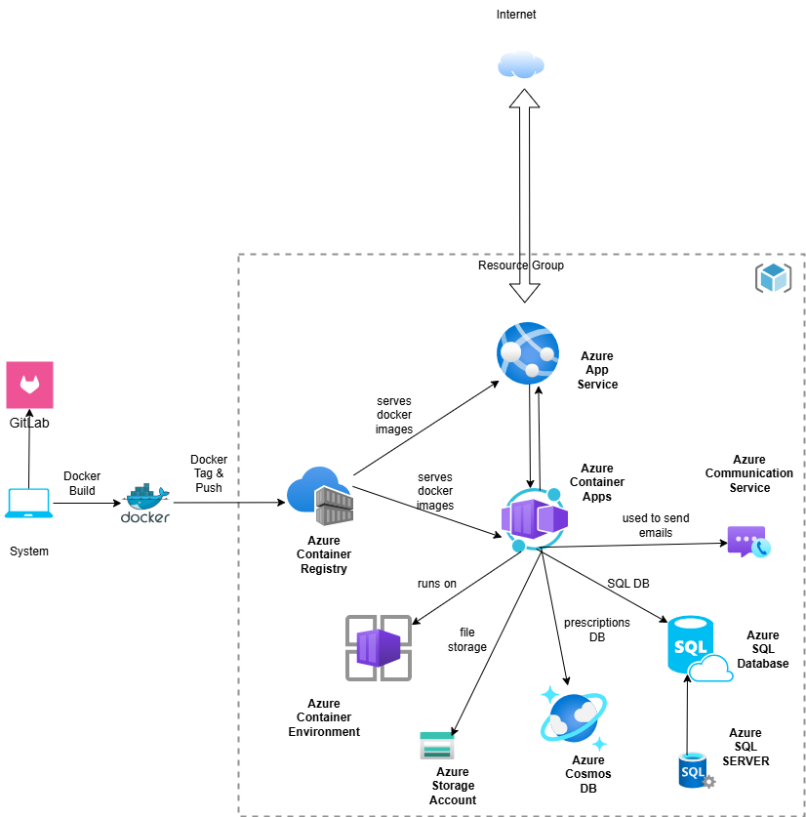

Figure : Architecture Diagram.

## Azure Services Used.

The Azure services used throughout this project are as follows:

**Azure Container App**

The Azure Container App is a serverless platform, mainly used for the deployment of backend (Flask AP) applications. The container app eases the management with auto-scaling, security management, monitoring and flexibility in deployment process. Additionally, the container app needs a container environment which supports the functioning of the container app. (craigshoemaker, 2024).

**Azure App Service**

The Azure App Service is mainly used for the deployment of React frontend applications. The Azure App Service is a platform that runs the application, abstracting away the infrastructure. Additionally, this service supports various web stacks such as .NET, Java (in Java SE, Tomcat, and JBoss flavours), Node.js, Python, and PHP and runs either on Linux or Windows (msangapu-msft, 2024).

**Azure Container Registry**

The Azure Container Registry acts as a repository for storing docker images. The images from the Registry are then consumed or deployed by server like Container apps and Azure app service.

**Azure SQL**

Azure SQL is a fully managed relational database-as-a-service (DBaaS). Moreover, Azure SQL is a managed SQL server database engine which falls under the platform as a service. Moreover, SQL Server is a built-in functionality and feature that requires extensive configuration. Therefore, this service is mainly used for the SQL database queries in this application (WilliamDAssafMSFT, 2024).

**Azure Cosmos DB**

The Azure Cosmos DB is a NoSQL database and is primarily used to store the prescription details. The Cosmos DB simplifies the development process of the application much faster in a single database (markjbrown, 2024) (AdamGuan13, 2024).

**Azure Communication Service.**

Azure Communication Service is used for the notification purpose, which will send an email to the patients about the cancellation of the appointment. Additionally, the service supports diverse communication formats (PetoMichalak, 2024) (MelanieHom, 2025).

**Azure Storage Accounts**

The Azure Storage service is Microsoft's cloud storage solution for modern data storage scenarios. The Azure storage offers durability, high availability, scalability, accessibility, and security for storing the data in the cloud. This service is primarily used to store the medical documents of patients, ensuring easy accessibility from anywhere (martinduefrandsen, 2025) (stevenmatthew, 2022).

## 6.3 Deployment Process.

After testing the web-app and being satisfied with the test results on local development environment, the next step was to deploy the web-app on Azure cloud. Now, deploying a full stack web application was a challenging experience. After reading through various articles and website blogs (RoseHJM J. , 2024) (Ahamed, 2020) (RoseHJM, 2025) (HeidiSteen, 2025) (JasonFreeberg, 2025) (CamSoper, 2024) (cephalin, 2025), I learned about the deployment methodologies which are been used across industry as of today. Some of the methodologies include CI/CD deployment, deploying application directly to the cloud services using GitHub and lastly deployment with the help of docker images.

Acknowledging that this is the first time, where I will deploy a full stack application on cloud. The methodology I chose for cloud deployment was the docker image deployments, the reason behind opting this methodology was due to its intuitive and simple to implement nature. Although being simple to implement, several official documentation and articles were thoroughly read and understood before even starting the deployment process. A dockerfile is necessary to be provided in the root of the folder structure, which comprises of all the necessary libraries and commands which are needed to run the app independently on the cloud.

This methodology seemed to prove helpful, as it easily aligned to our applications architecture. The developed web app follows N-tier architecture, therefore the frontend and backend are two separate entities and should be deployed separately. Although the deployment of backend and frontend will be done separately, the initial steps need to be followed for both are similar.

Below are the common steps for both backend and frontend to build docker images and publish them to cloud.

(Refer Appendix O for the snippets of entire development process.)

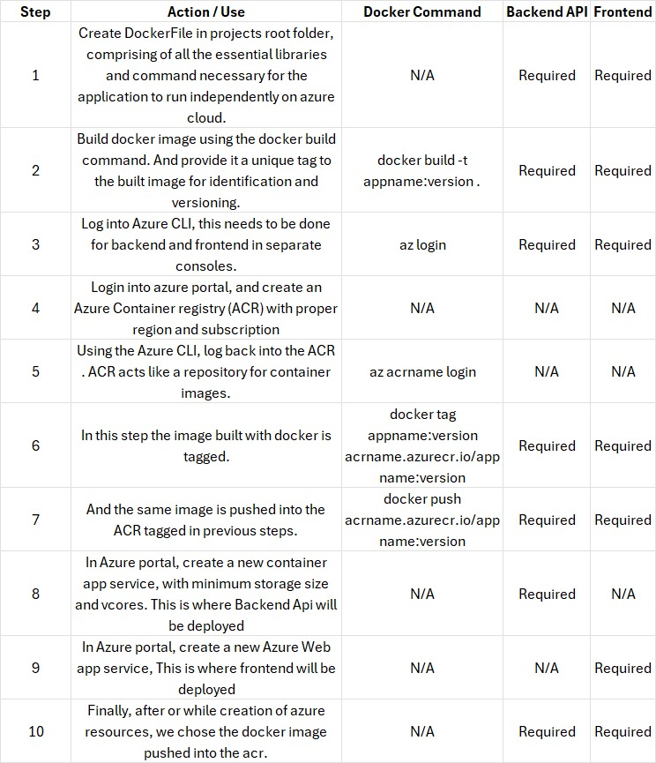

After successfully deploying the Backend and Frontend to their respective azure services. It was decided to add a custom domain to avoid CORS error. To implement this additional security layer of CORS, a new domain name for both Backend ‘api.thehealme.com’ and frontend ‘*thehealme.com*’ were purchased from GoDaddy website. Furthermore, after purchasing the DNS, it was added to Azure web app and container app in the custom domain sections of each. Additionally, we configured a azure self-managed SSL certificate for the website or endpoint to be https. During this process, the domain validation was essential. Azure performed the validation since it gave information to fill in the DNS section within GoDaddy. Upon successful verification, the domain was added. Additionally, the certificate is secured with https.

The in-depth explanation of the deployment process is provided below, respective of Frontend and Backend.

**Frontend**

Initially, we had to create the Azure App service called FrontendGpSystem, assuming we are in the Azure Resource Group (rg_gp_uk). After choosing the app service, the Deployment section appears in a left panel. To view the application deployment details, choose the Deployment Centre inside the deployment option in the left navbar. Here, we select and save the revised picture tag. This procedure assures that the right docker image is being retrieved and ran (Refer Appendix Deployment: O.23: Deployment Center(FrontendGpSystem)).

**Backend**

Conversely, for the backend application, create the Azure App Container named gpsystemukcont, assuming we are in the Azure Resource Group (rg_gp_uk). After selecting the container app, the Application section appears in the left panel. To view the application deployment details, choose the Containers inside the application section. Here, we should select the revised image tag and save. Therefore, this confirms that the correct image is being retrieved and ran (Refer Appendix Deployment: O.24: Containers (gpsystemukcont).). The Azure Container Apps is configured mainly for Flask API backend applications, which include details of the subscription and resource group. In this process the container app environment was needed to be created, as the environment would secure the container apps running in it

# Results.

## Achievements.

The outcomes that the project has led to are outlined below:

Successful development and integration of the backend and frontend was accomplished seamlessly. Cross-site request forgery (CSRF) and JWT tokens (cookies) have been implemented to ensure secure communication and authentication between the frontend and backend application layers. Additionally, CORS has been implemented as an additional layer of security. The overall implementation process for the automated GP system, ensures that security has been given the highest priority.

The dashboards for users like admin, doctors/nurses and patients were designed with careful consideration of demographics. Each of these dashboards are given access based on their user roles, ensuring no authorised user can access protected or sensitive information.

Azure Cloud services like Azure Web Apps, Azure Container Apps, Storage Accounts, Azure Cosmos DB, and Azure SQL are used to successfully deploy the web-app. Integration of the business logic with these azure services will help the system to be available 99% of the time, as the chosen services are fully managed by Azure. An instance of using azure service which led to convenient data storage was the medical documents uploaded by the patients are stored securely in the Azure Blob Storage, associating their files with their unique patient_id.

The developed application is fully responsive for all types of screens. Ensuring this web-app can be accessed anywhere and anytime. This functionality has been achieved using React Bootstrap's classes and have been tested across mobile devices. The application's overall usability and navigation are quite straightforward, ensuring simple, user-friendly website navigation.

Stripe payment integration with the backend business logic has been implemented to securely allow patients to purchase the medicines prescribed by the doctor. Additionally, the webhooks feature of Stripe allows us to track the status of every payment made.

The Backend follows a scalable, modular and easy to understand folder structure. This has been done to ensure seamless integration of any features that will be implemented in near future.

## Lesson Learned.

The lessons learnt from this project are mentioned below:

* Importance of literature survey of the existing applications and technology used for developing the application not only supported me during the development phase but also helped build the foundational knowledge necessary in the tech industry today.
* Gained hands-on experience in developing a full-stack application using the React JS, Bootstrap and Flask API (Python) with regards to tech stack. Understood the need to learn these tools, which is basically to solve real world problems faced in day-to-day life.
* Learnt about the significance of JWT and CSRF tokens in the software engineering space. Implementing of these concepts within the code was a challenge, however both were deeply studied and acknowledged.
* Configured a DNS, which I had never tried before. While configuring the DNS with deployed web-app, came across the concept of CORS (Cross origin resource sharing). After indulging into some articles and documentation, got an understanding of this concept as well.
* Familiarized myself with the deployment process on Microsoft Azure and explored the services provided by Azure. Some of the services were used during the application deployment for better understanding and gaining knowledge.

All the lesson learned from this paper, not only will help in building the foundational knowledge but also allow me to consider and explore these experiences deeper in future.

## Own Piece of Code.

This section will exclaim about my ideas and thoughts used and applied in this paper.

1. **Send Cancellation Email Function** – Book/Cancel Appointment Module

The send_cancellation_email is a helper function that's used to send an email to patient asking them to reschedule their appointment, when an appointment is cancelled by the doctor. To implement this function, initially the Azure Communication service verified the domain ‘thehealme.com’ purchased from GoDaddy. Upon DNS verification, the communication string which is necessary to use Azure communication Service with our backend API was integrated and stored in the environment variable file.

This function was utilised by the /cancel_doctor_appointment/<int:appointment_id> endpoint. The cancellation email sent to the patient included the doctors' first names, doctors' last names, slots and date on which the appointment was scheduled. The challenging part to implement this utility function was the configuration and integration of the Azure Communication service with the Backend App deployed on Azure Container App. Please Refer Appendix Function C.6: Send cancellation email continuation., Function C.4: Send Cancellation email to view the code implantation and the email sent to patient.

1. **Staff Verification Function** – Login Module

This function is specifically implemented to help users like patient, doctor or admin to navigate to their respective dashboard without much hassle. This function will be invoked when the users are logging into the web-app.

When the user provides credentials and tries to login, the function logic triggers. For example, when the email says [ramu.doctor@thehealme.com](mailto:ramu.doctor@thehealme.com) , the developed function splits the email from the ‘.’ Till the ‘@’ retrieving the doctor string only. This then helps identify staff type and then based on the staff type the users are navigated to their respective dashboard.

Refer Appendix Function C.5.: Staff Verification. for code implementation.

1. **Azure Container name allocation** – Medical Record Module

The main purpose of the container is to store the medical records of each patient. During registration, each of the patients is allocated a container with a unique name. The unique name is a combination of patients first name, last name, date of birth and unique id. To configure this Azure Storage Service, the connection string provided by Azure is added into the environment variable file of Backend APIs. Refer Appendix Code snippet M.1: Container Name

1. **Provide Prescription** – Prescription Module

The prescriptions are stored in the Cosmos DB, which is a NoSQL database. Cosmos DB was primarily chosen to store every patient’s prescription separately based on their patient Id. Therefore, the Cosmos DB was configured in such a way that every time a prescription is provided to an existing patient, the prescription will be stored in that specific patient’s partition.

To store the prescription data and configure cosmos DB with backend code, a connection string provided by Azure was added in the environment variable list of Backend code.

Refer Appendix Code snippet M.3: Prescription Creation

## Limitations

Most of the features of the Automated system for local GP were implemented, however there are certain limitations which do exist and those will be discussed in this section.

* During the process of registration, the patient is not additionally verified via email verification or SMS, due to which the system lacks an additional security layer.
* The web app does not allow users to reset their password. The password is defined at the time of registration and cannot be changed after the registration.
* The patients can only view the list of medical records uploaded but cannot access the document through the blob storage URL, unlike doctor who can view the document using the blob storage URL. Additionally, once the documents are uploaded the patient can't delete the uploaded records.
* The patient and staff personal details cannot be modified.
* The recommendation of nearby pharmacies using machine learning, and postcode is not implemented. And would be considered to developed in future releases.
* No reminders about the appointment or appointment booking confirmation emails are sent to the patient.
* Usability and User acceptance testing of the application is not performed. This leaves a grey area, where decision on the scalability of the app remains.
* Once the doctor sets the availability for a particular date and instantly a patient books an appointment for the same date and slot. And under certain circumstances if the doctor had to cancel their availability, then the system would not allow the doctor to do so. Hence, this could be one of the major drawbacks of the system.
* Finally, the current cloud infrastructure is not designed to the security standards expected to manage patient data. A lot of improvements like deploying the Web-app in a Virtual network with public and private subnets could have been considered. However, due to shortage of time and lack of industry expertise this improvement will be done in the near future.

# Conclusion.

To summarise, the development of an Automated GP system acts as a thorough iteration over the existing less user friendly and unavailable GP services. While, the healthcare sector faces tremendous challenges like over-worked staff & lack of digital infrastructure support, the integration of video consulting & machine learning in the existing GP system will significantly empower the healthcare sector in the UK. By strategically implementing the above-mentioned features and strengthening the existing GP system, this system will evolve into a powerful and efficient tool for the healthcare staff and will also pave the way for proactive and patient-centric GP system.

## Future Scope.

Inspecting the current scenario across the world, where issues like global wars, shortage of medical staff, lack of infrastructure to produce pharmaceutical products and provide GP services are at its peak. There are still positive advancements in the healthcare sector like adoption of Artificial intelligence and Machine Learning, IOT and much more. These advancements will support the GP services in-near future to carry out their work more efficiently without being over-stressed.

However, speaking about the Future scope of the developed system. The current system could be further improvised by implementing feature like Video & Text consulting by developing knowledge of Real time communication technologies, early detection of major health issues like cancer and tuberculosis through machine learning and Artificial Intelligence, ensuring data privacy through complying with GDPR policies and focusing on designing cloud infrastructure which is more like a Virtual network wherein traffic from outside world like attackers would not be able to interact with patient data.

All these features mentioned above could be developed one by one in the further releases of An Automated System for Local GP by keeping in mind the time constraints, planning and robust testing of each of these features.

# References

1. AdamGuan13. (2024, 09 14). *Understanding distributed NoSQL databases*. Retrieved from Microsoft Leran: https://docs.azure.cn/en-us/cosmos-db/distributed-nosql
2. Ahamed, A. (2020, August 15). *Front End Application Deployment in Azure WebApp*. Retrieved from Medium: https://aashikahamed.medium.com/front-end-application-deployment-in-azure-webapp-519aa747407a
3. Begum, S., & C. P. Indumathi. (2016). *ER diagram based web application testing.* Madurai, India: IEEE. doi:10.1109/ICCIC.2015.7435786
4. CamSoper, D. (2024, 09 15). *Tutorial: Host a RESTful API with CORS in Azure App Service*. Retrieved from Micrsoft Learn: https://learn.microsoft.com/en-us/azure/app-service/app-service-web-tutorial-rest-api
5. cephalin, g. (2025, 03 28). *Authentication types by deployment methods in Azure App Service*. Retrieved from Microsoft Learn: https://learn.microsoft.com/en-us/azure/app-service/deploy-authentication-types
6. craigshoemaker, l. (2024, November 19). *Azure Container Apps overview*. Retrieved from Microsft Learn : https://learn.microsoft.com/en-us/azure/container-apps/overview
7. Daniela Berardi, G. D. (2005). Reasoning on UML class diagrams. *Artificial Intelligence*. doi:https://doi.org/10.1016/j.artint.2005.05.003
8. *Describing the UI*. (n.d.). Retrieved from Learn React: https://react.dev/learn/describing-the-ui
9. Genilloud, A. W. (2001). The Role of “Roles” in Use Case Diagrams. doi:https://doi.org/10.1007/3-540-40011-7_15
10. HeidiSteen, a. (2025, 01 31). *Configure Azure AI services virtual networks*. Retrieved from Microsoft Learn: https://learn.microsoft.com/en-us/azure/ai-services/cognitive-services-virtual-networks?context=%2Fazure%2Fai-services%2Fopenai%2Fcontext%2Fcontext&tabs=portal
11. Igor Kukhtevich, V. G. (2021). *Aspects of Using Intelligent Cloud Technologies in Professional Training of General Practitioners.* IEEE. doi:DOI: 10.1109/TELE52840.2021.9482574
12. JasonFreeberg, y. (2025, 01 24). *Deployment best practices*. Retrieved from Microsoft Learn: https://learn.microsoft.com/en-us/azure/app-service/deploy-best-practices
13. Khan, Z. (2023). The Emerging Challenges and Strengths of the National Health Services: A Physician Perspective. *Cureus*. doi:10.7759/cureus.38617
14. Lee, K. S. (2004). Are use case and class diagrams complementary in requirements analysis? An experimental study on use case and class diagrams in UML. *Requirements Engineering*. doi:https://doi.org/10.1007/s00766-004-0203-7
15. MacConnachie, V. (2024, May 28). *Is it impossible to see a GP?* Retrieved from NHS Confederation: https://www.nhsconfed.org/articles/it-impossible-see-gp
16. markjbrown, W. (2024, 12 03). *Azure Cosmos DB - Database for the AI Era*. Retrieved from Microsft Learn: https://learn.microsoft.com/en-us/azure/cosmos-db/introduction
17. martinduefrandsen, D.-D. (2025, 03 04). *Storage account overview*. Retrieved from Microsoft Learn: https://learn.microsoft.com/en-us/azure/storage/common/storage-account-overview
18. *Medical staffing in the NHS.* (2025, March 28). Retrieved from BMA: https://www.bma.org.uk/advice-and-support/nhs-delivery-and-workforce/workforce/medical-staffing-in-the-nhs#:~:text=The%20high%20rate%20of%20doctors,their%20organisation%20values%20their%20work.
19. *Medical staffing in the NHS.* (2025, April 24). Retrieved from BMA (British Medical Association): https://www.bma.org.uk/advice-and-support/nhs-delivery-and-workforce/workforce/medical-staffing-in-the-nhs
20. MelanieHom. (2025, 01 08). *Azure Communication Services*. Retrieved from Microsoft Learn: https://learn.microsoft.com/en-us/rest/api/communication/
21. Mohammad Mehrtak, S. S. (2021, Jul-Aug). *Security challenges and solutions using healthcare cloud computing.* doi: 10.25122/jml-2021-0100
22. msangapu-msft, P. d.-m. (2024, 04 24). *App Service overview*. Retrieved from Microsoft Learn: https://learn.microsoft.com/en-us/azure/app-service/overview
23. Nasaruddin, N. S., & Izzatdin Abdul Aziz. (2018). *Web-Based Electronic Healthcare Record System (Ehrs) Based on Feedback.* Langkawi, Malaysia: IEEE. doi: 10.1109/AINS.2018.8631427
24. Pernice, K. (2016, December 18). *UX Prototypes: Low Fidelity vs. High Fidelity*. Retrieved from NN/g: https://www.nngroup.com/articles/ux-prototype-hi-lo-fidelity/
25. PetoMichalak, P. (2024, 05 09). *What is Azure Communication Services?* Retrieved from Microsoft Learn: https://learn.microsoft.com/en-us/azure/communication-services/overview
26. Rasha Talal Hameed, N. T. (2015). *Design of e-Healthcare Management System Based on Cloud and Service Oriented Architecture.* IEEE.
27. RoseHJM. (2025, 03 07). *Reliability in Azure Deployment Environments*. Retrieved from Microsoft Learn: https://learn.microsoft.com/en-us/azure/reliability/reliability-deployment-environments?toc=%2Fazure%2Fdeployment-environments%2Ftoc.json&bc=%2Fazure%2Fdeployment-environments%2Fbreadcrumb%2Ftoc.json
28. RoseHJM, J. (2024, 05 30). *Key concepts for Azure Deployment Environments*. Retrieved from Microsoft Learnc: https://learn.microsoft.com/en-us/azure/deployment-environments/concept-environments-key-concepts
29. rwestMSFT. (2025, 02 13). *What is SQL Server Management Studio (SSMS)?* Retrieved from Microsoft Learn: https://learn.microsoft.com/en-us/ssms/sql-server-management-studio-ssms
30. Shuaibu, M. B., & Ruqayyat Ahmad Ibrahim. (2017). *Web application development model with security concern in the entire life-cycle.* Salmabad, Bahrain: IEEE. doi:10.1109/ICETAS.2017.8277849
31. Song, I.-Y., Mary Evans , & E.K. Park. (1995). A Comparative Analysis of Entity-Relationship Diagrams. *Journal of Computer and Software Engineering*, 427 - 459. Retrieved from chrome-extension://efaidnbmnnnibpcajpcglclefindmkaj/https://www.cin.ufpe.br/~in1008/aulas/A%20Comparative%20Analysis%20of%20Entity-Relationship%20Diagrams.pdf
32. Staff, C. (2024, Aug 08). *What Is High Fidelity?* Retrieved from Coursera: https://www.coursera.org/gb/articles/high-fidelity
33. stevenmatthew, t. (2022, 11 21). *What is Azure Blob storage?* Retrieved from Microsoft Learn: https://learn.microsoft.com/en-us/azure/storage/blobs/storage-blobs-overview
34. WilliamDAssafMSFT, J. (2024, 09 27). *What is Azure SQL?* Retrieved from Microsft Learn: https://learn.microsoft.com/en-us/azure/azure-sql/azure-sql-iaas-vs-paas-what-is-overview?view=azuresql

# Appendix

## Background Research

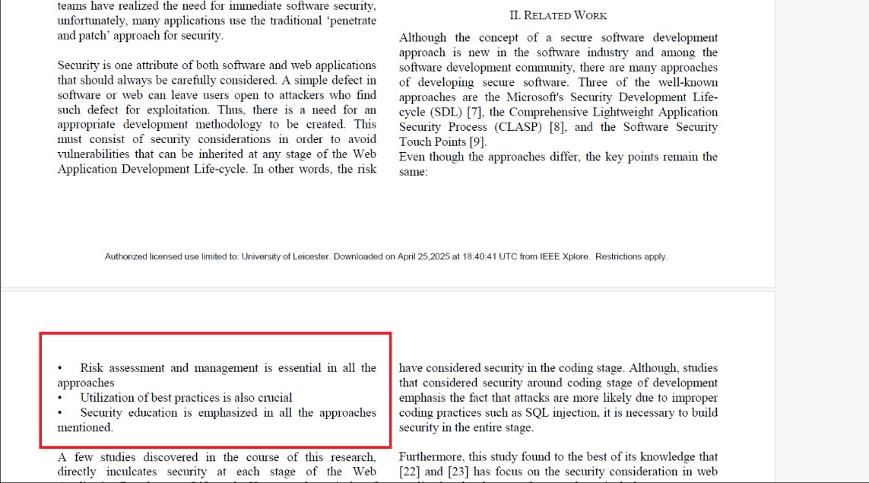

Literature ..1: Approaches key point. Image is taken from the literature survey.

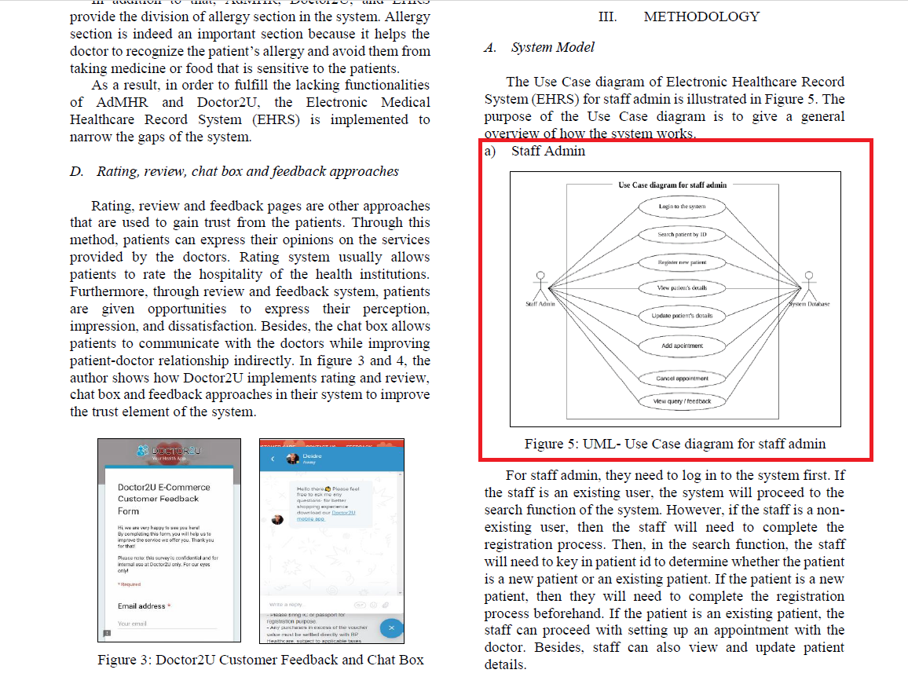

Literature . A.2:Use Case Diagram for Staff Admin.

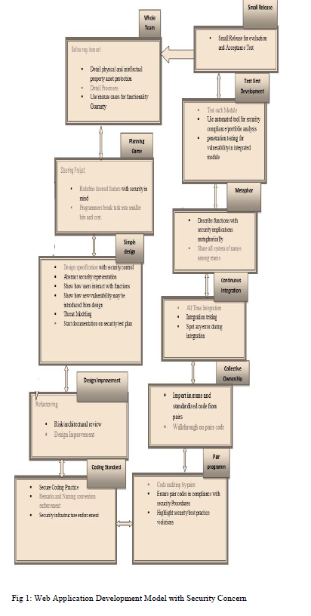

Literature . A.3: Web application Development Model with security Concerns

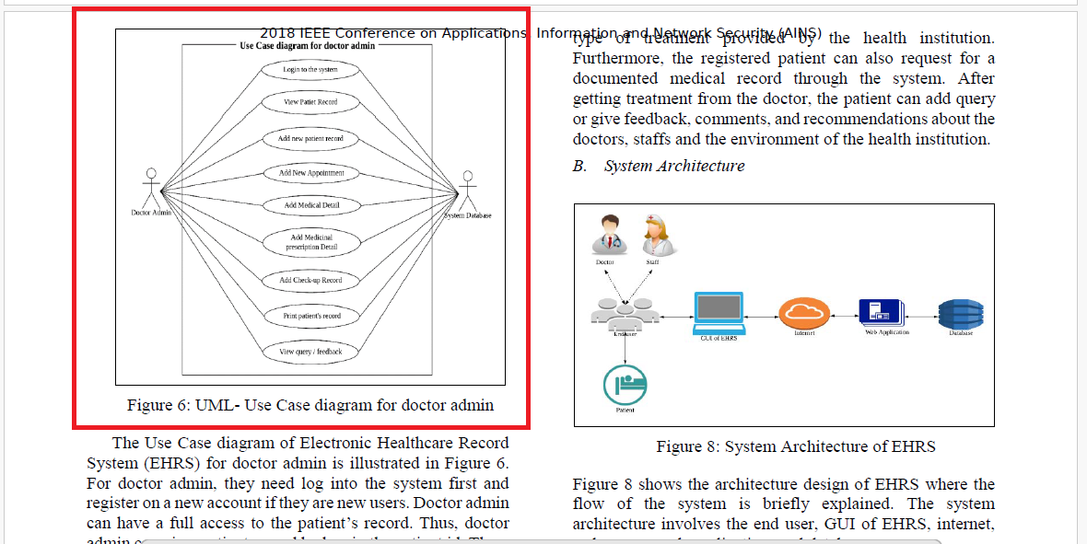

Literature . A.4:Use Case Diagram for Doctor Admin.

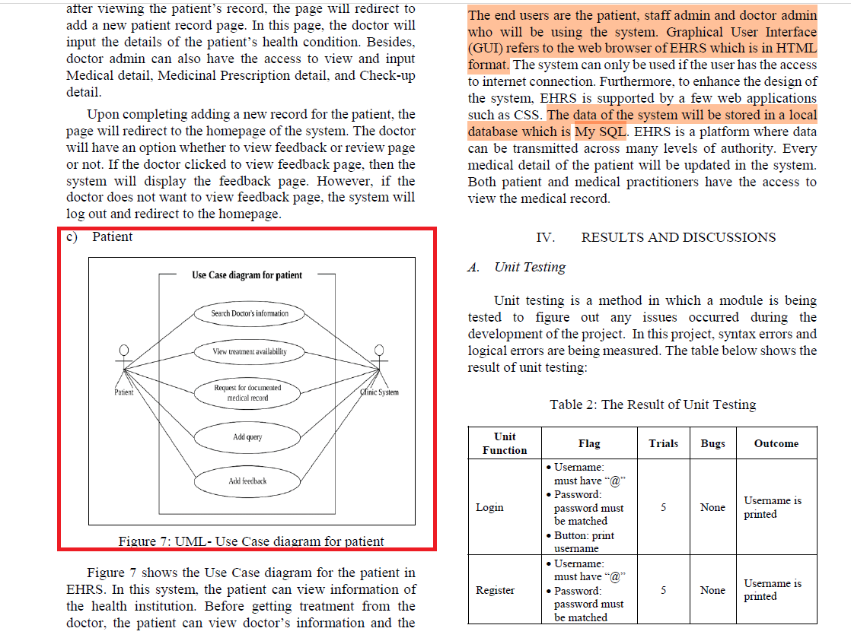

Literature . A.5: Use Case diagram for patient.

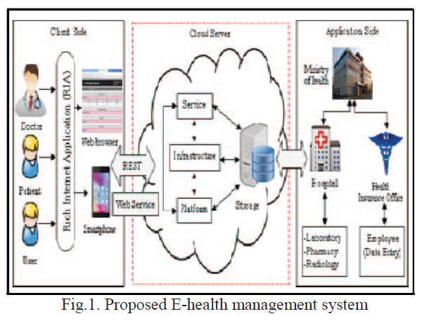

Literature . A.6: Proposed System Architecture..

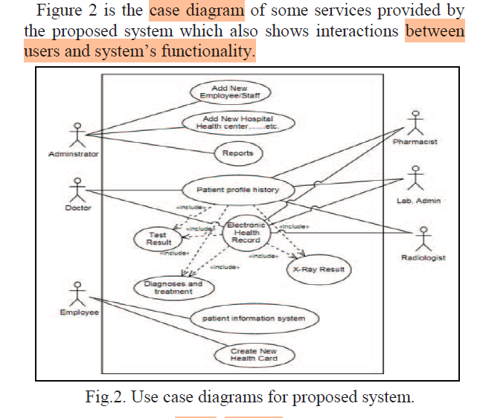

Literature . A.7: Use Case Diagram

## Existing GP Websites

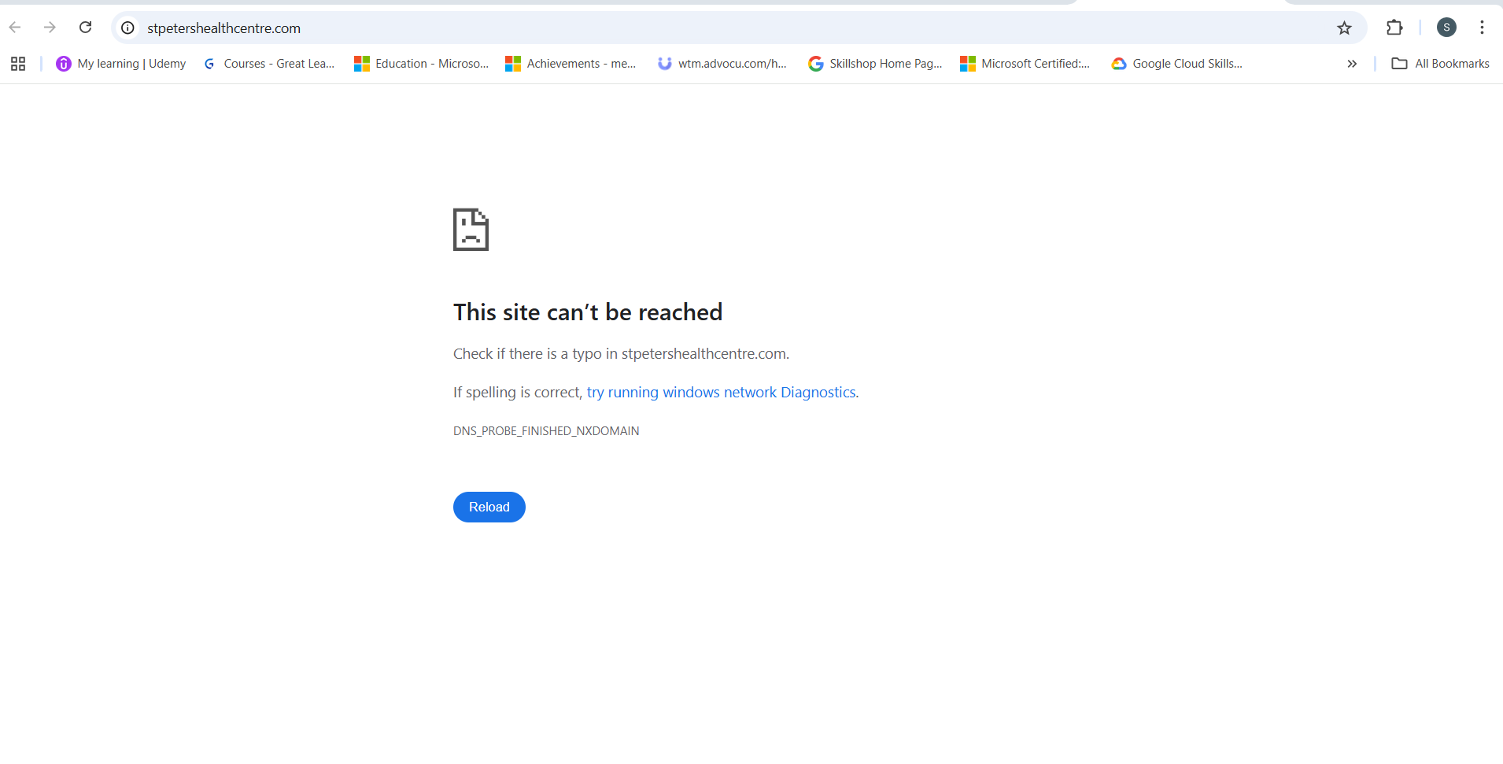

Existing Websites B.1: Queens Road Surgery.

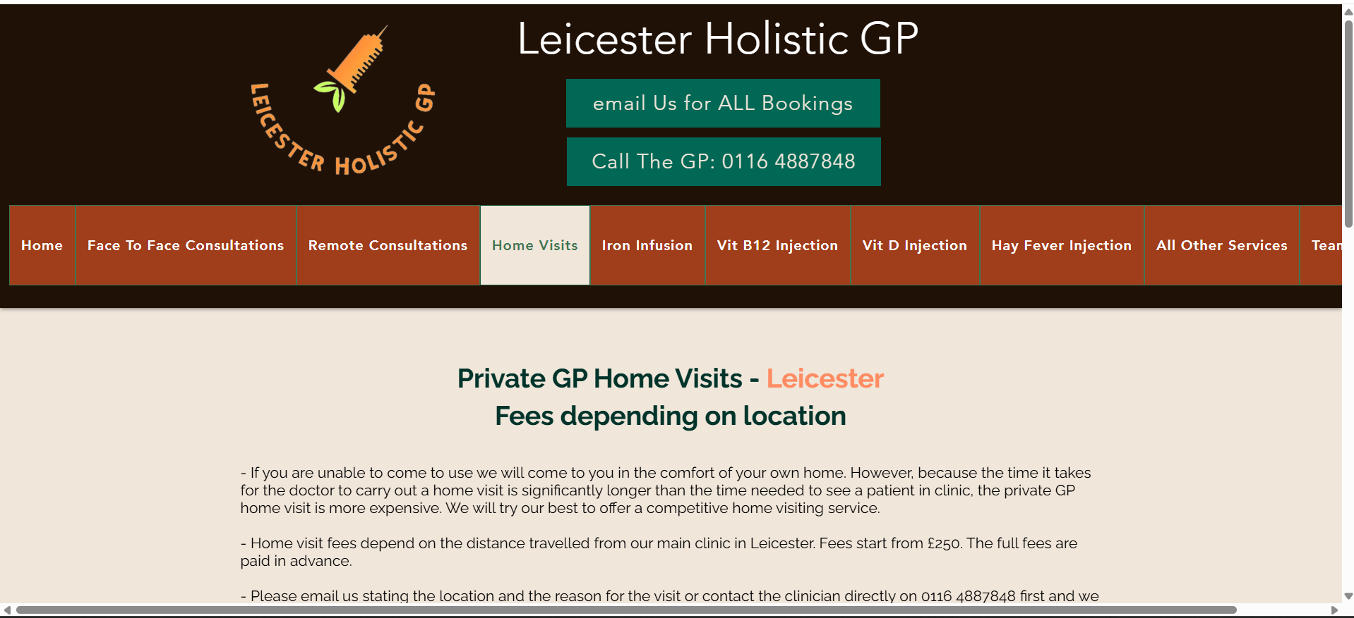

Existing Websites B.2: Leicester Holistic GP

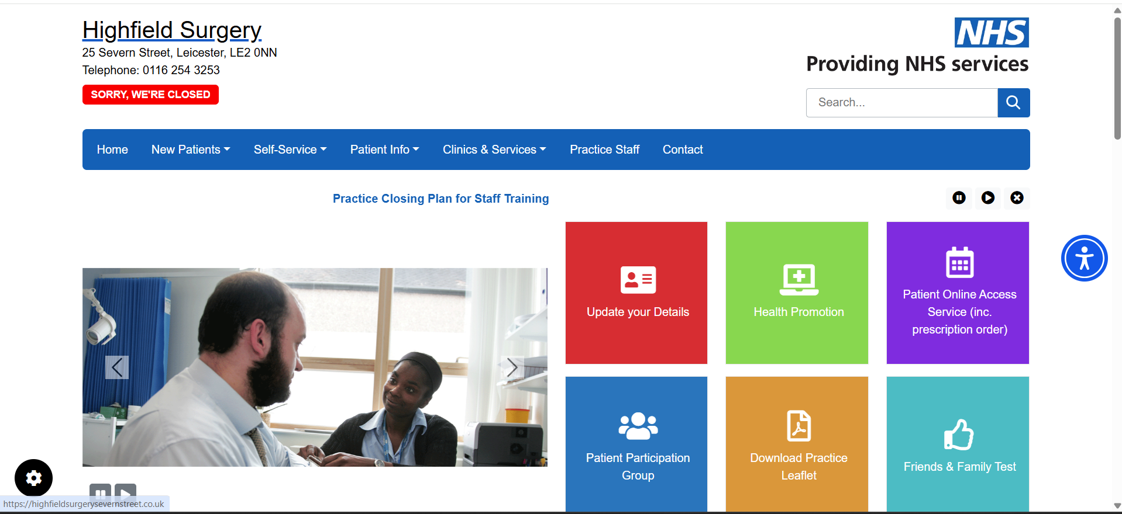

Existing Websites B.3: Highfield Surgery

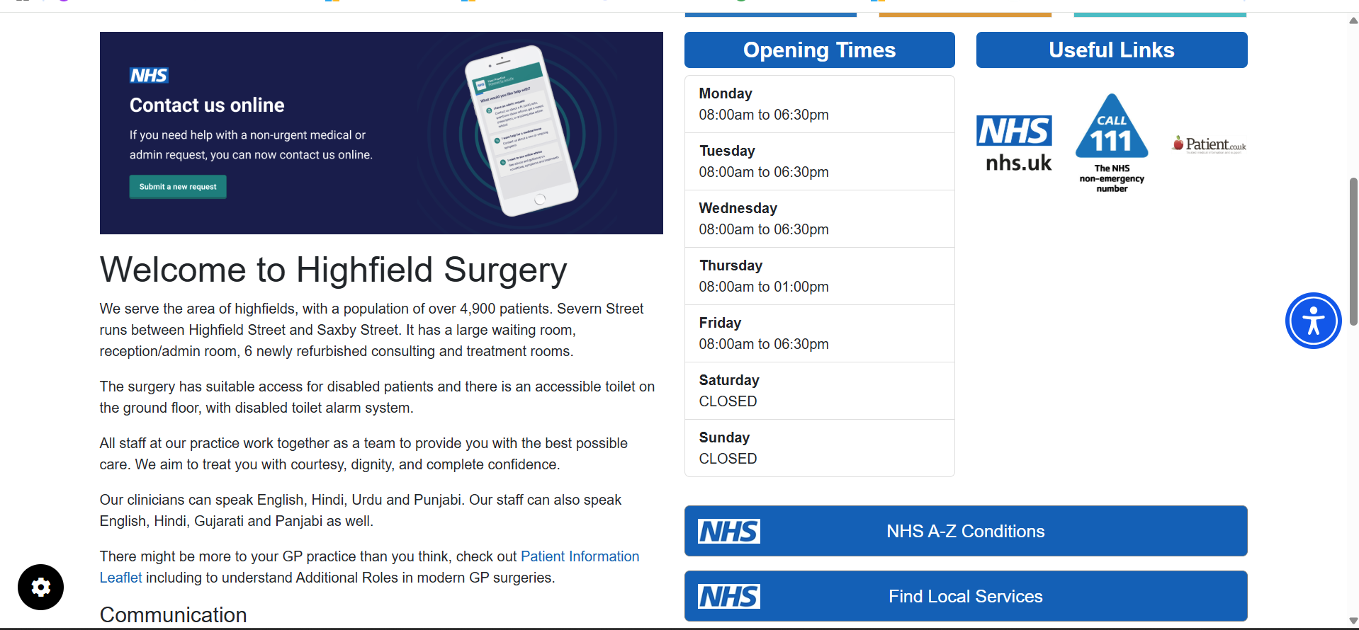

Existing Websites B.4: Highfield Surgery Website.

## Utility Functions.

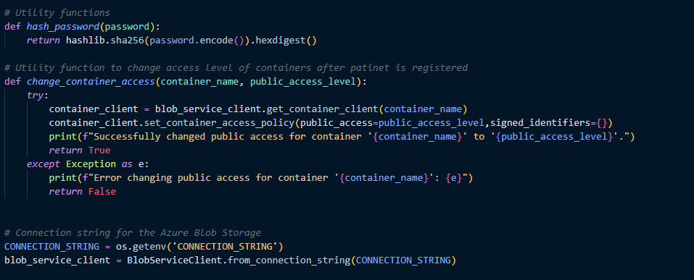

Function C.1: Container Access.

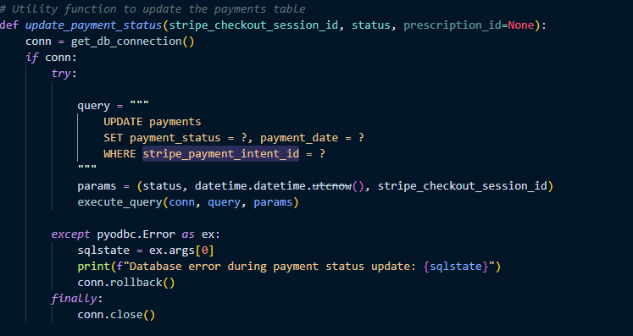

Function C.2: Update Payment Session.

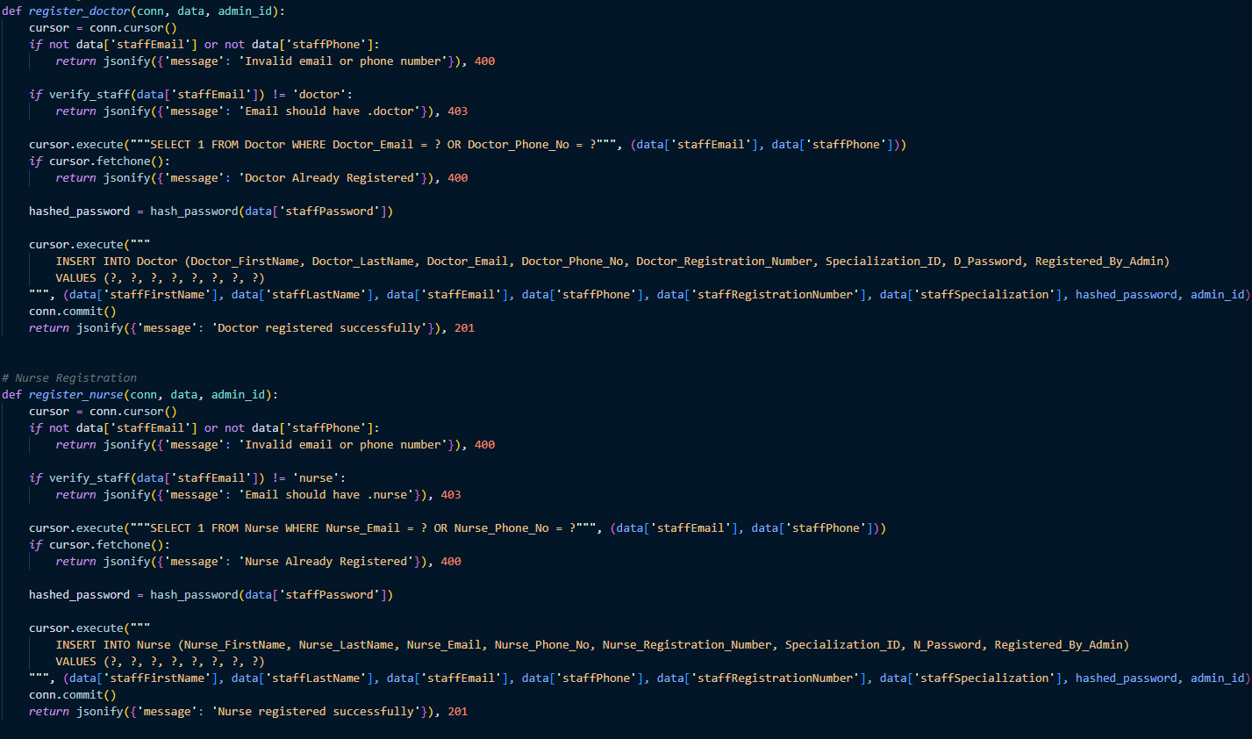

Function C.3: Register doctor and Register nurse.

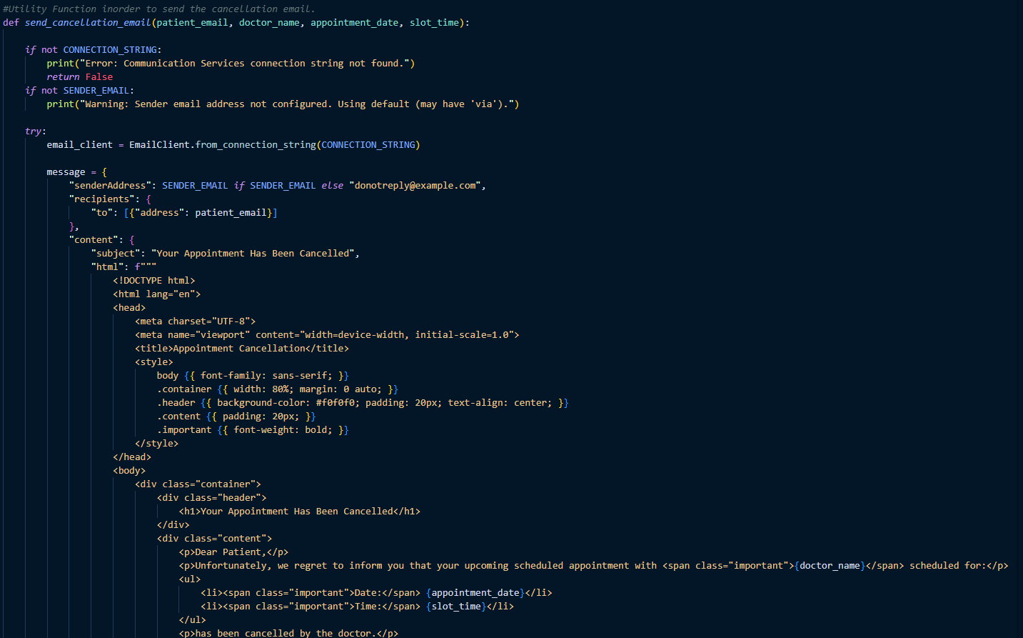

Function C.4: Send Cancellation email

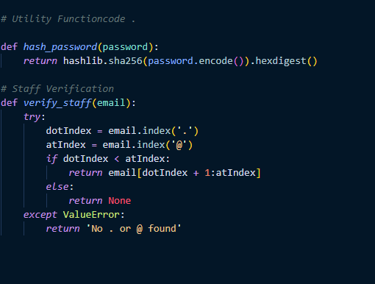

Function C.5.: Staff Verification.

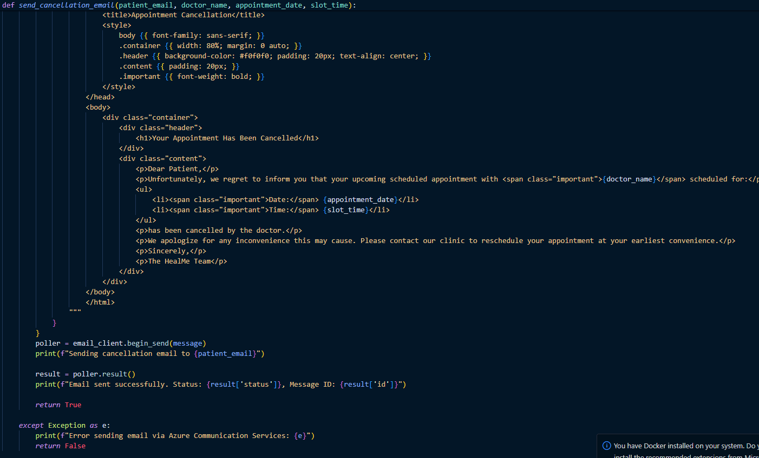

Function C.6: Send cancellation email continuation.

## Booking Appointment code snippet

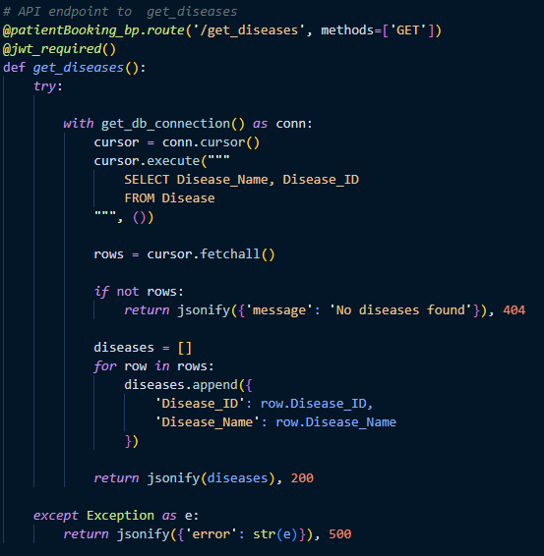

Code snippet D.1: Get Diseases.

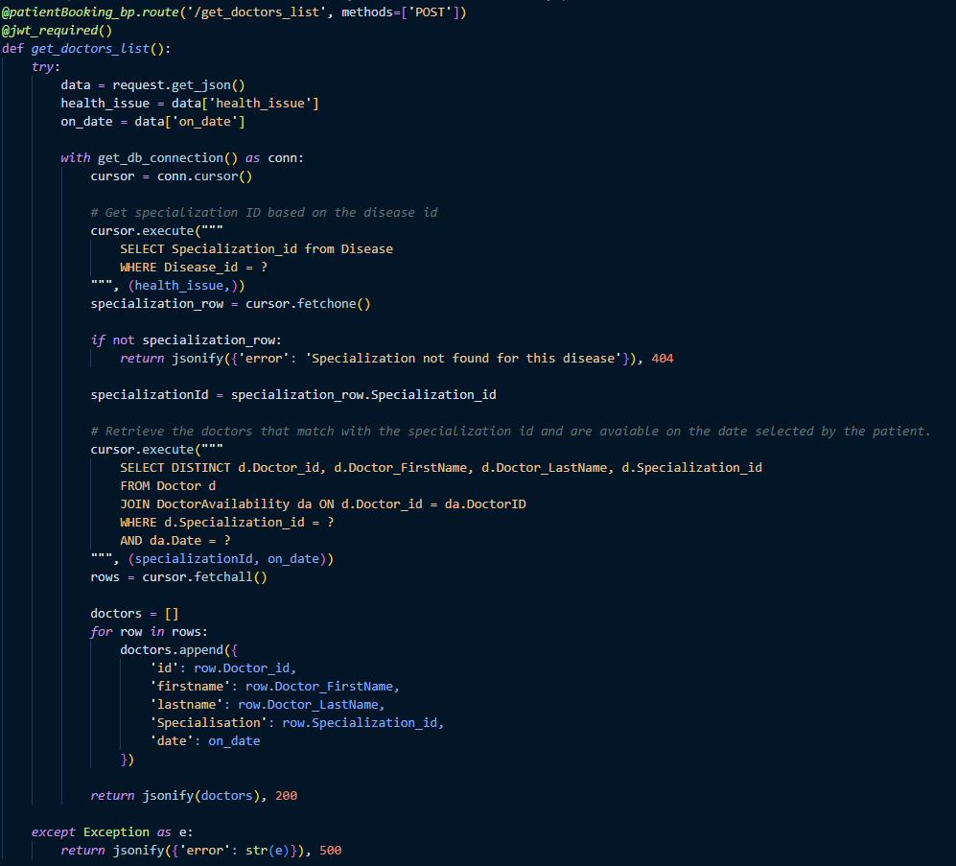

Code snippet D.2: Get Doctor List

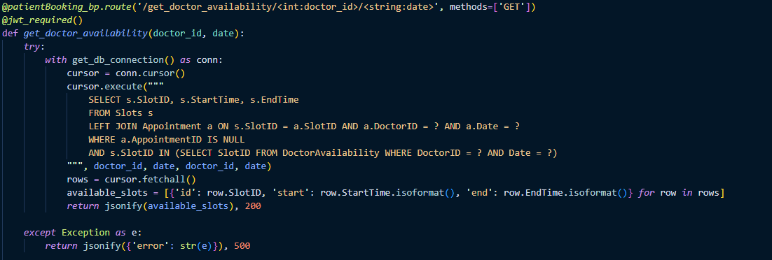

Code snippet D.3: Get doctors availability

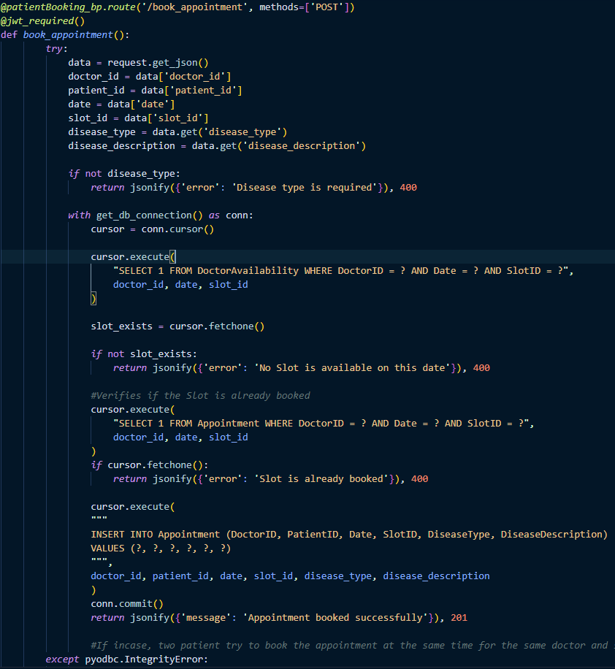

Code snippet D.4: Book Appointments.

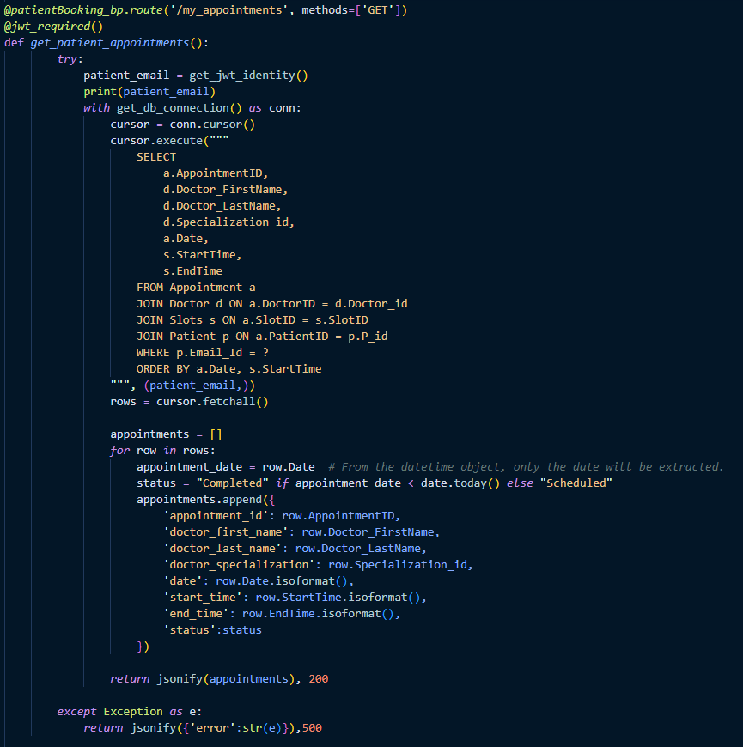

Code snippet D.5: My Appointments.

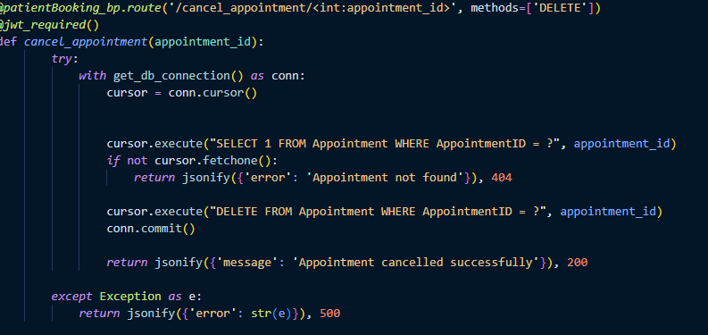

Code snippet D.6: Delete Appointments.

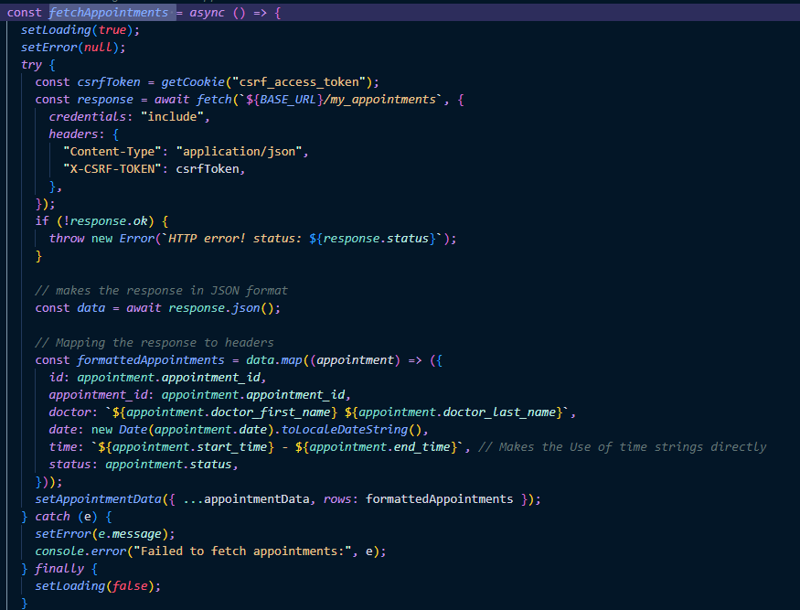

Code snippet D.7: Fetch Appointment function.

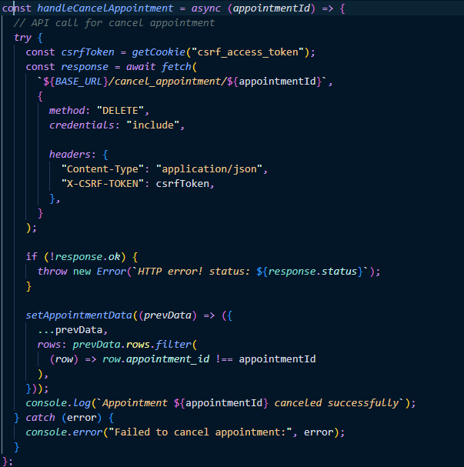

Code snippet D.8: Cancel Appointment Function.

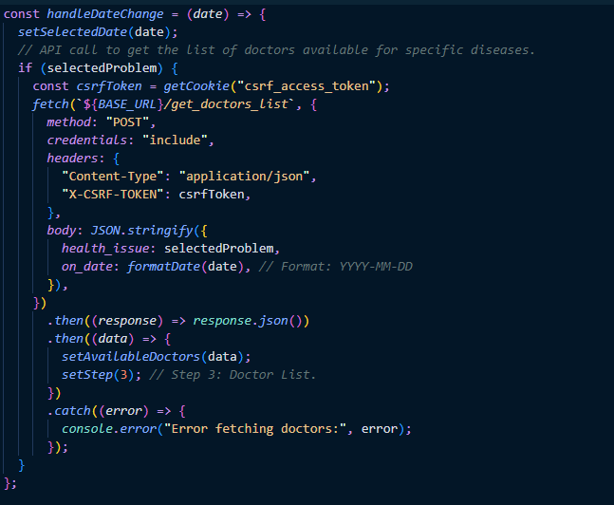

Code snippet D.9: Handle date change function.

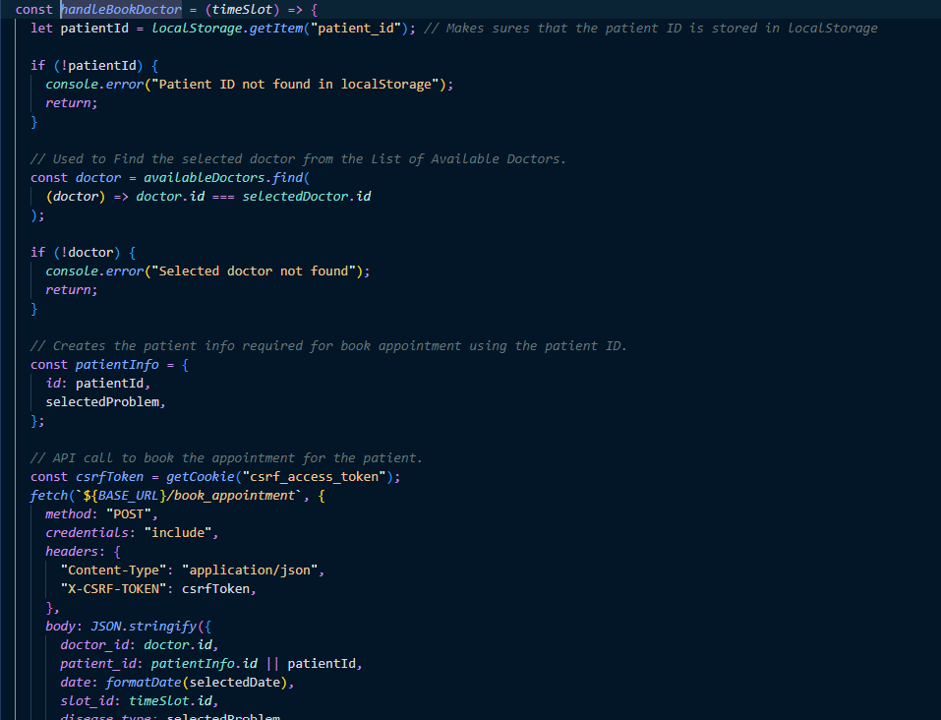

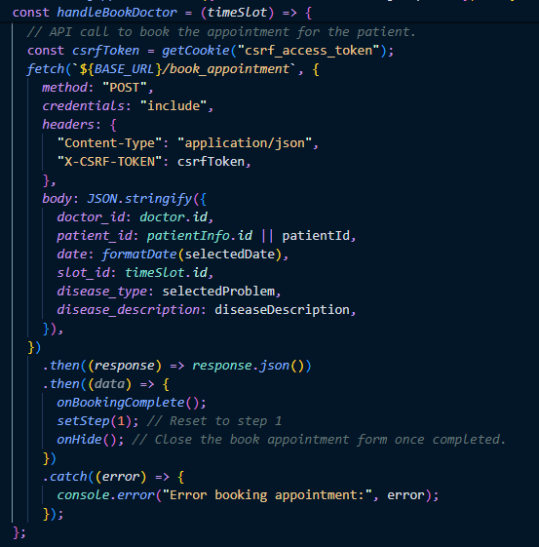

Code snippet D.10: Handle book doctor function.

## Buy Prescriptions code snippet

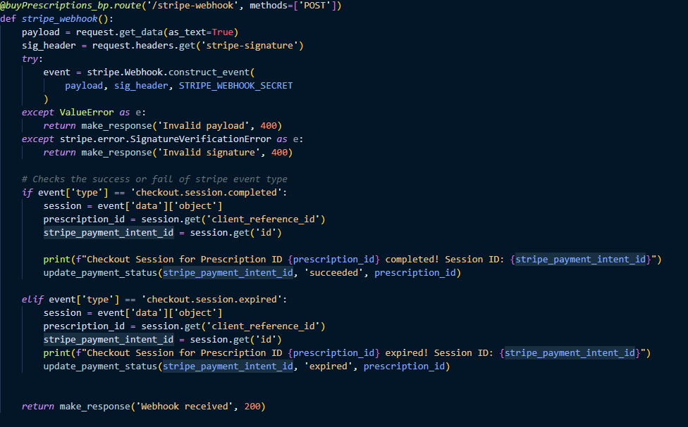

Code snippet E.1: Stripe Webhooks

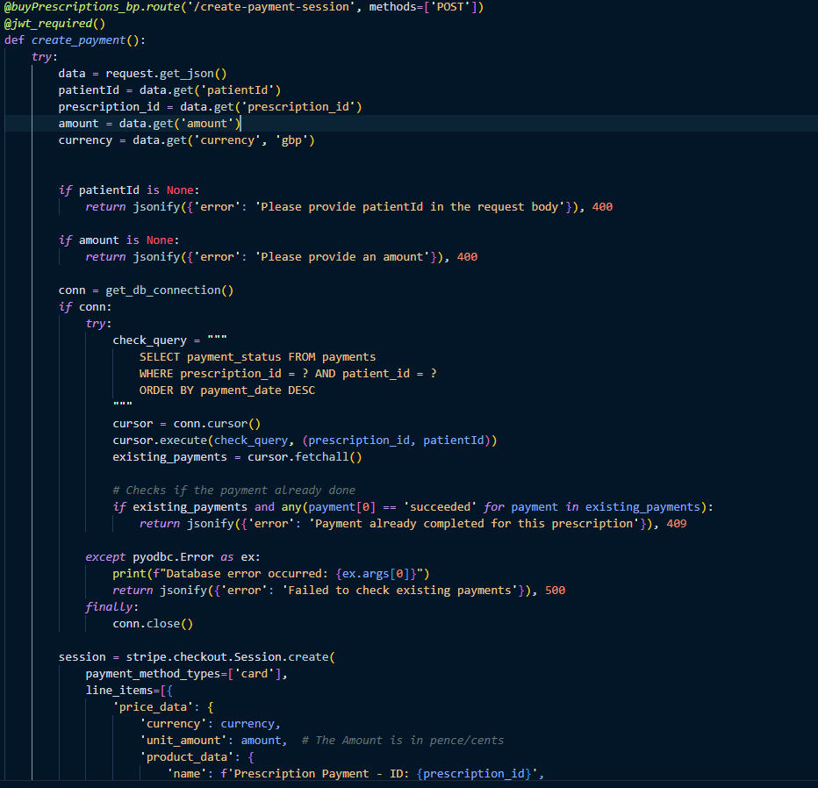

Code snippet E.2: Create Payment Session.

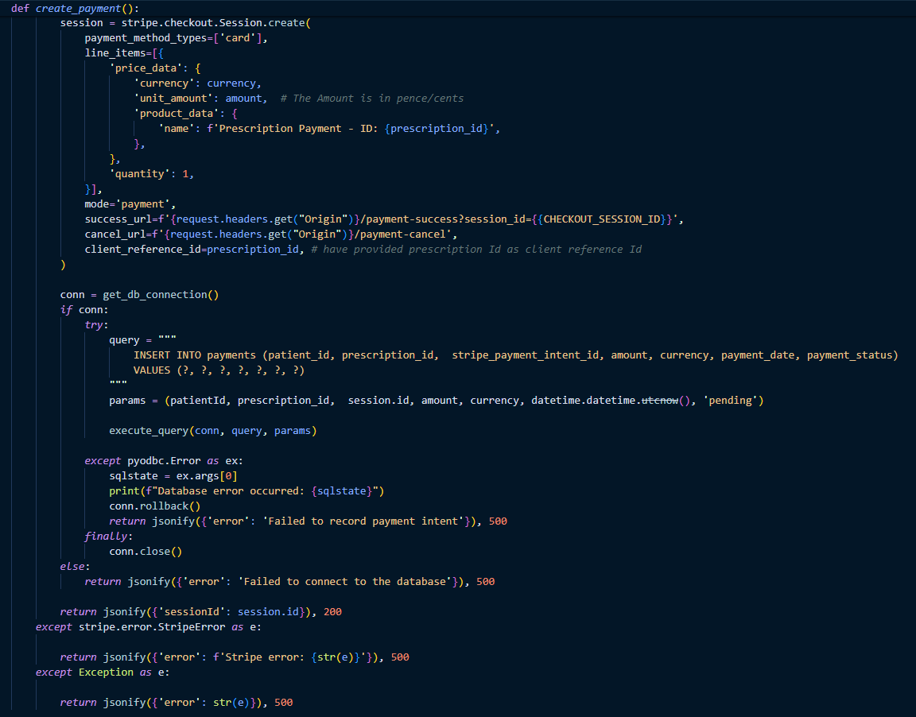

Code snippet E.3: Create payment session continuation.

## Admin Routes code snippet

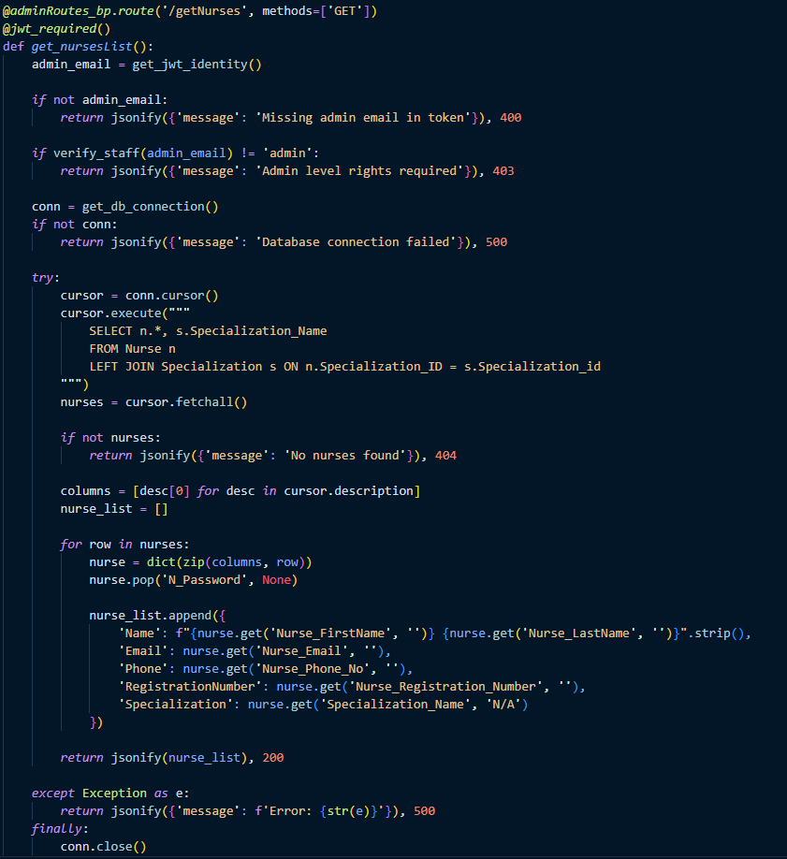

Code Snippet F.1: Get Nurses

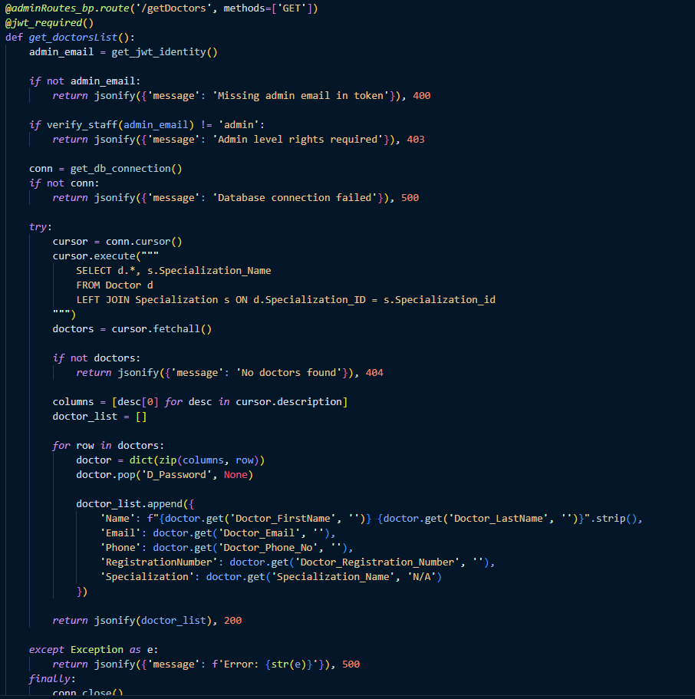

Code Snippet F.2: Get Doctors

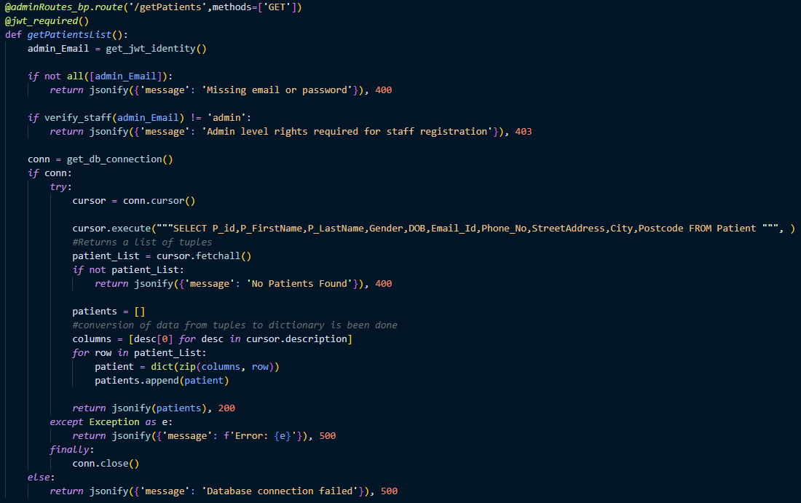

Code Snippet F.3: Get patients.

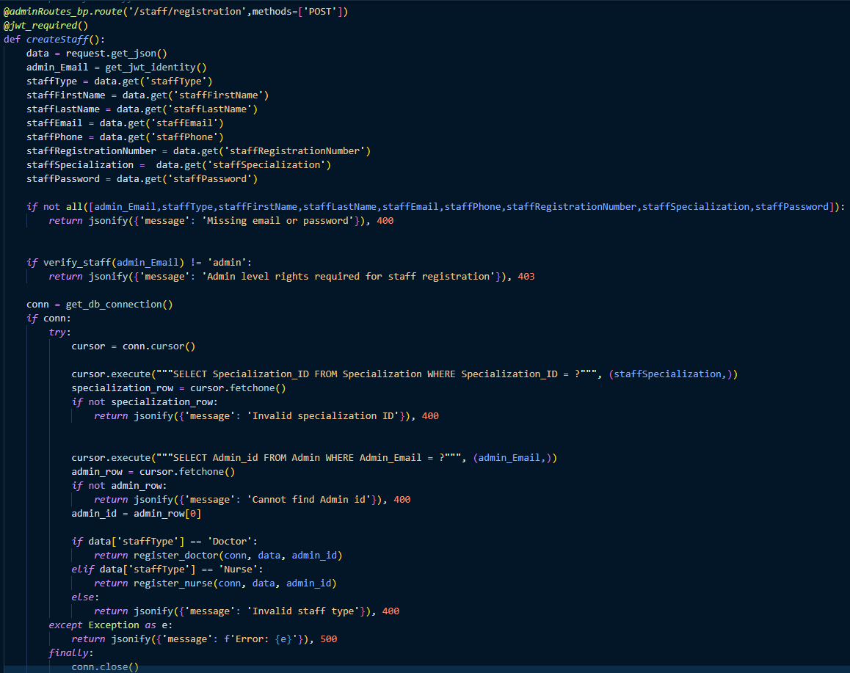

Code Snippet F.4: Staff Registration.

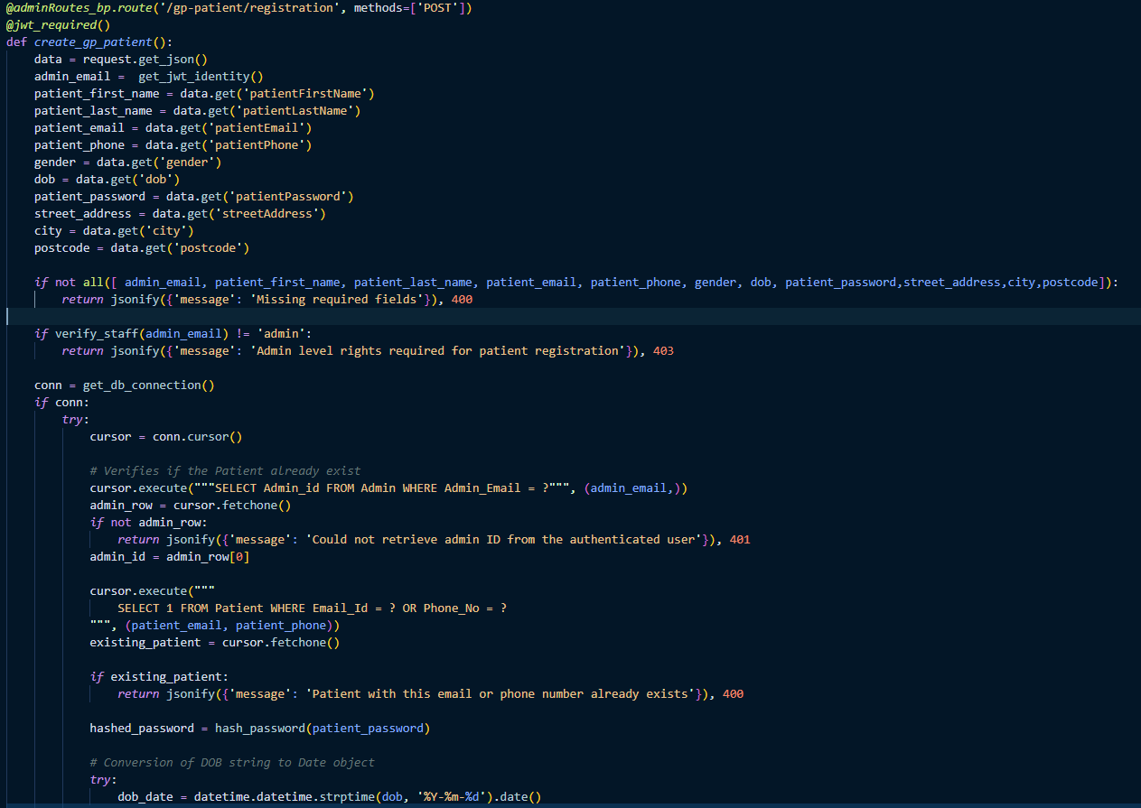

Code Snippet F.5: Patient Registration.

## Doctor Manage Appointments code snippet

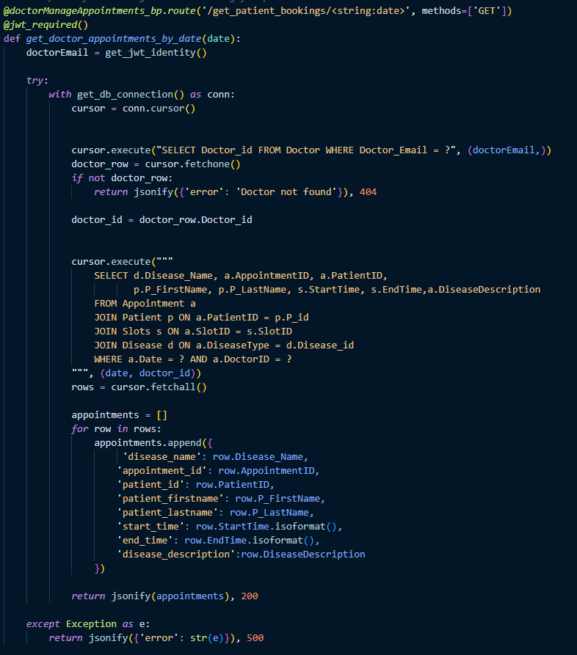

Code snippet G.1: Get patient Booking.

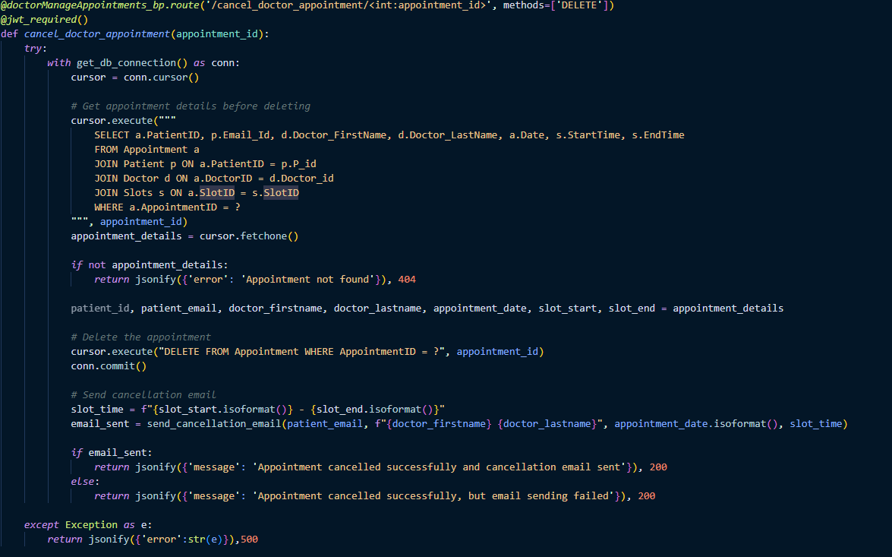

Code snippet G.2: Cancel Appointment by doctors.

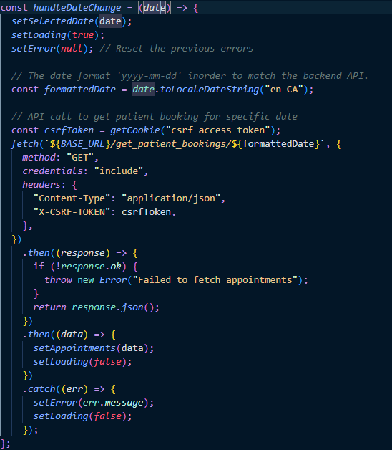

Code snippet G.3: Handle date change function.

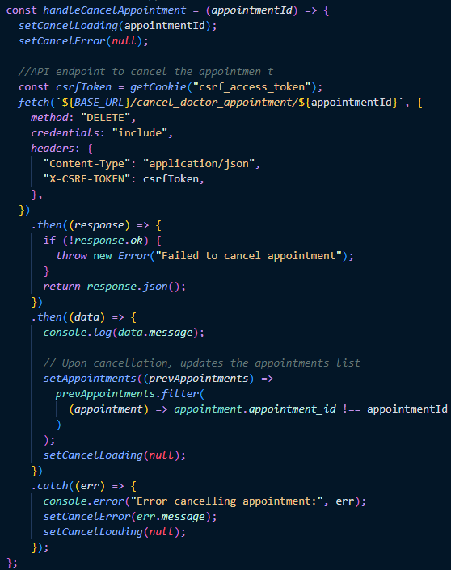

Code snippet G.4: Handle cancel appointment.

## Prescription code snippet

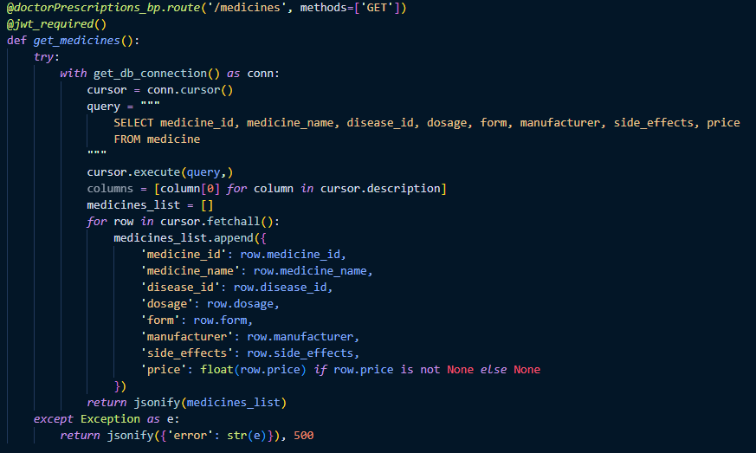

Code snippet H.1: Get medicines.

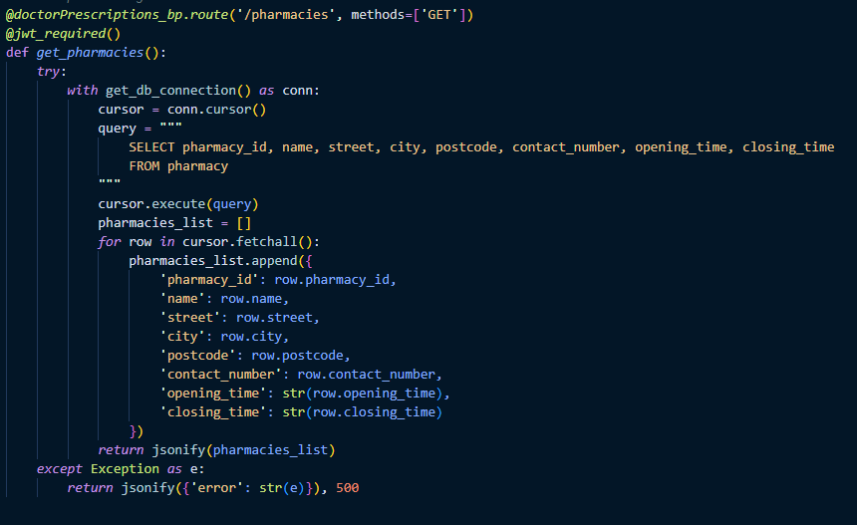

Code snippet H.2: Get Pharmacies.

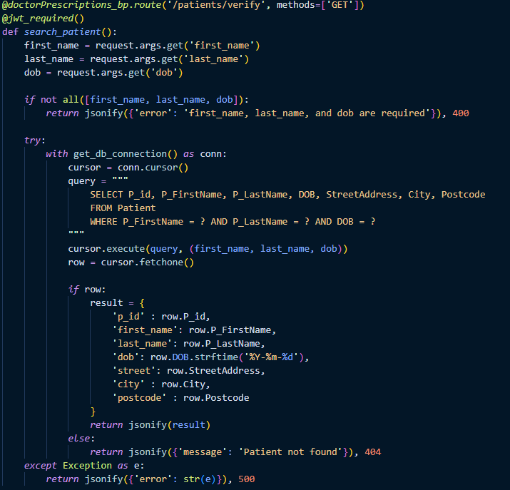

Code snippet H.3: Verify Patient.

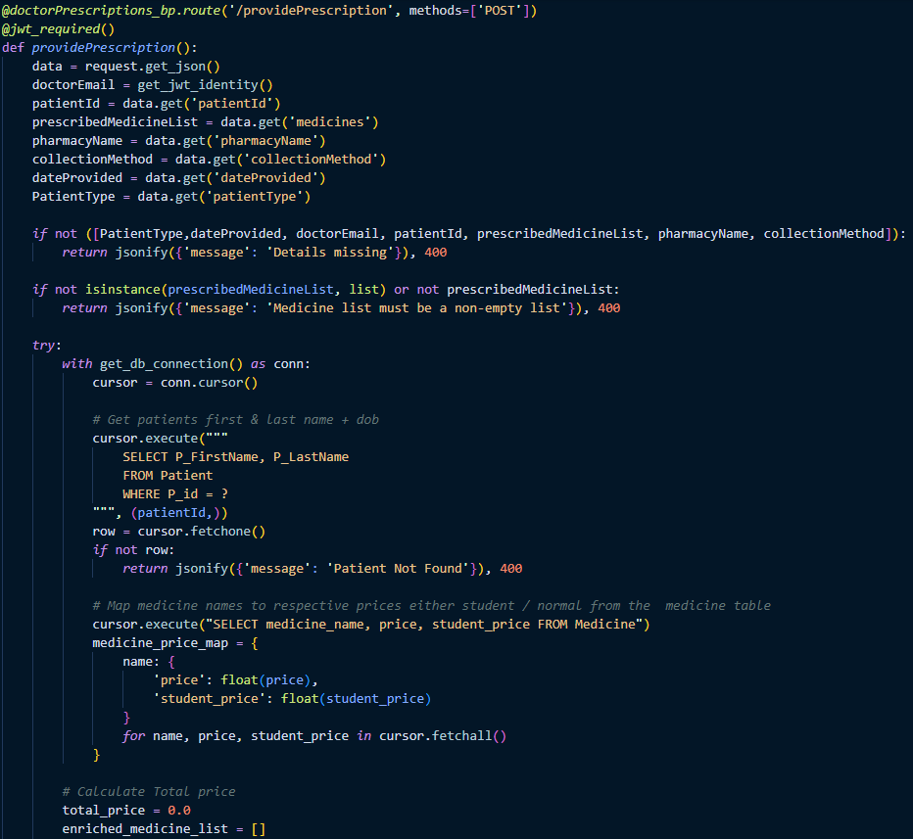

Code snippet H.4: Provide Prescription

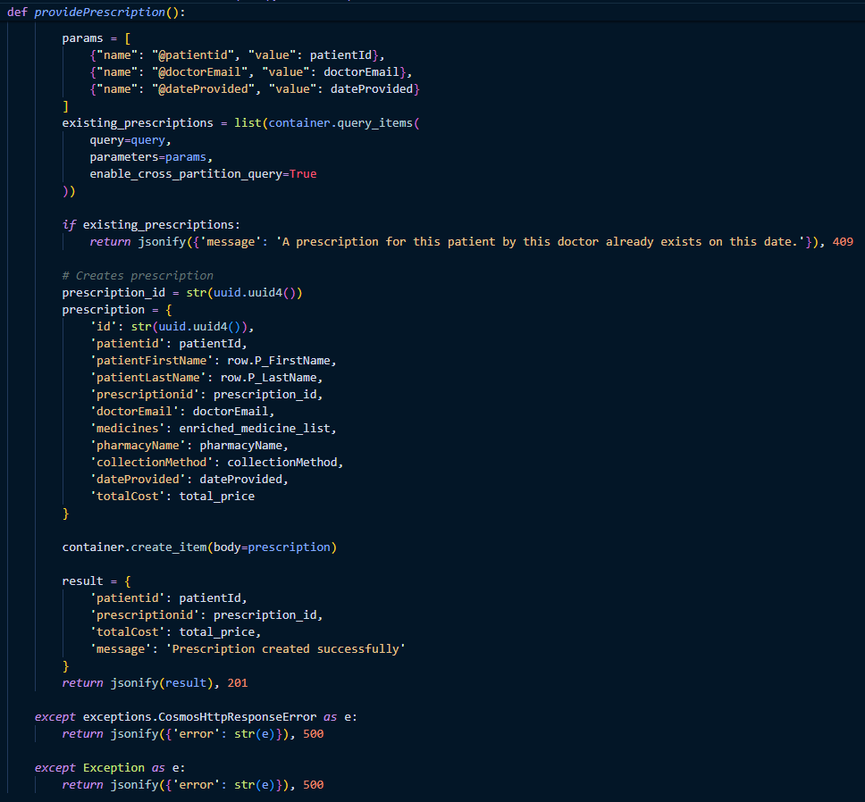

Code snippet H.5: Provide Prescription Continuation.

## Staff Authentication code snippet

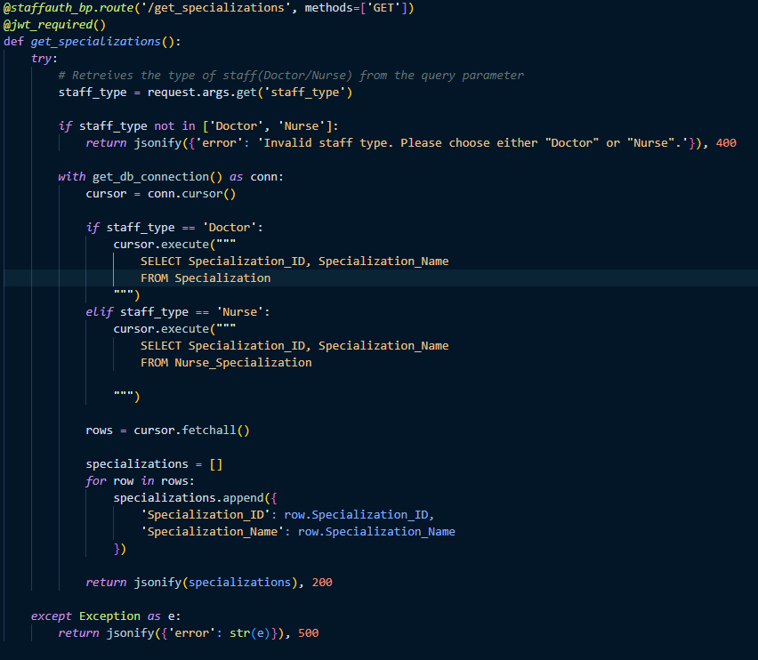

Code snippet I.1: Get Specialization.

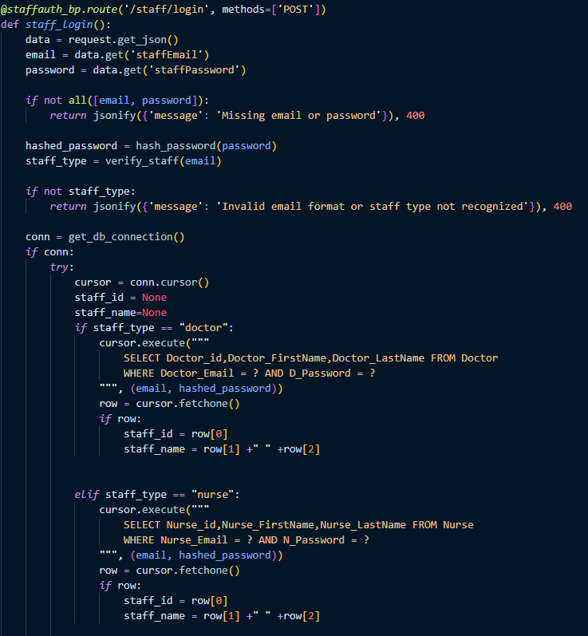

Code snippet I.2: Staff Login

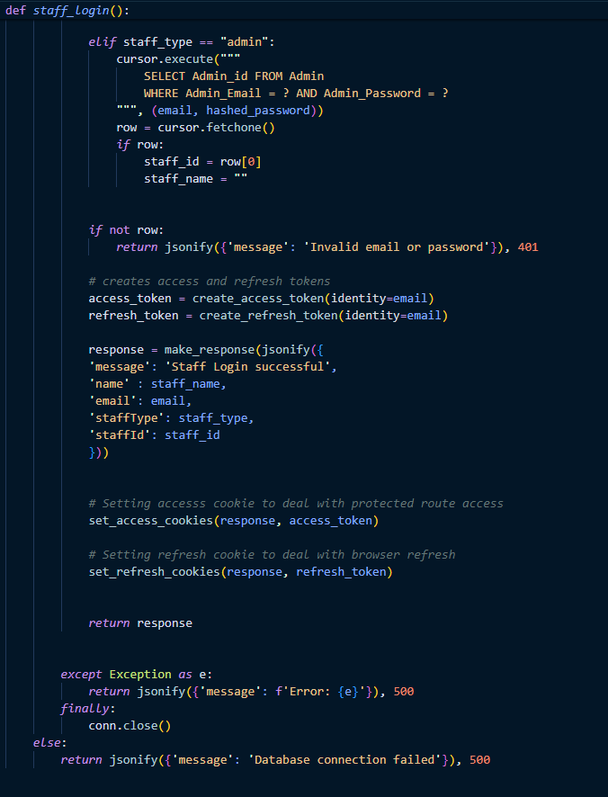

Code snippet I.3: Staff Login continuation.

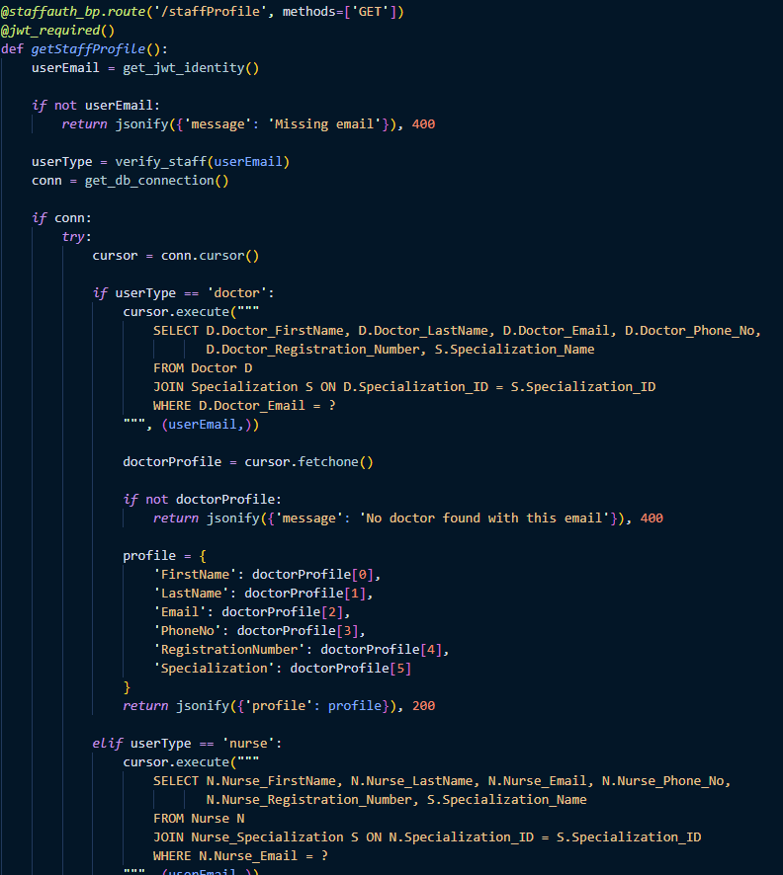

Code snippet I.4: Staff Profile

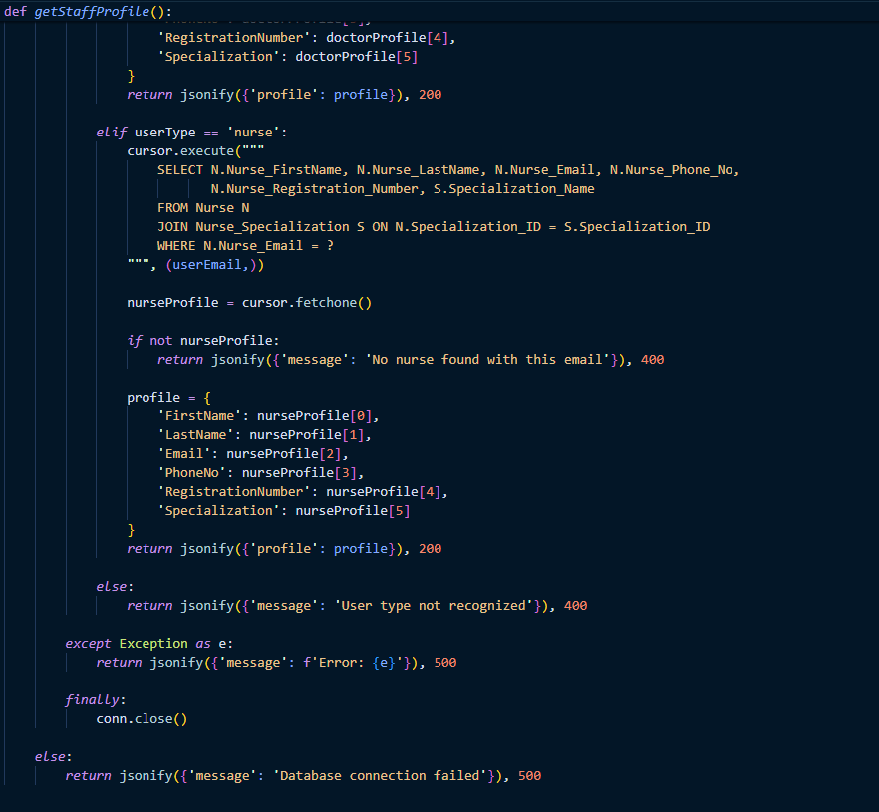

Code snippet I.5: Staff profile Continuation.

## Staff Availability code snippet

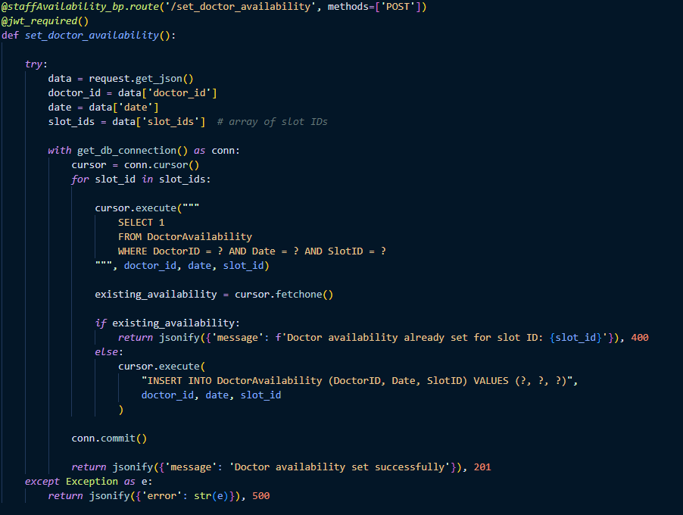

Code snippet J.1: Set Doctor Availability.

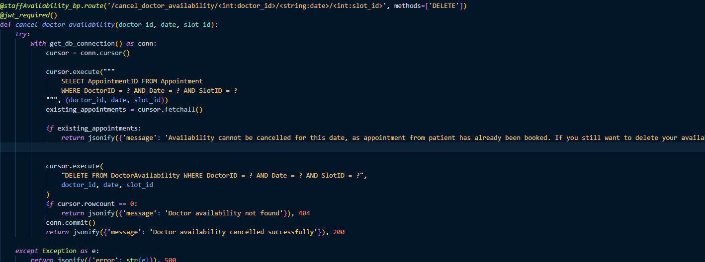

Code snippet J.2: Cancel Doctor Availability.

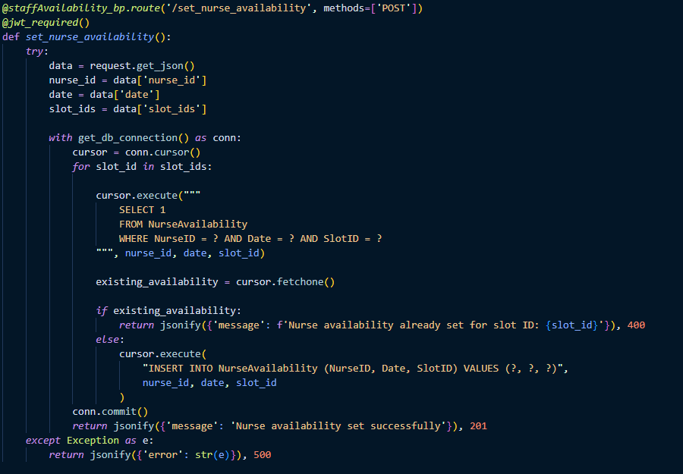

Code snippet J.3: Set Nurse Availability.

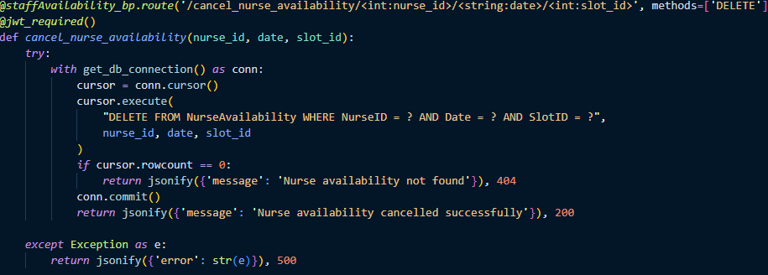

Code snippet J.4: Cancel Nurse Availability.

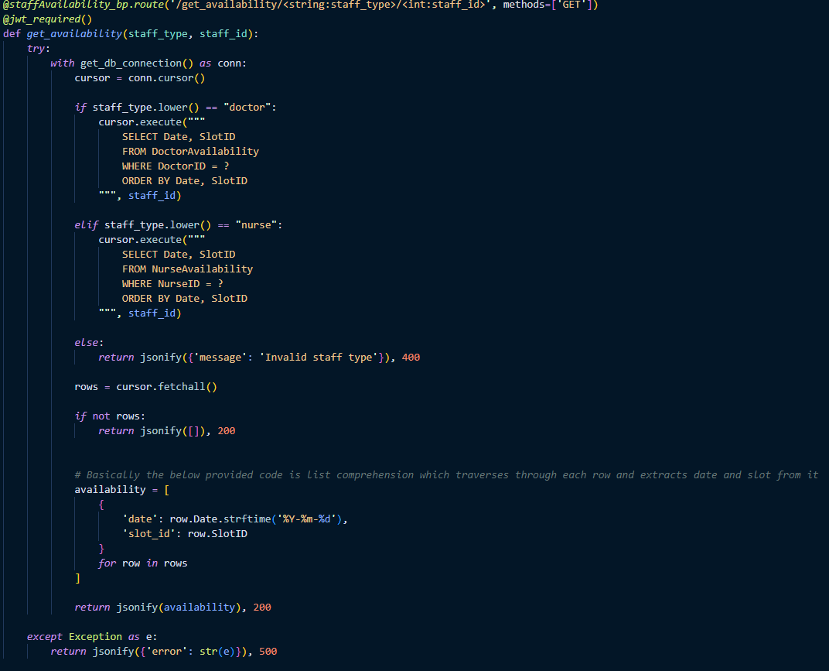

Code snippet J.5: Get the Availability.

## Medical Records code snippets.

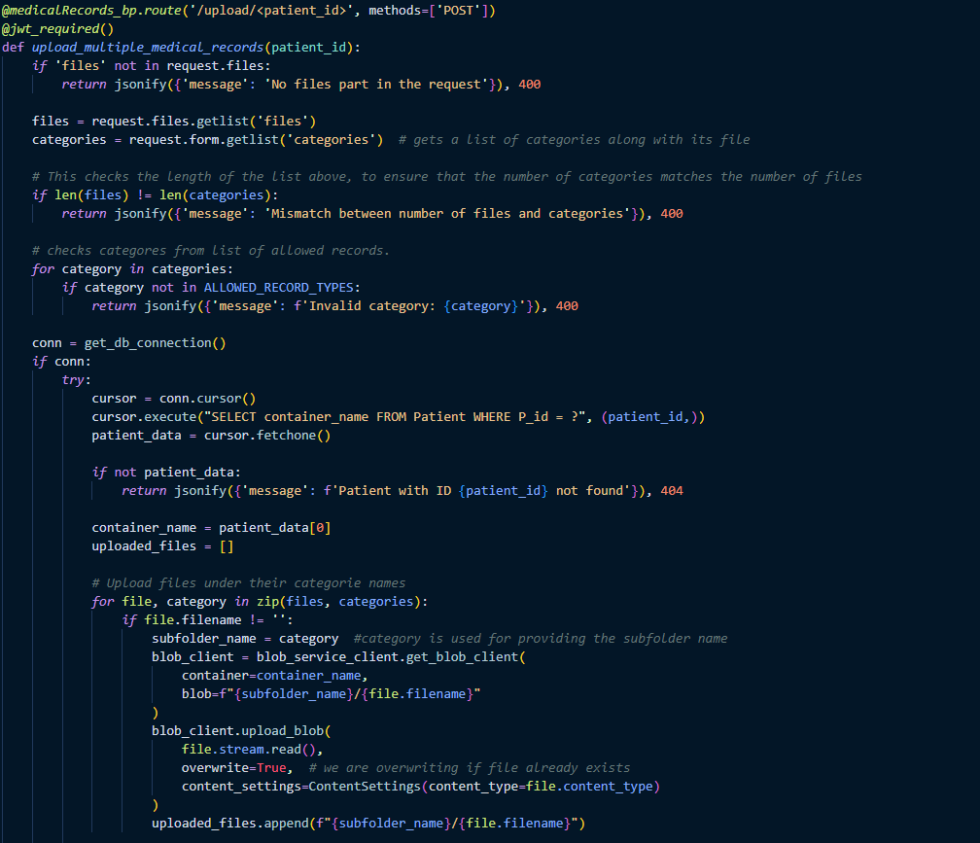

Code snippet K.1: Upload the medical records.

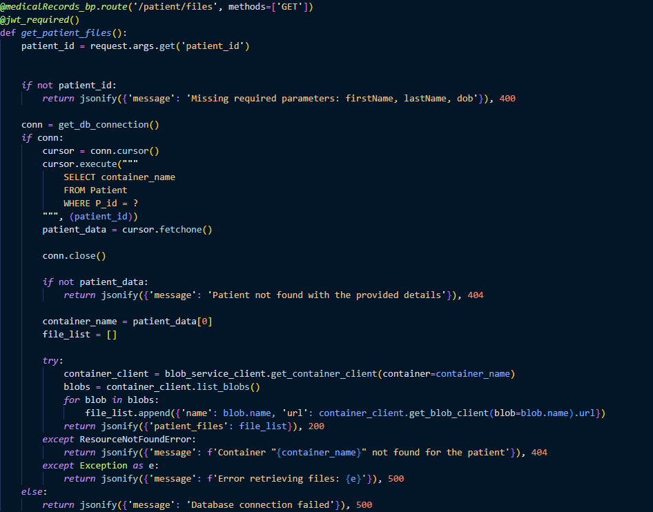

Code snippet K.2: Get patients file

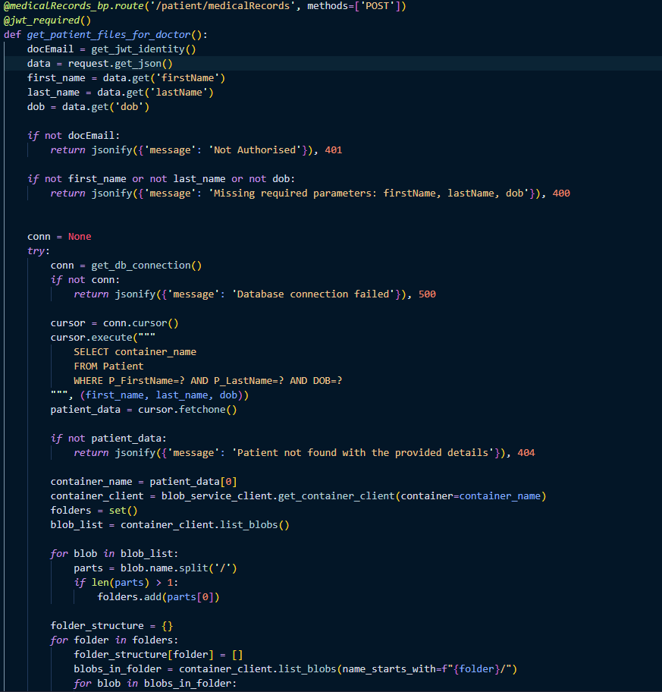

Code snippet K.3: Doctors views the medical records.

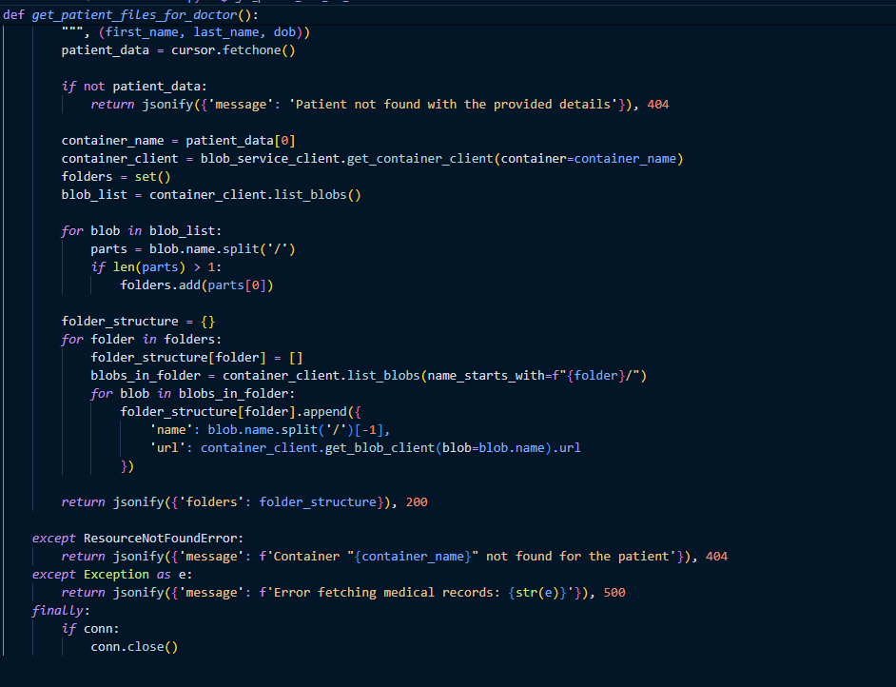

Code snippet k.4: Doctors view the medical record continuation.

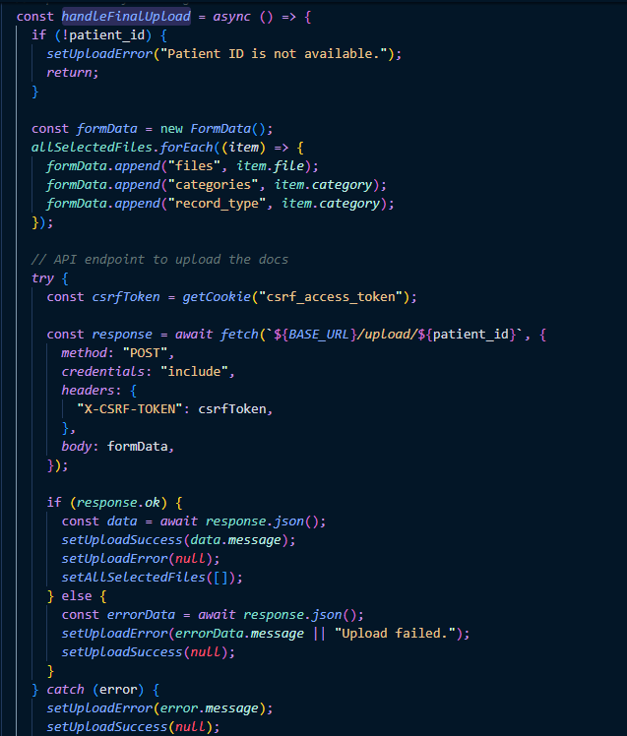

Code snippet K.5: Handle final upload function.

## Register code snippets

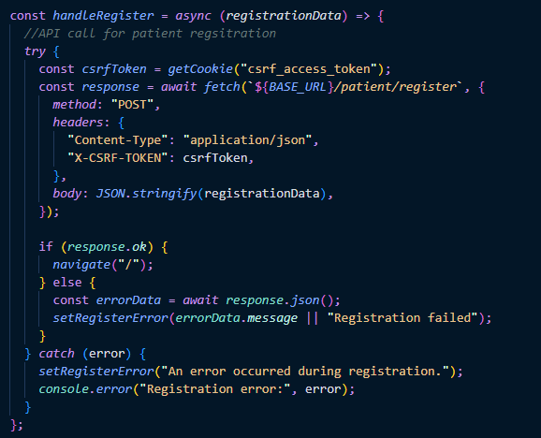

Code snippet L.1: Handle Register.

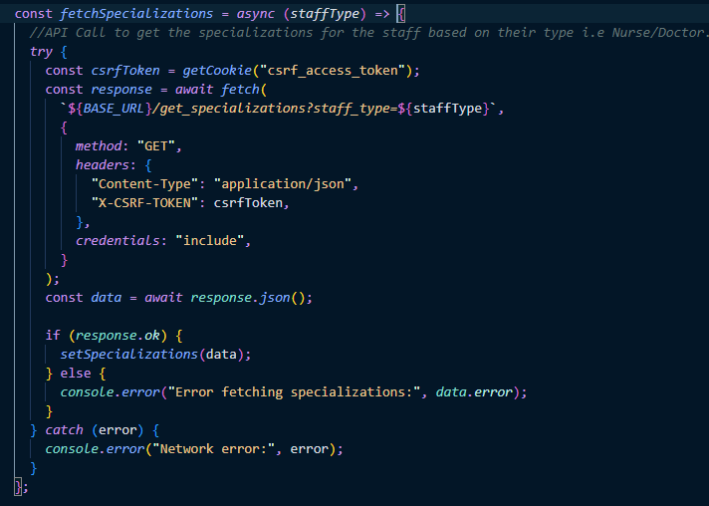

Code snippet L.2: Fetch Specialization function.

## Own Piece of Code snippets

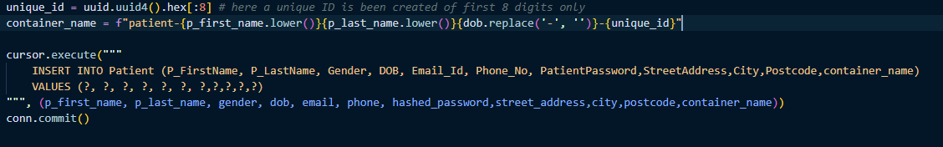

Code snippet M.1: Container Name

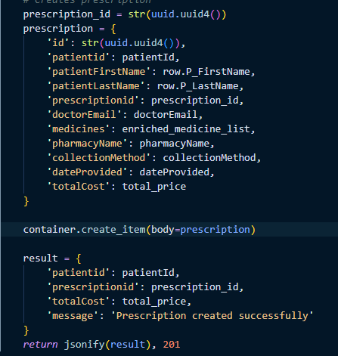

Code snippet M.3: Prescription Creation

## Diagrams.

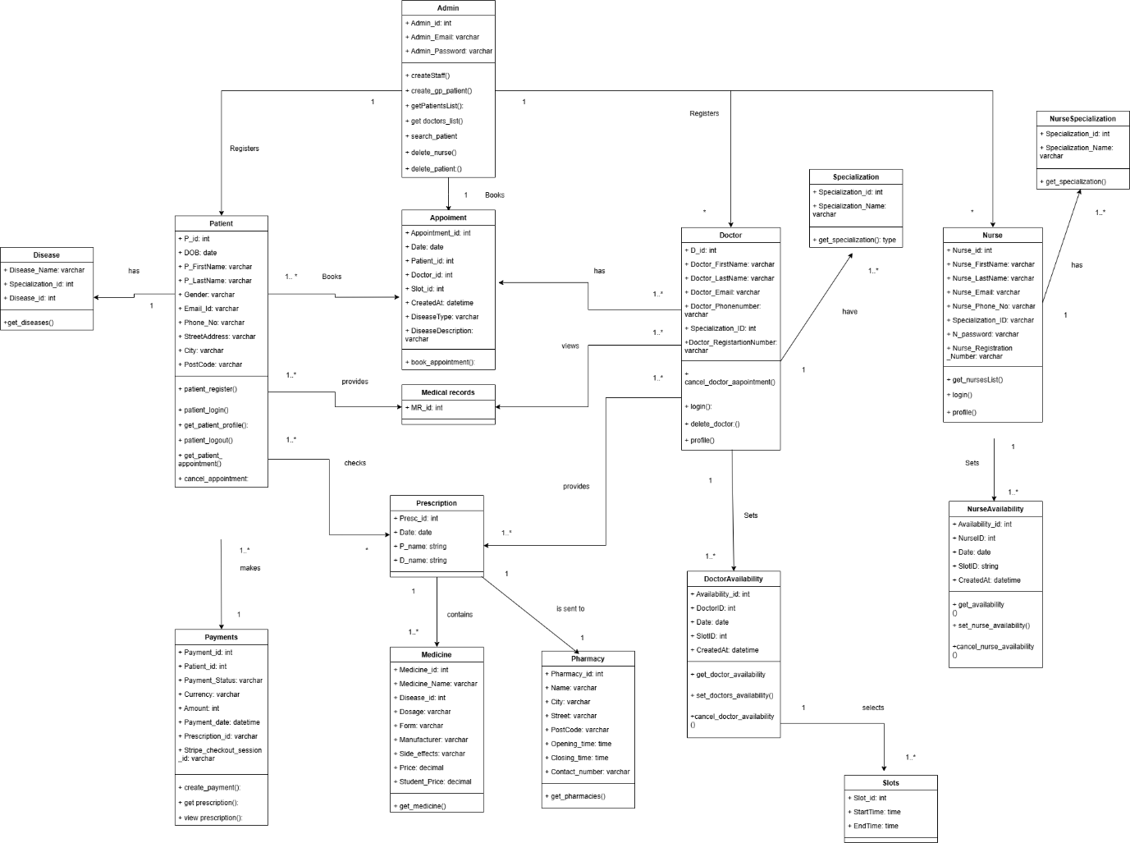

Diagram N.: Class Diagram .Done by Author

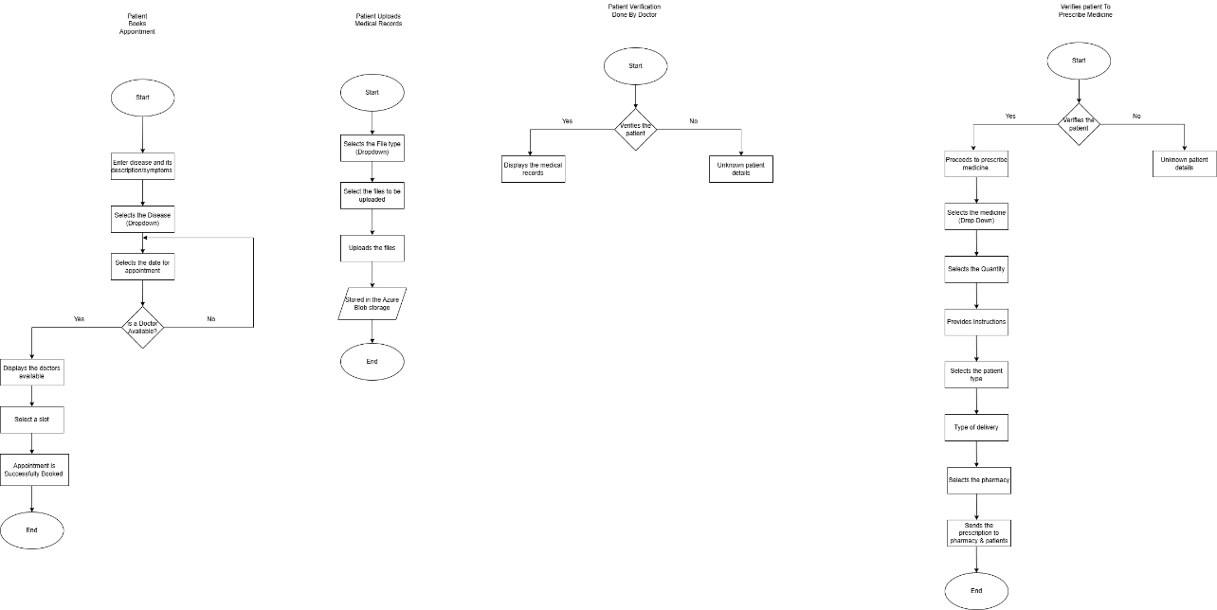

Diagram N.: Flow Diagram .Done by Author

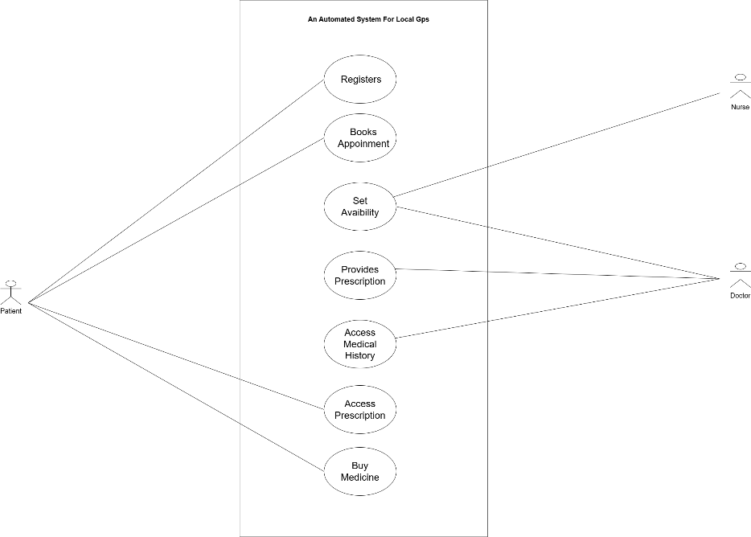

Diagram N.: Use Case Diagram. .Done by Author

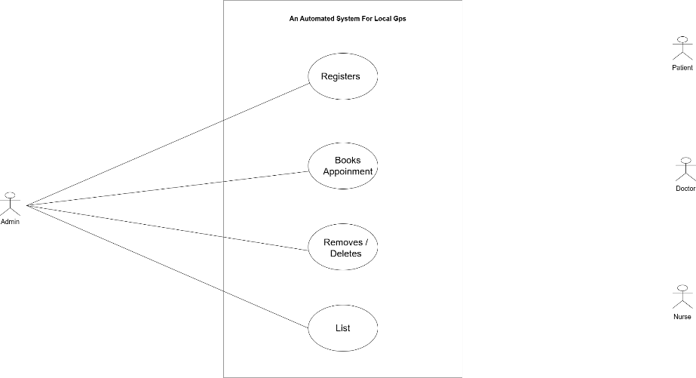

Diagram N.: Use case Diagram for admin. .Done by Author

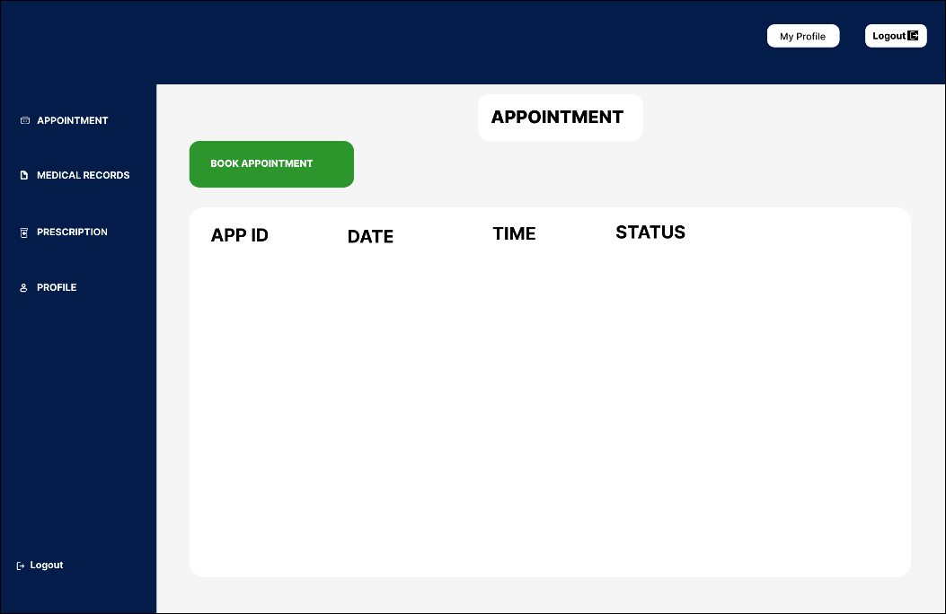

Diagram N.: High Fidelity Prototype 1. .Done by Author

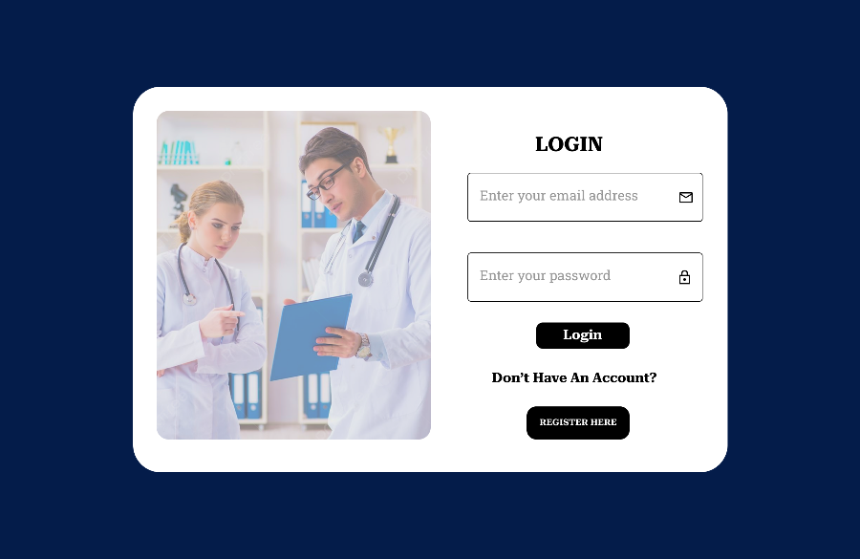

Diagram N.: High Fidelity Prototype 2. .Done by Author

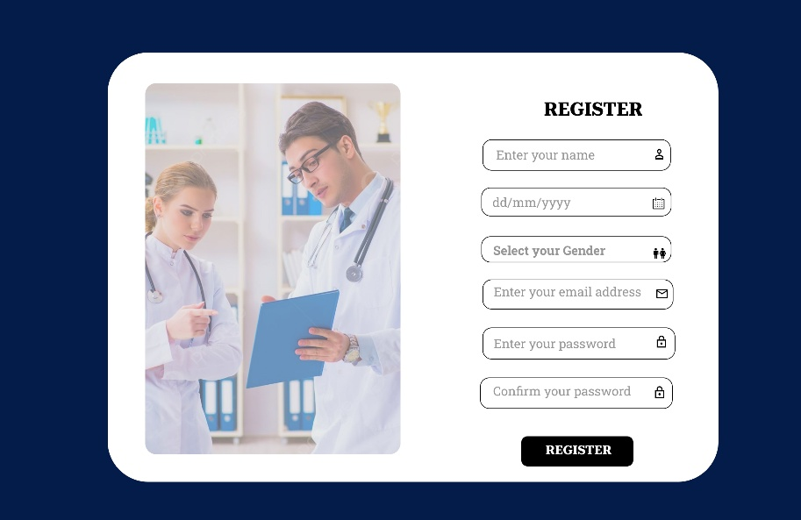

Diagram N.: High Fidelity Prototype 3.Done by Author

## Deployment Snippets

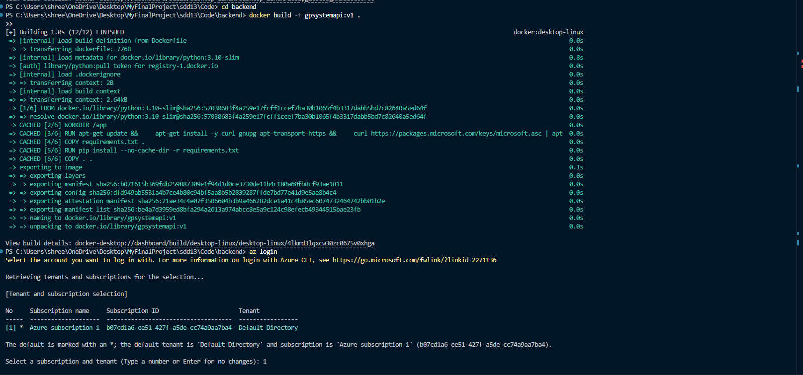

Deployment: O.1: Docker build(Backend)

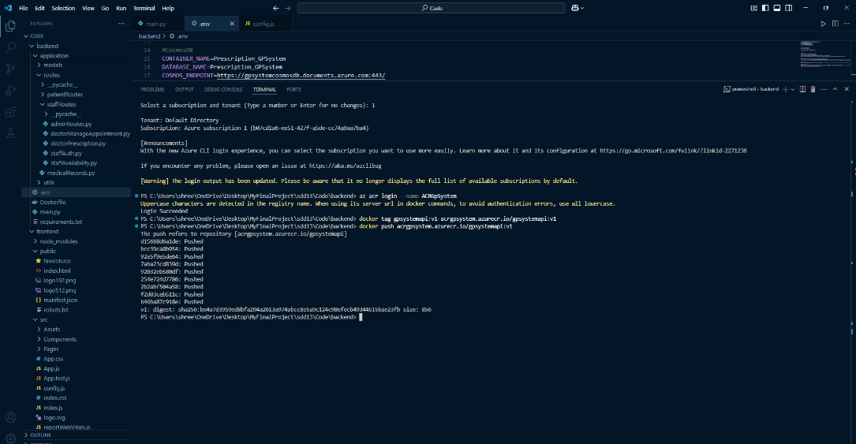

Deployment: O.2: Docker tag and push (backend).

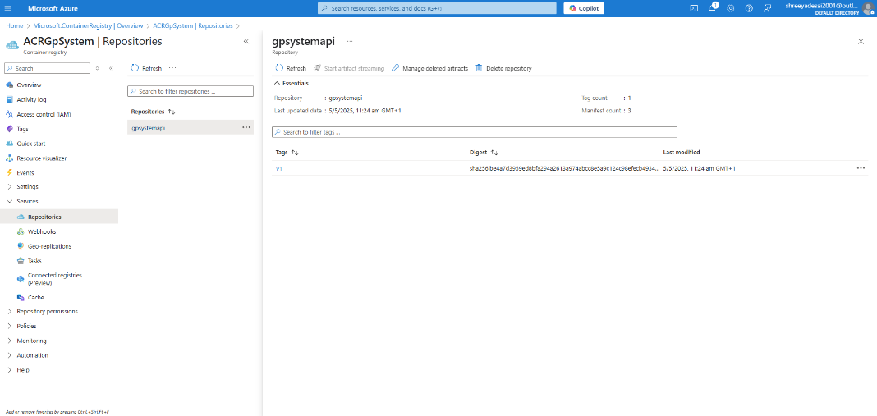

Deployment: O.3: Azure Dashboard (Container registry)

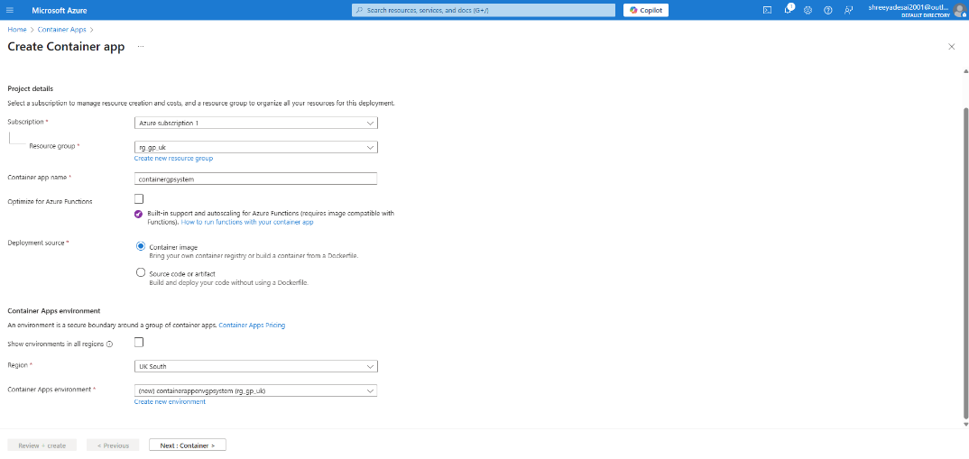

Deployment: O.4: Create Container App Configuration.

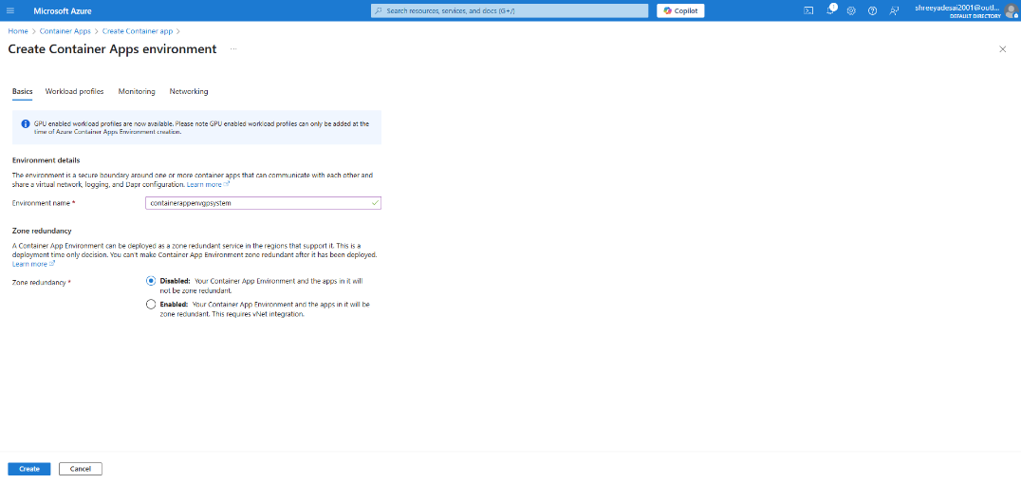

Deployment: O.5: Create Container App Environment.

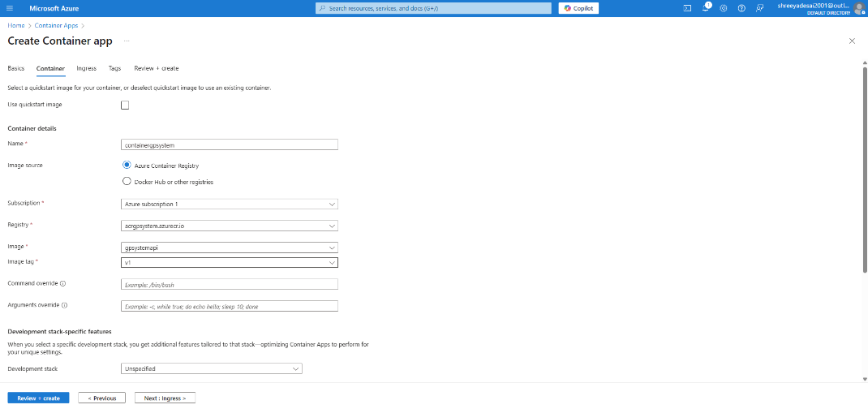

Deployment: O.6: Container App (Container Configuration).

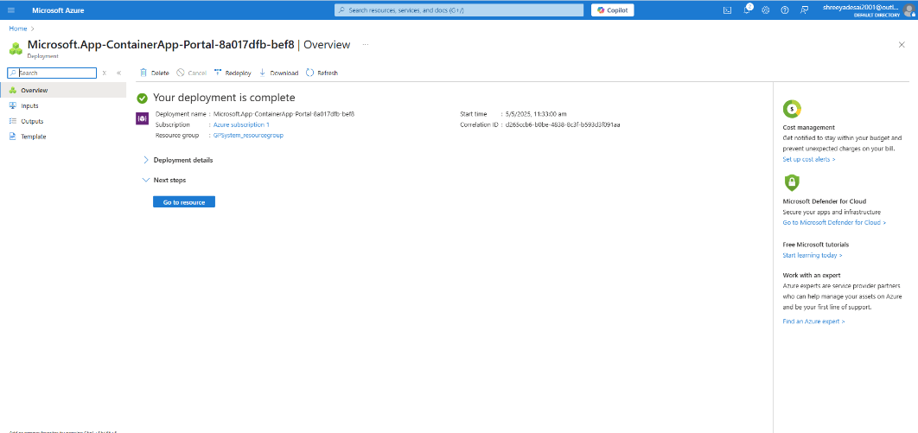

Deployment: O.7: Deployment complete (Azure Container App)

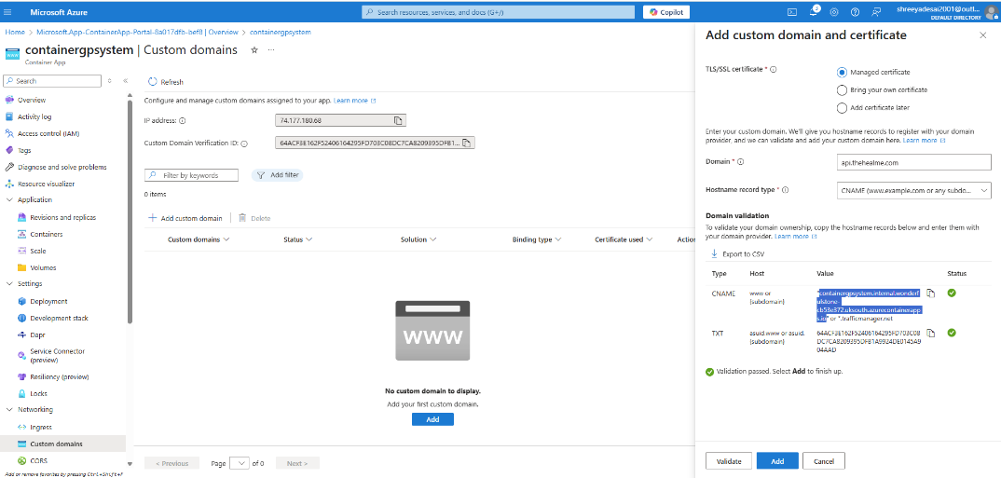

Deployment: O.8: Adding Custom Domain(Container App)

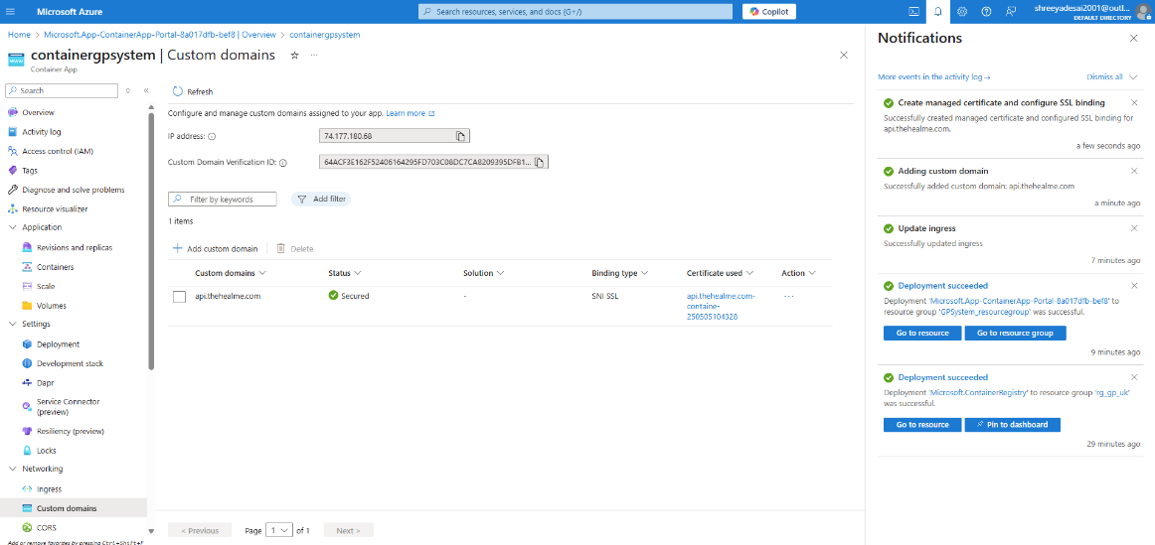

Deployment: O.9: Added Successfully.

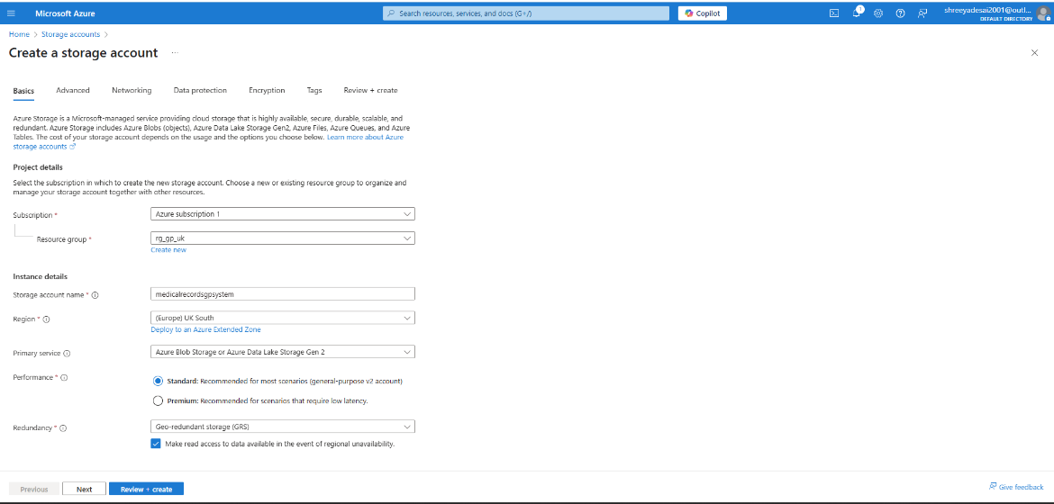

Deployment: O.10: Storage Account Configurations.

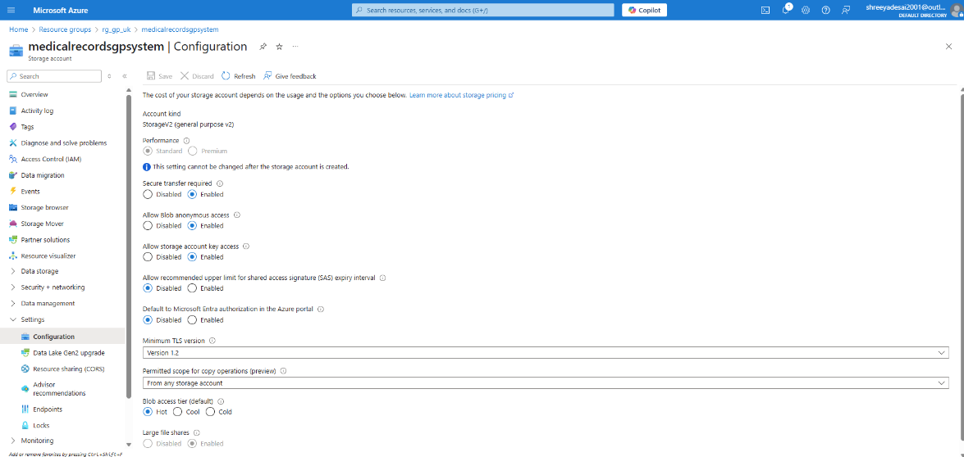

Deployment: O.11: Storage Account Configurations.

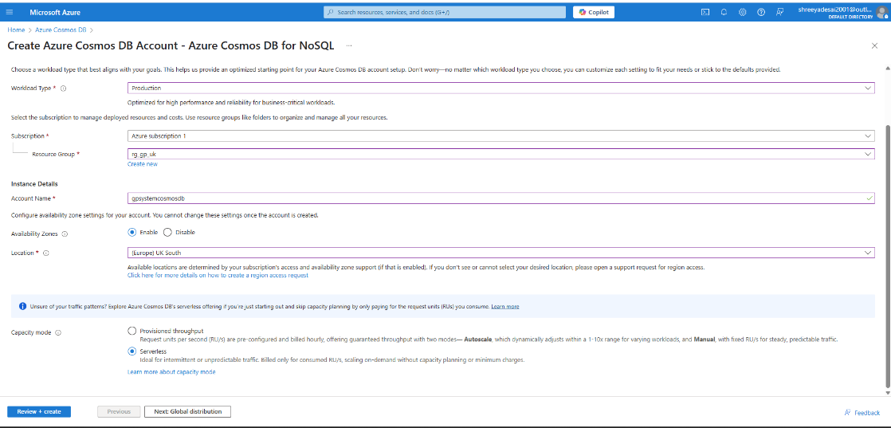

Deployment: O.12: Cosmos DB Creation.

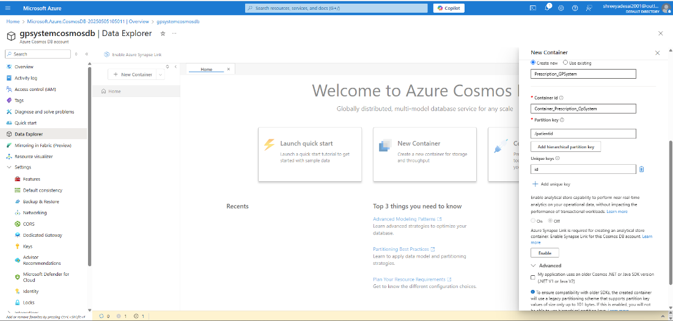

Deployment: O.13: Adding the New Container

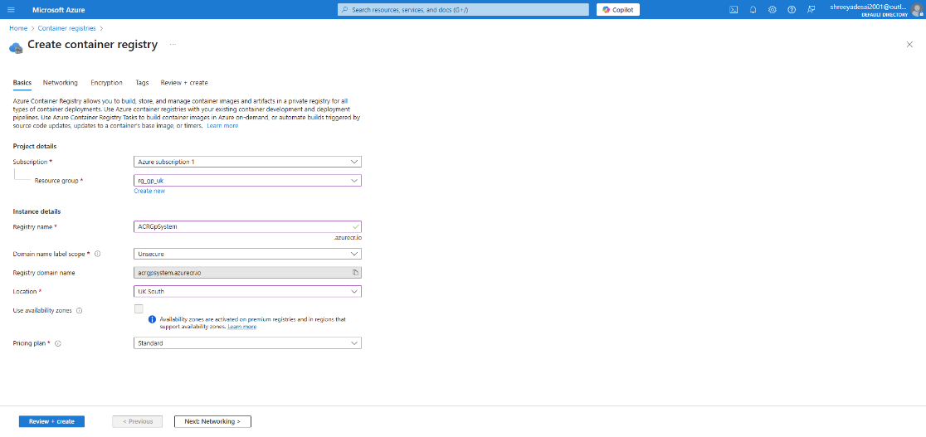

Deployment: O.14: Creation of Container Registry.

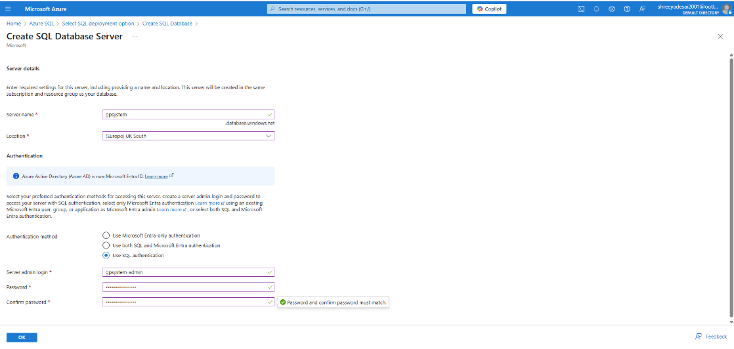

Deployment: O.15: Creation of SQL Database Server.

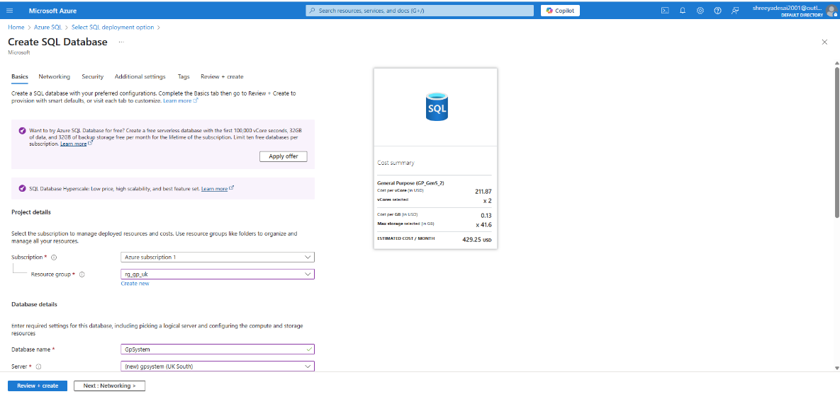

Deployment: O.16: Creation of SQL database.

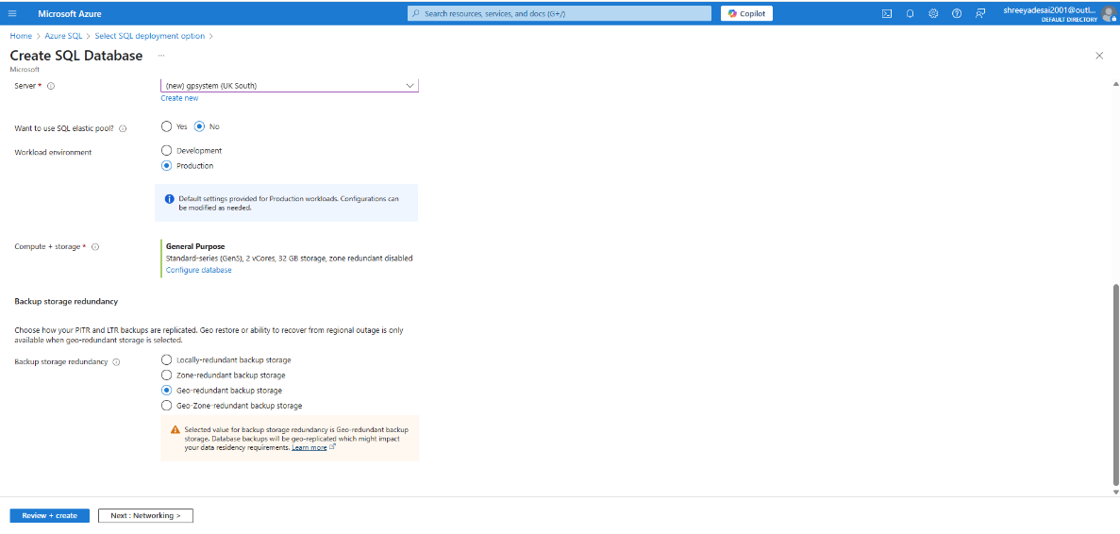

Deployment: O.17: Configuration of SQL database.

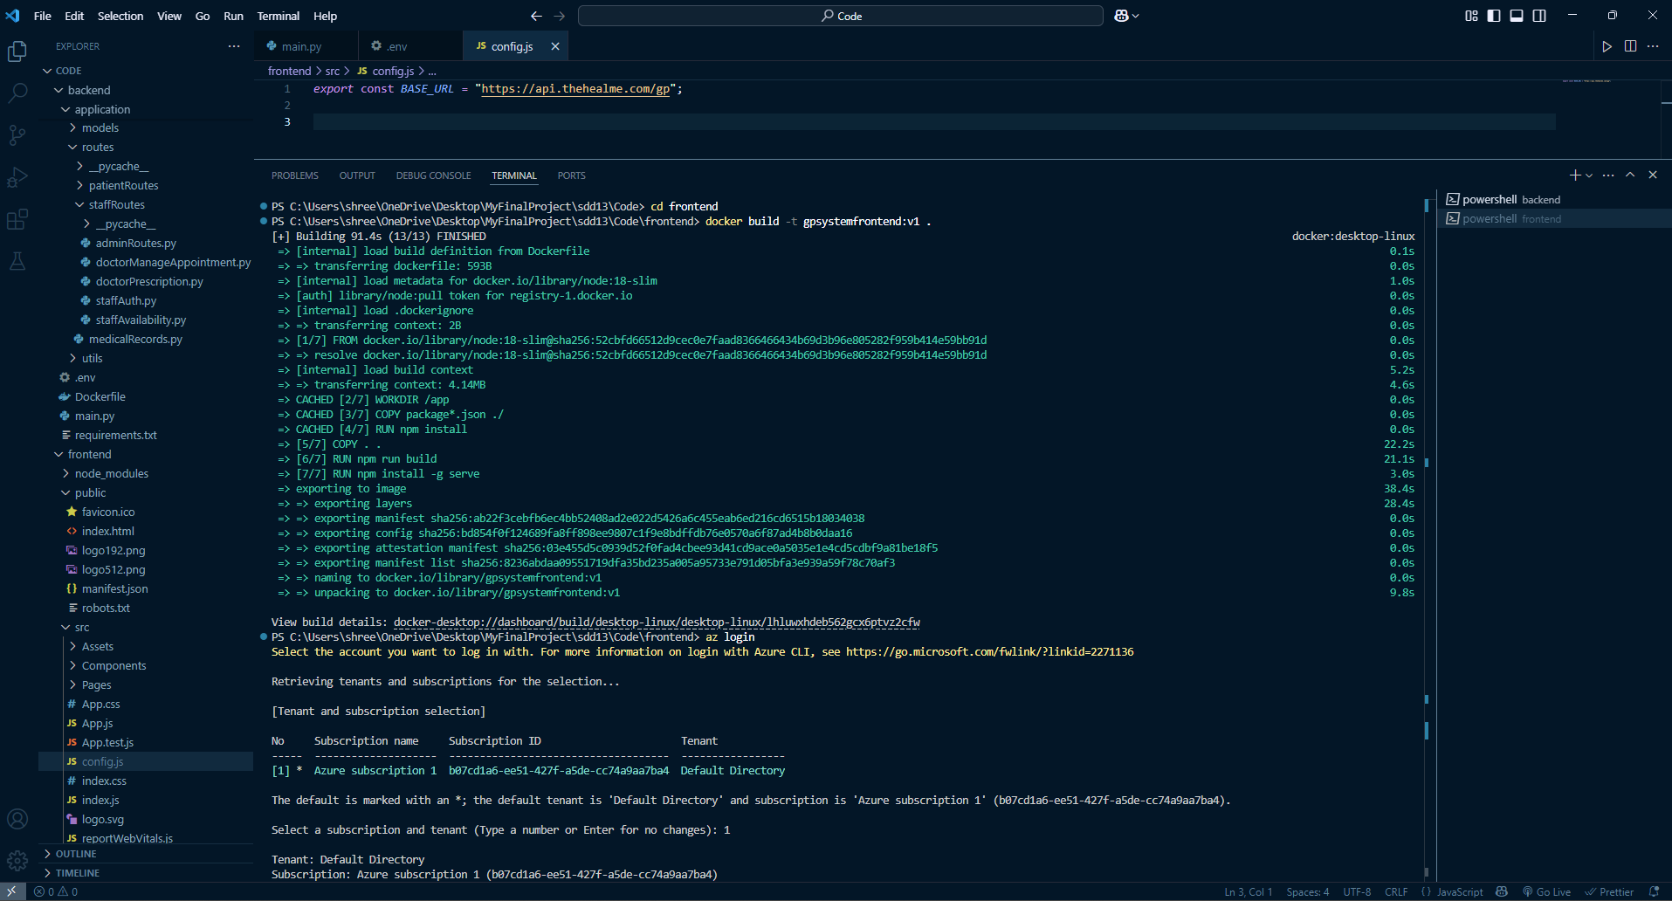

Deployment: O.18: Docker build(frontend).

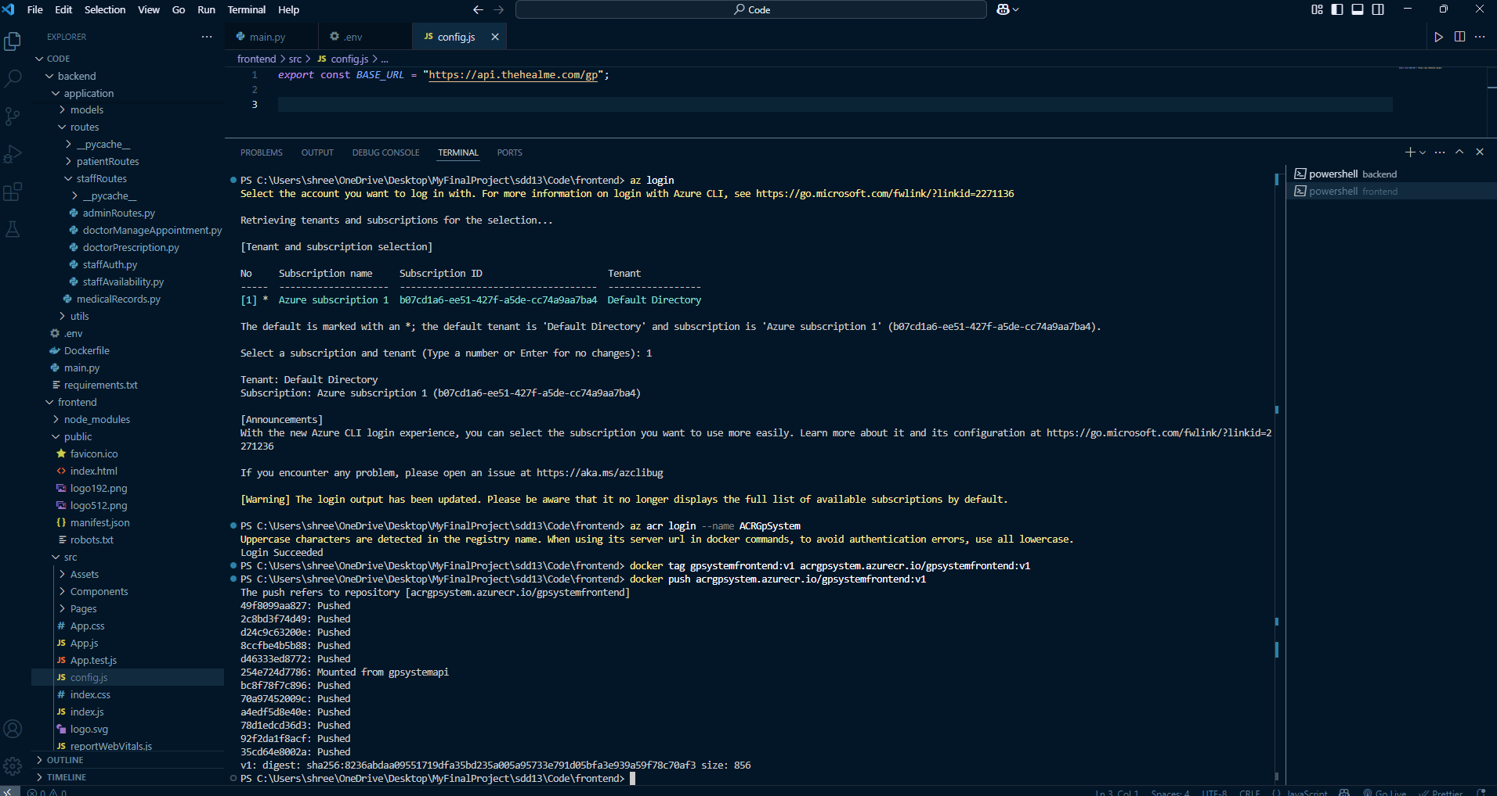

Deployment: O.18: Docker tag and push(Frontend).

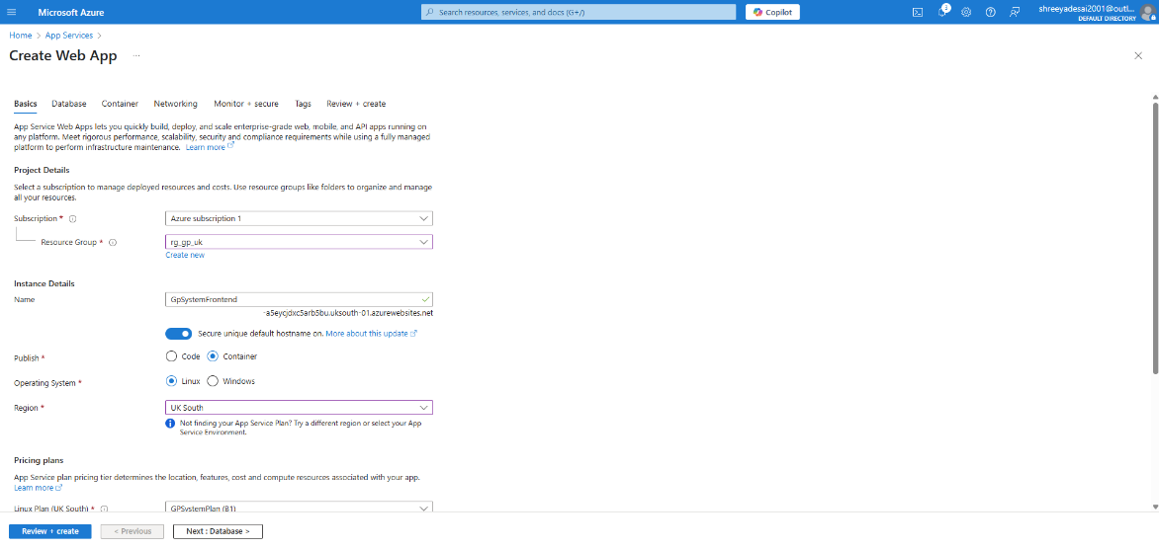

Deployment: O.20: Create Web App

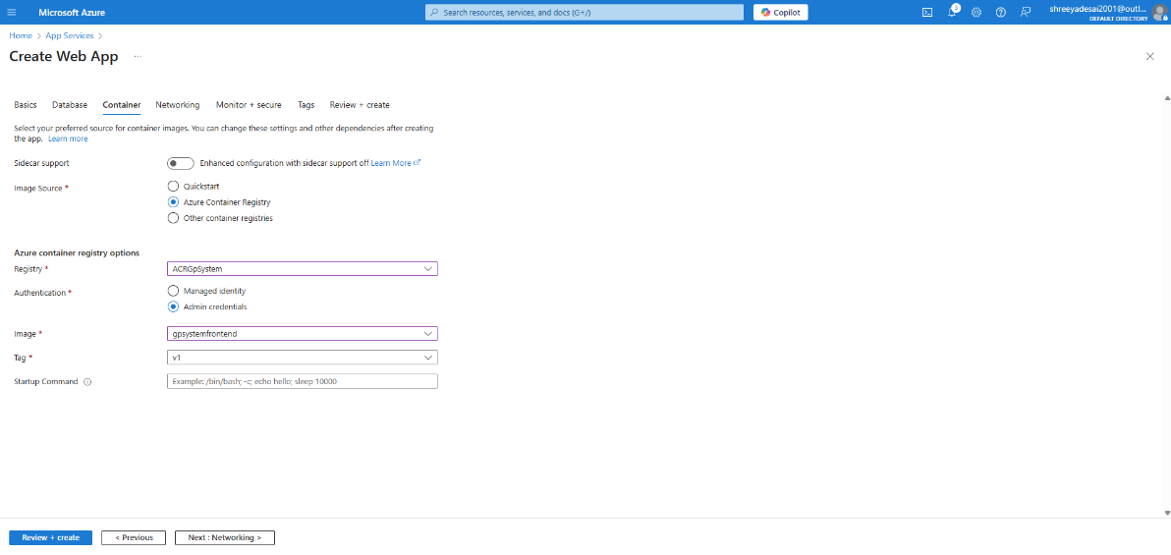

Deployment:O.21: Container configurations(Web app).

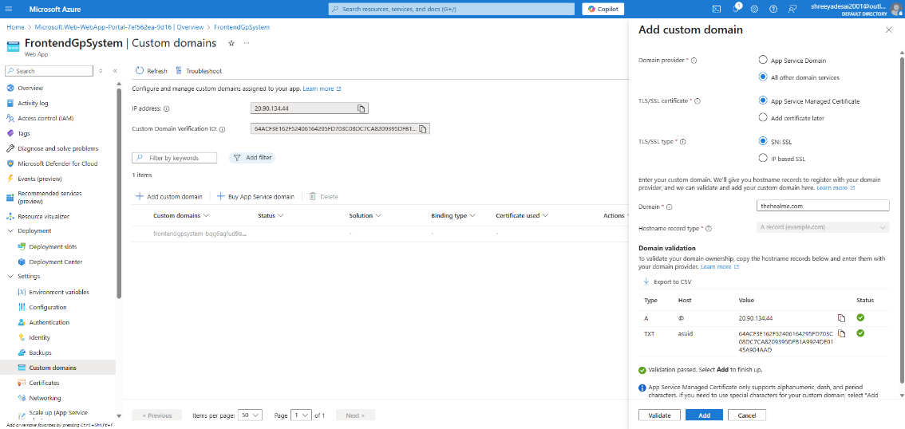

Deployment: O.22: Adding custom Domain.

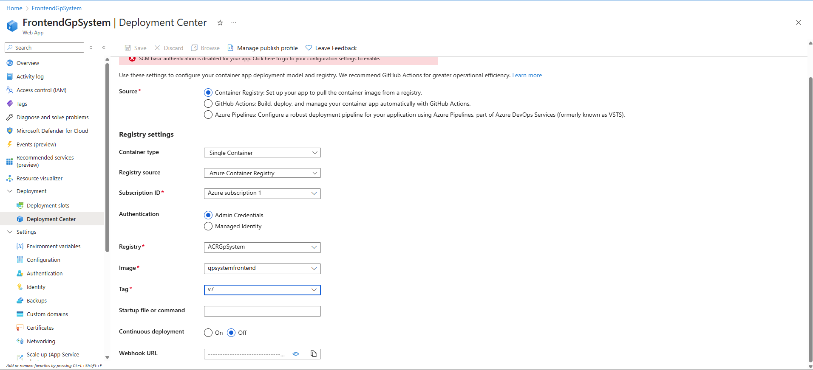

Deployment: O.23: Deployment Center(FrontendGpSystem)

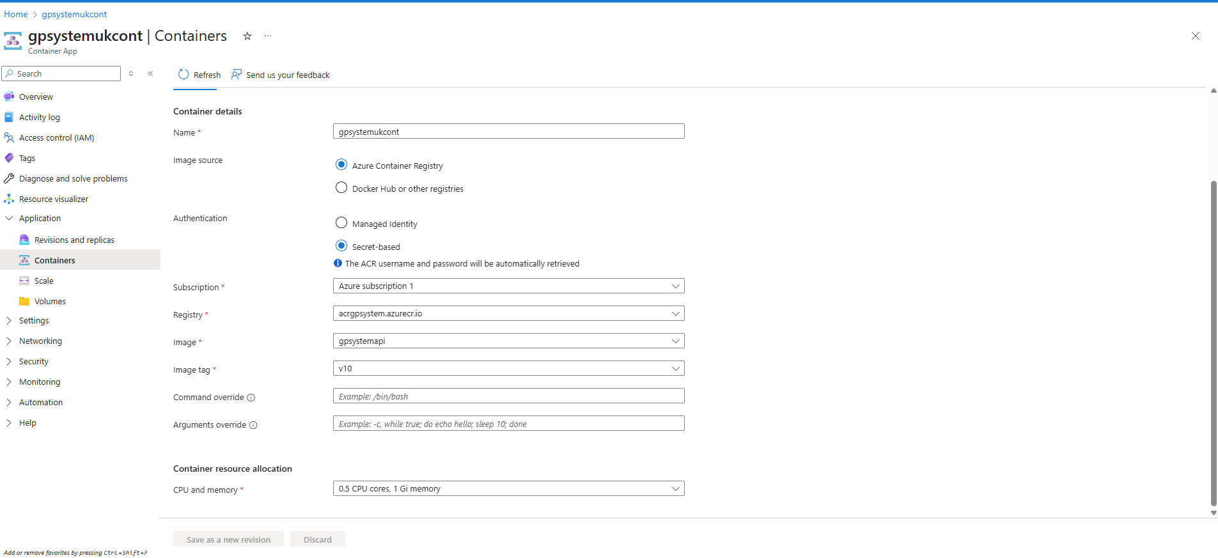

Deployment: O.24: Containers (gpsystemukcont).

## Application Snippets.

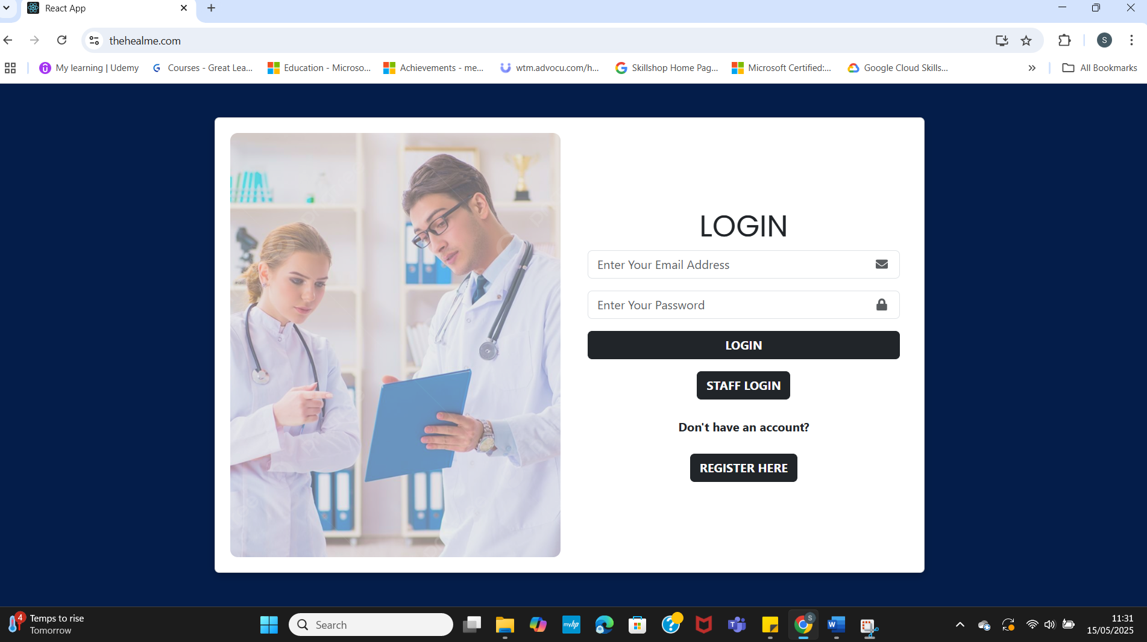

thehealme P.1: Landing/Login page.

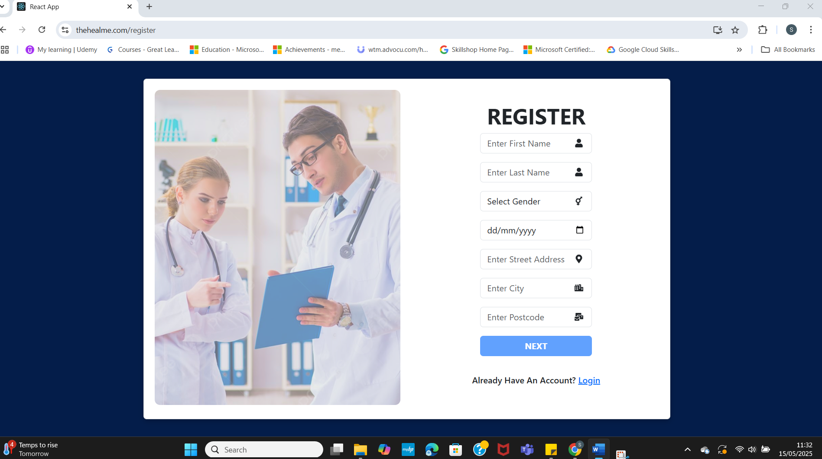

thehealme P.2: Register Page.

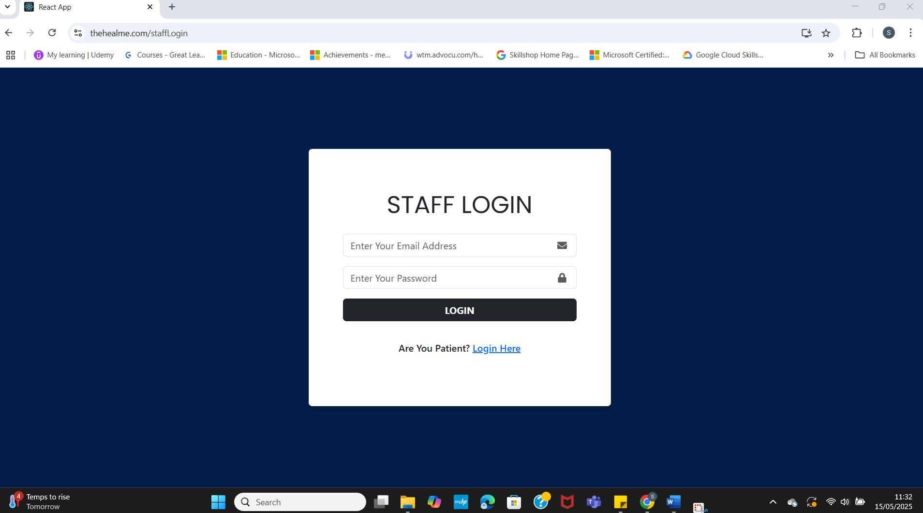

thehealme P.3: Staff login Page.

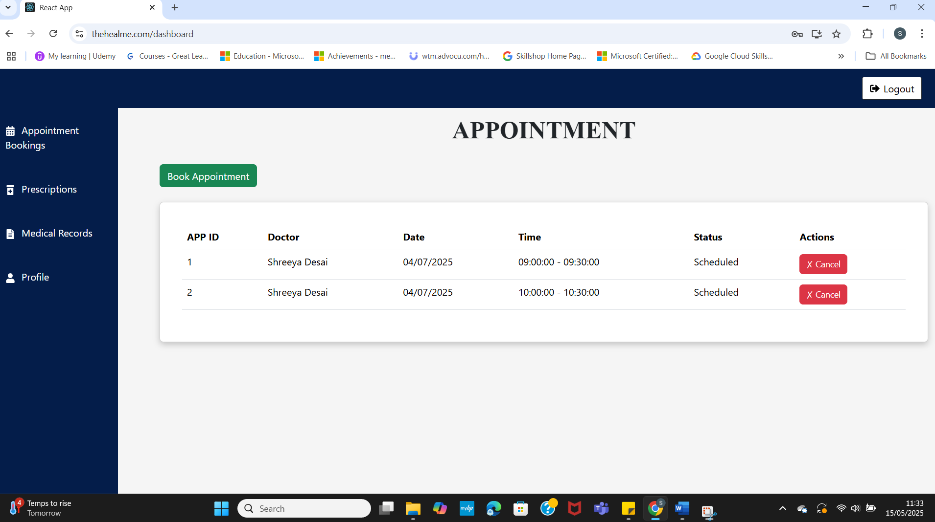

thehealme P.4: Patient Dashboard.

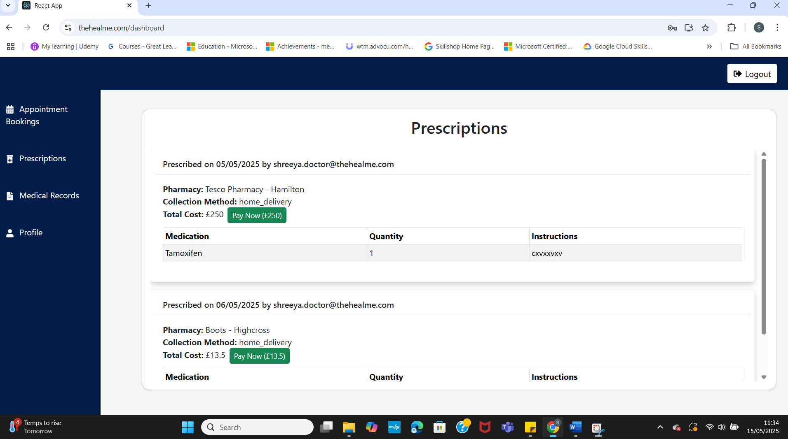

thehealme P.5: Prescriptions Screen (Patient).

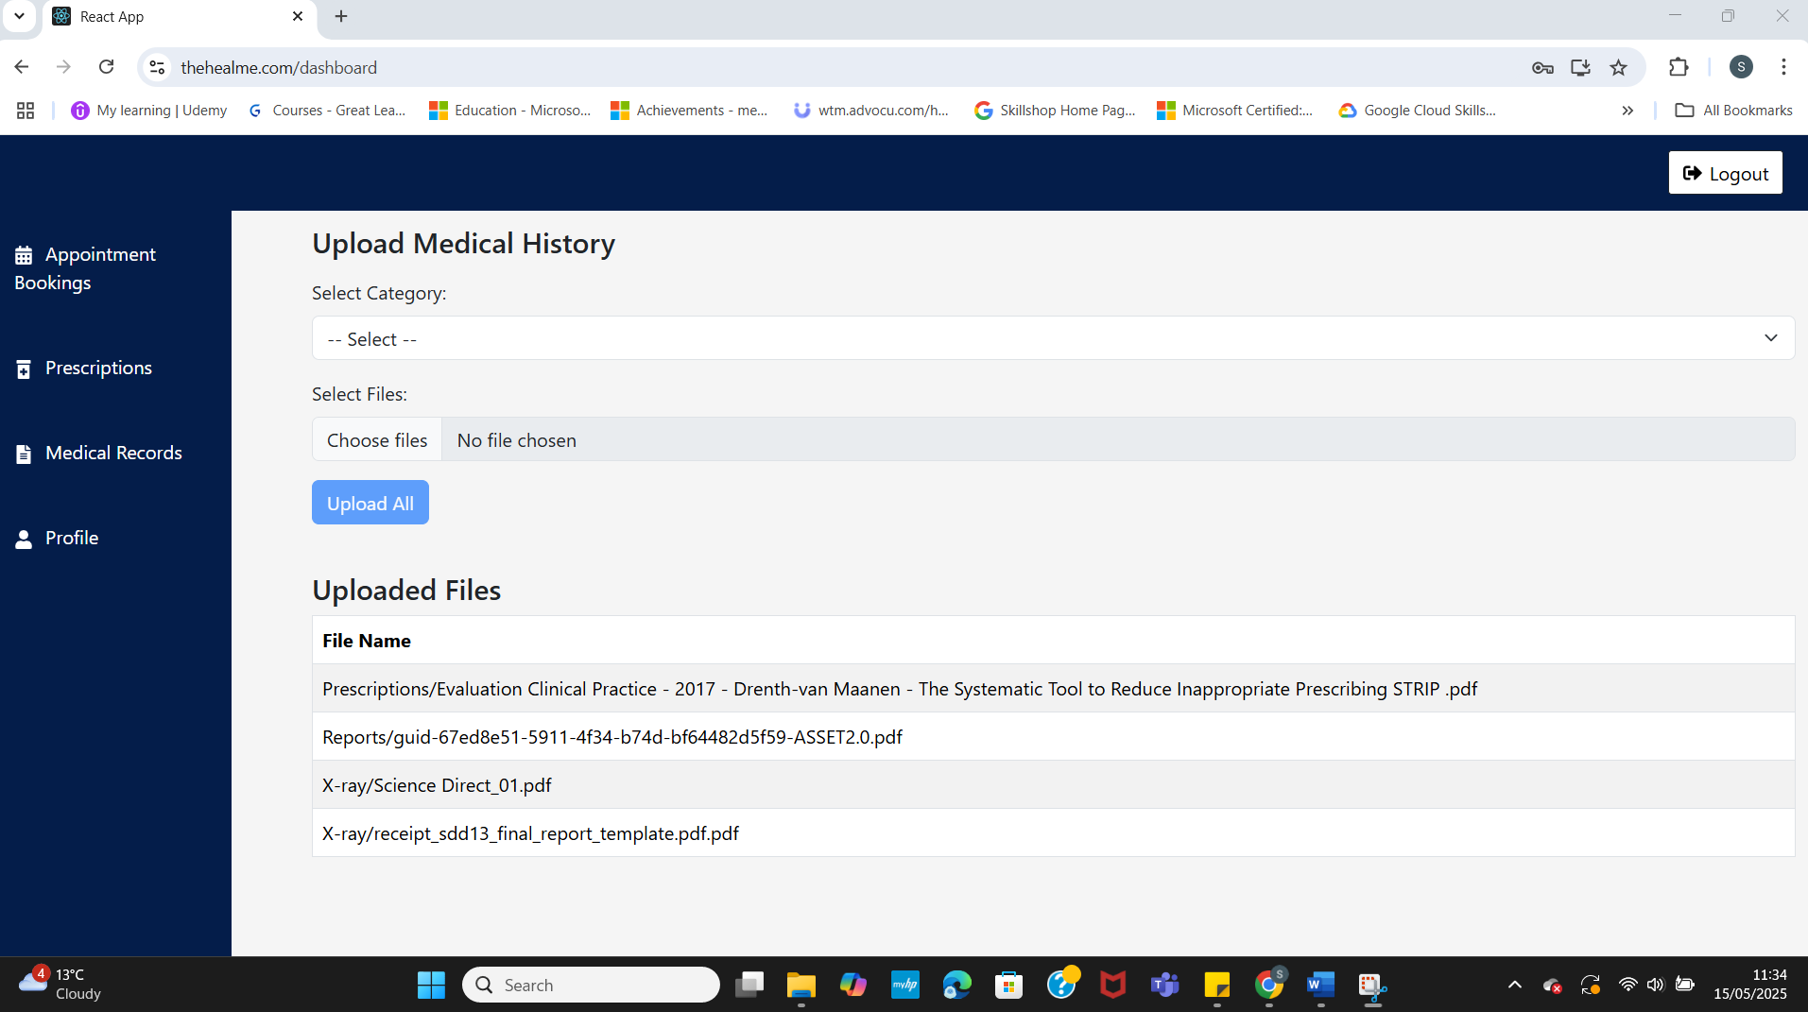

thehealme P.6: Uplaod Medical Histroy Screen(Patient).

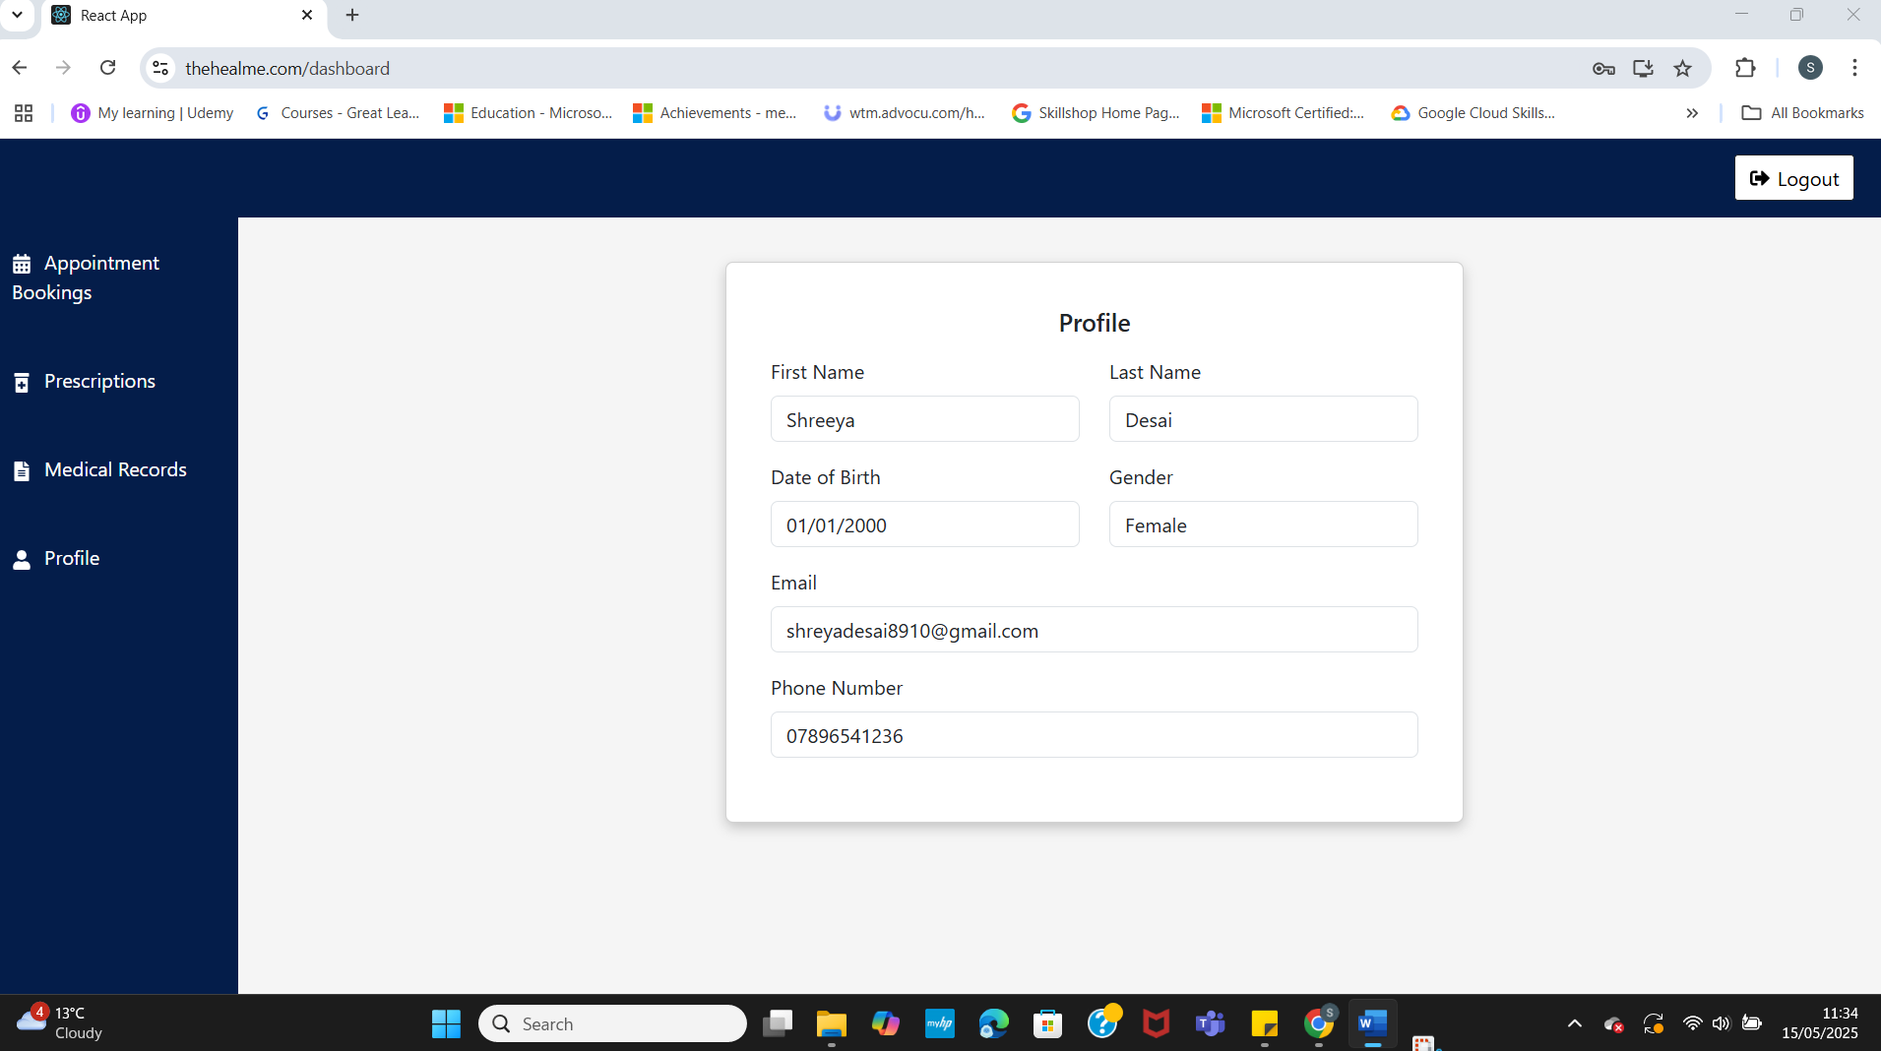

thehealme P.7: Profile(Patient).

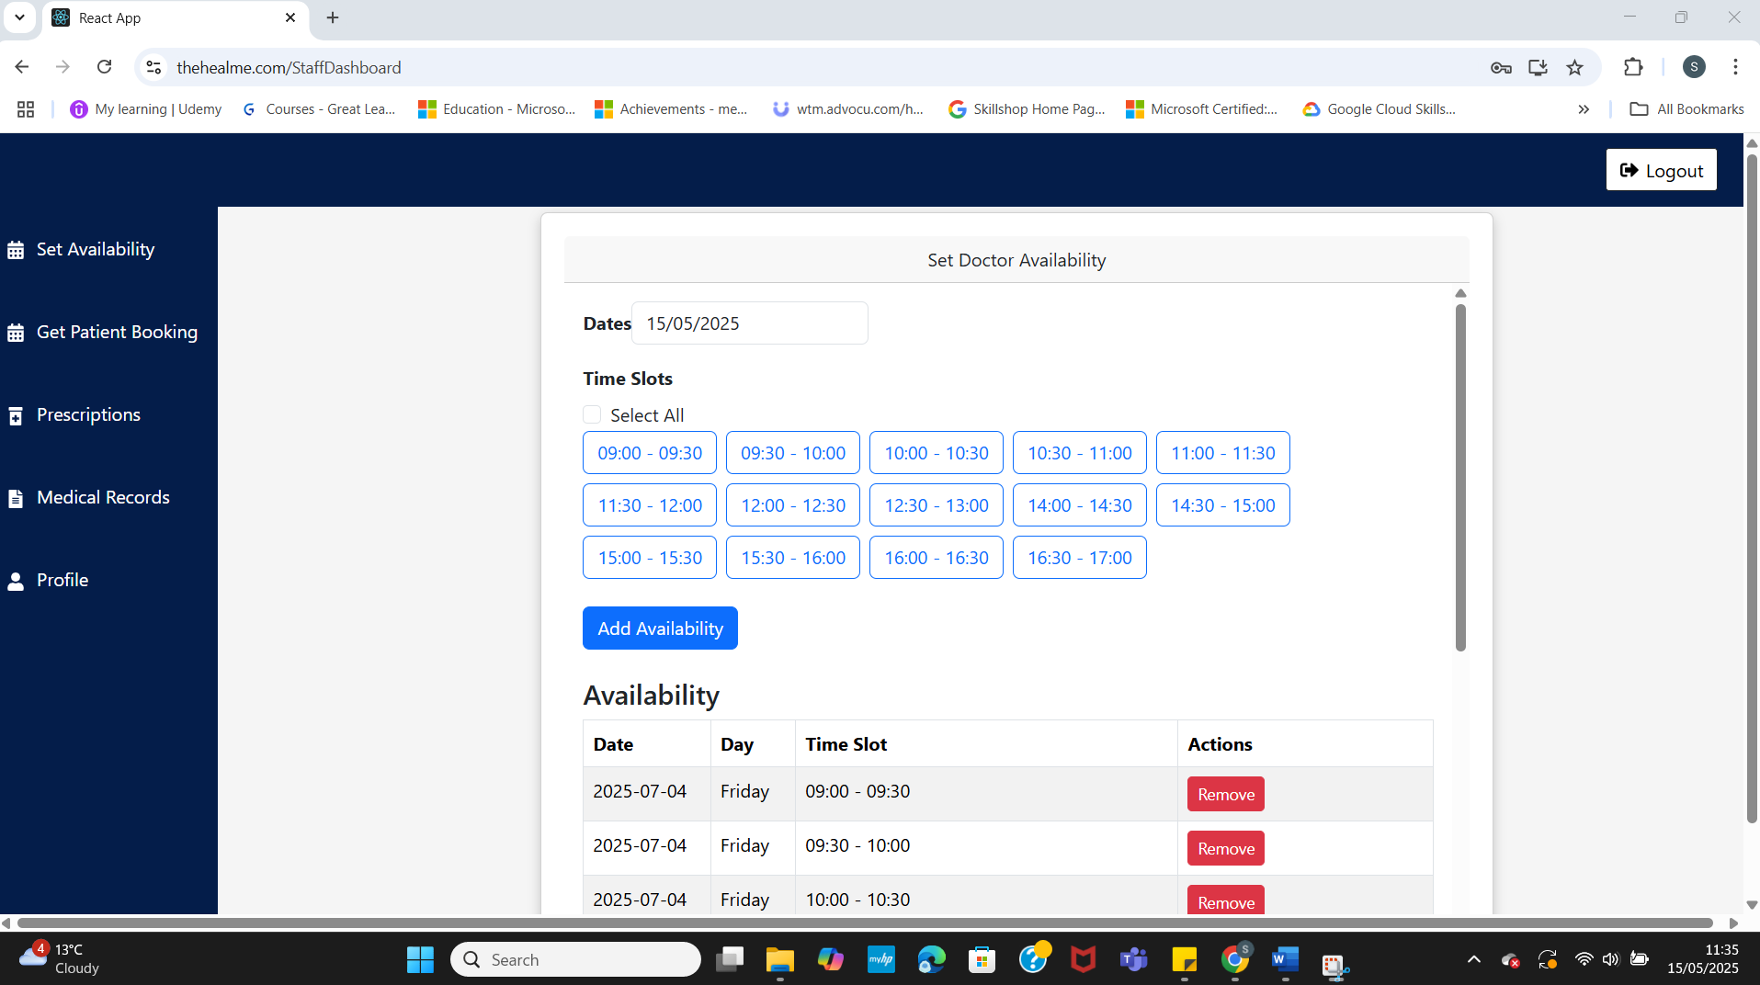

thehealme P.8: Staff Dashboard (Doctor)

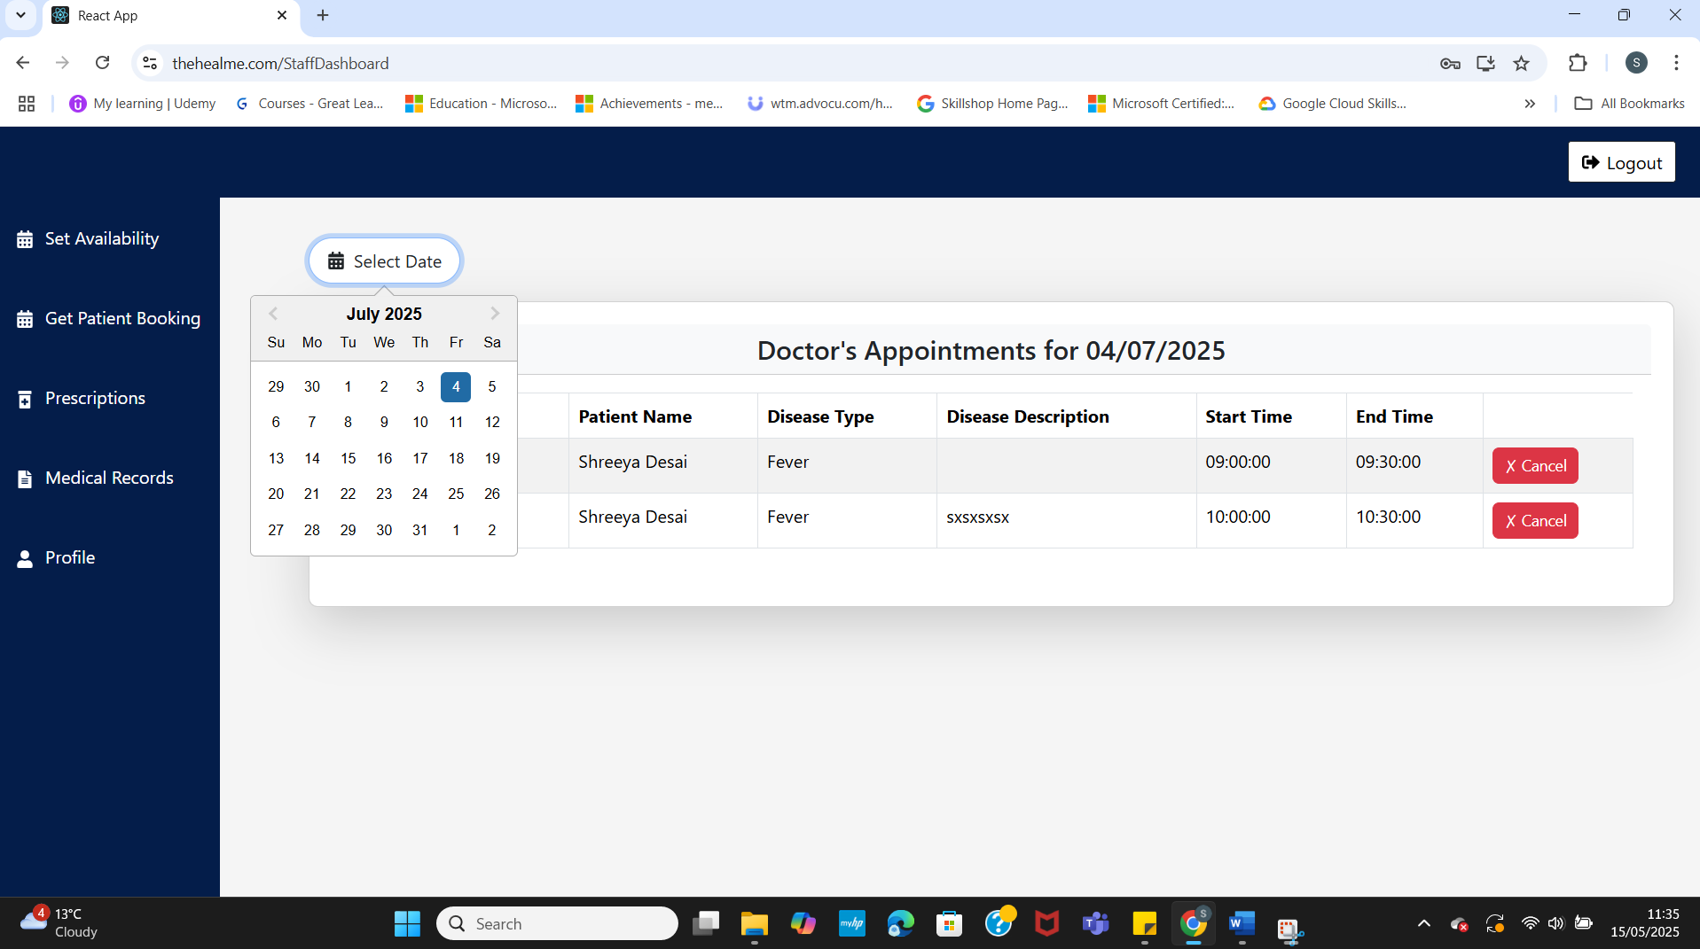

thehealme P.9: Get Patient booking (Doctor)

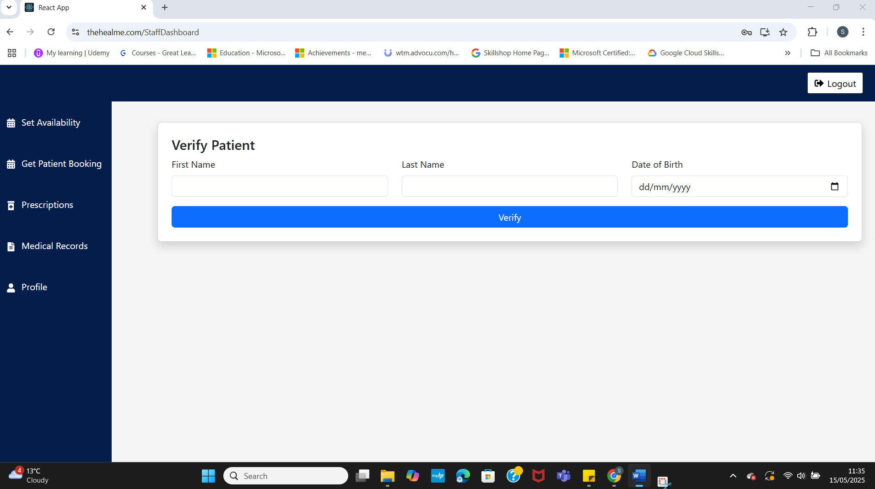

thehealme P.10: Provide Prescription.

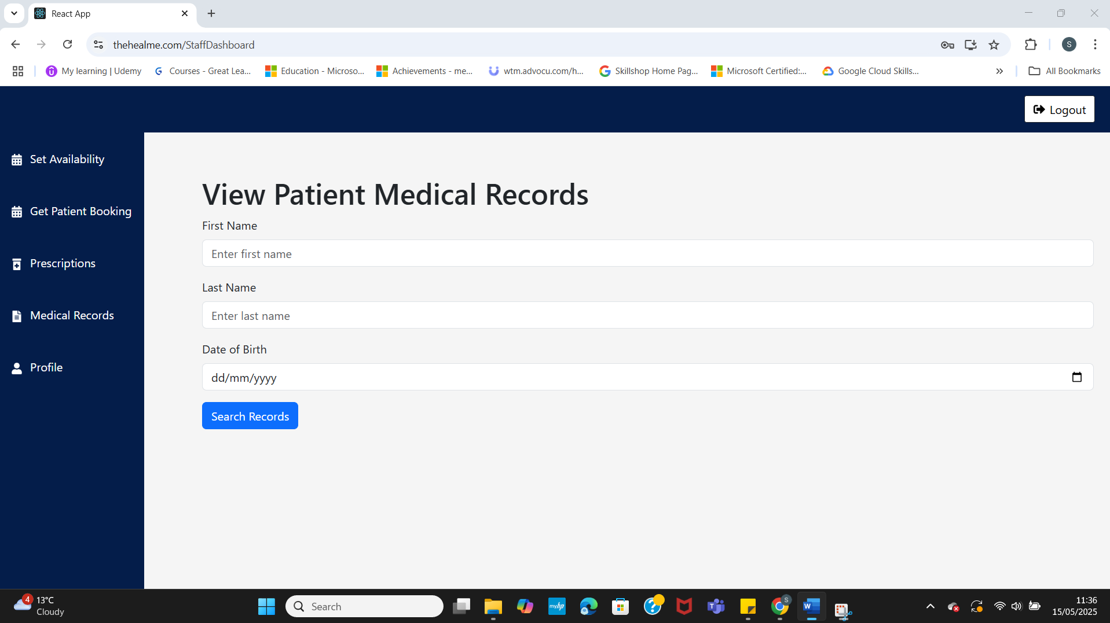

thehealme P.11: View Medical Records.

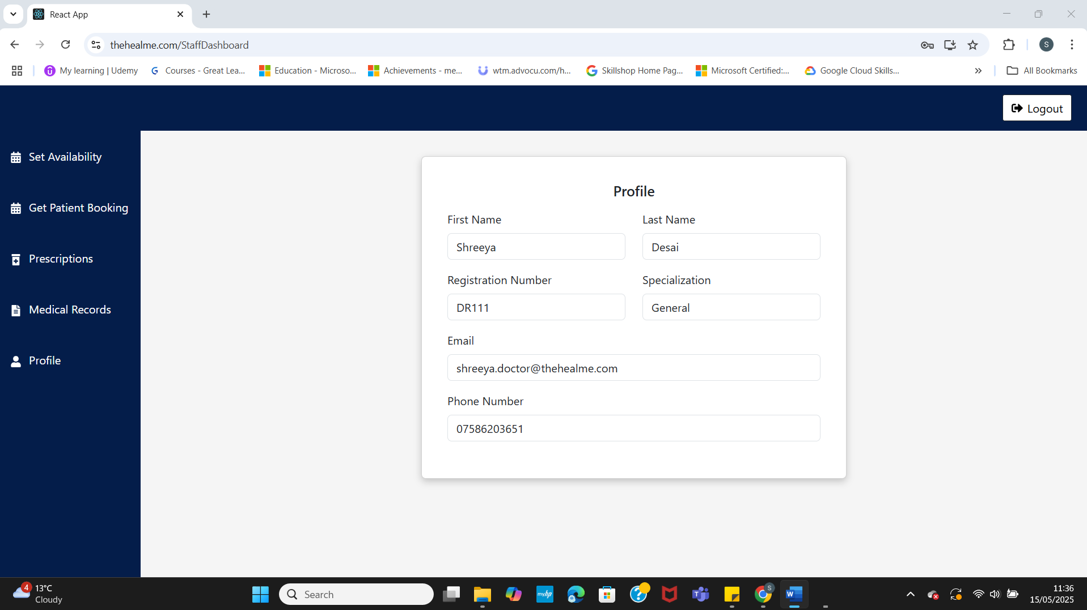

thehealme P.12: Profile (doctor).

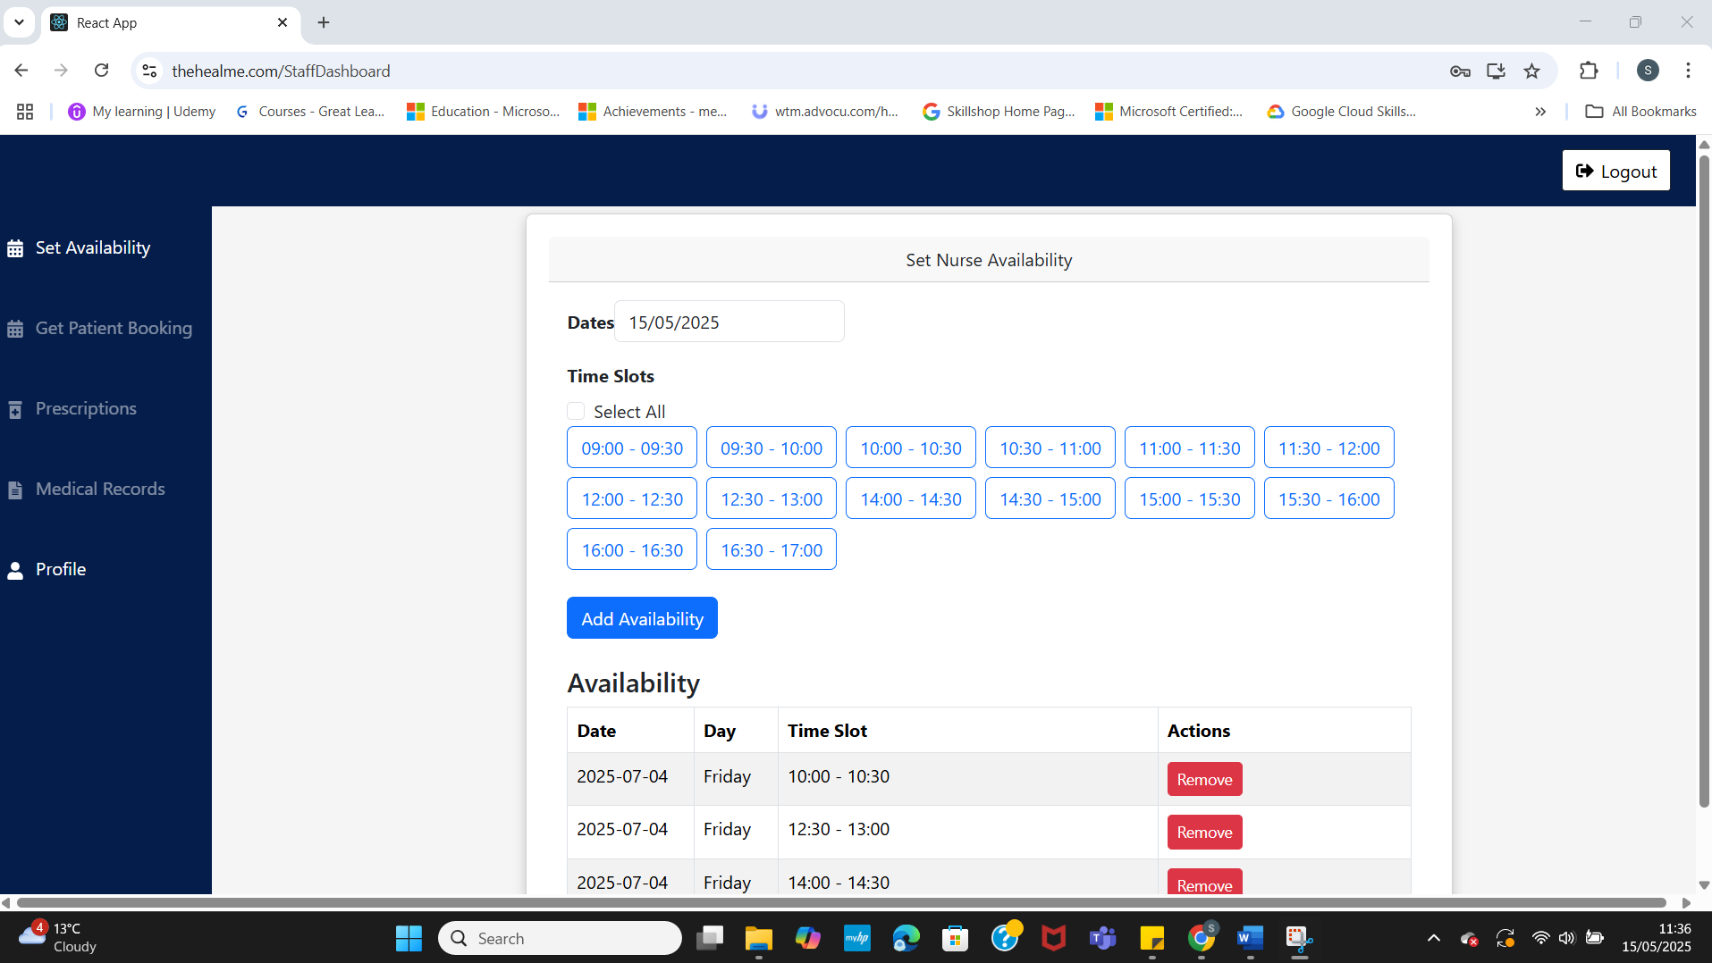

thehealme P.13: Staff Dashboard (Nurse)

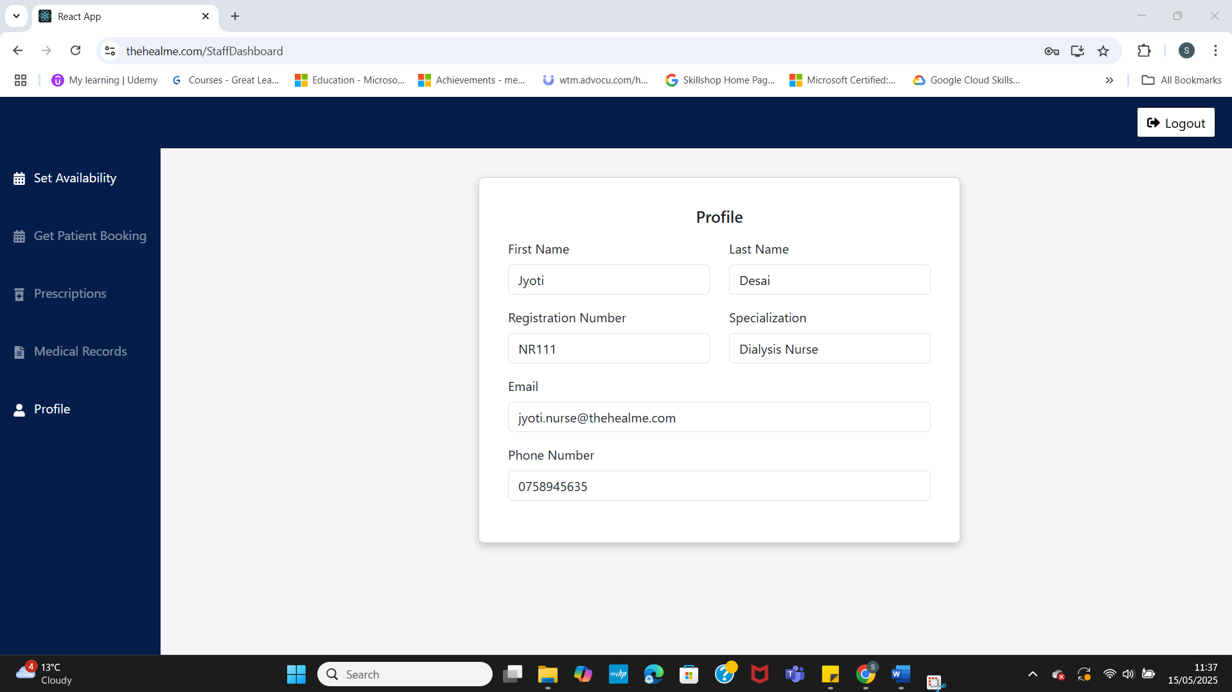

thehealme P.14: Profile(Nurse)

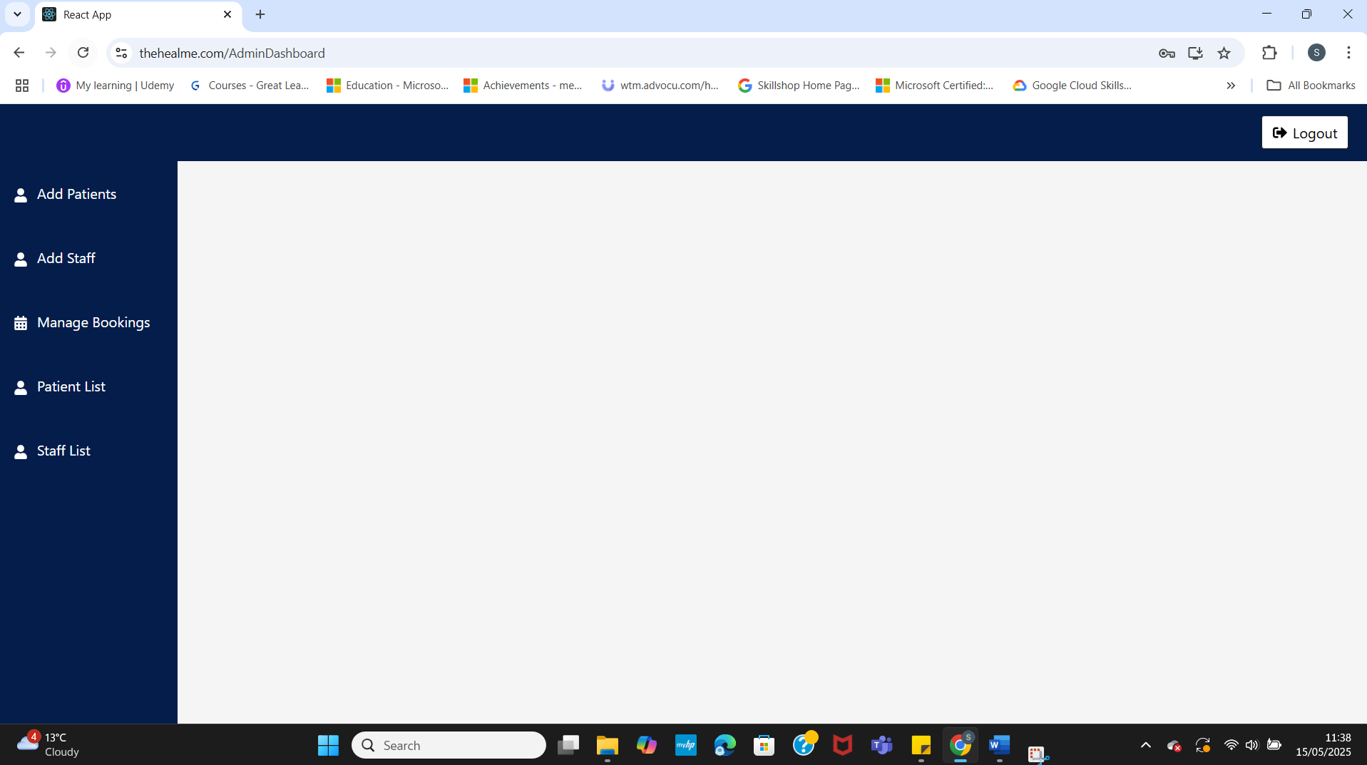

thehealme P.15: Admin dashboard

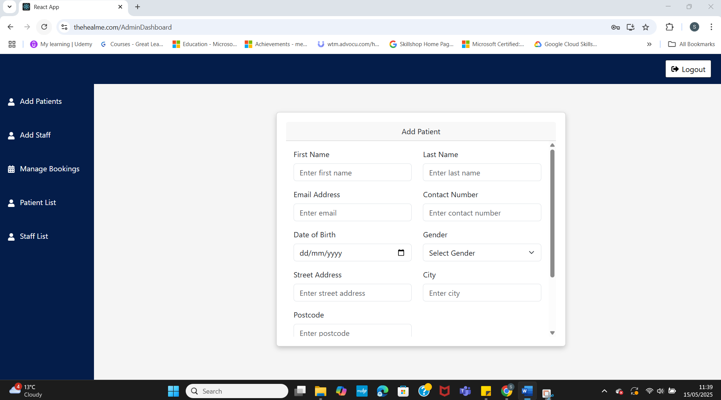

thehealme P.16: Add Patient.

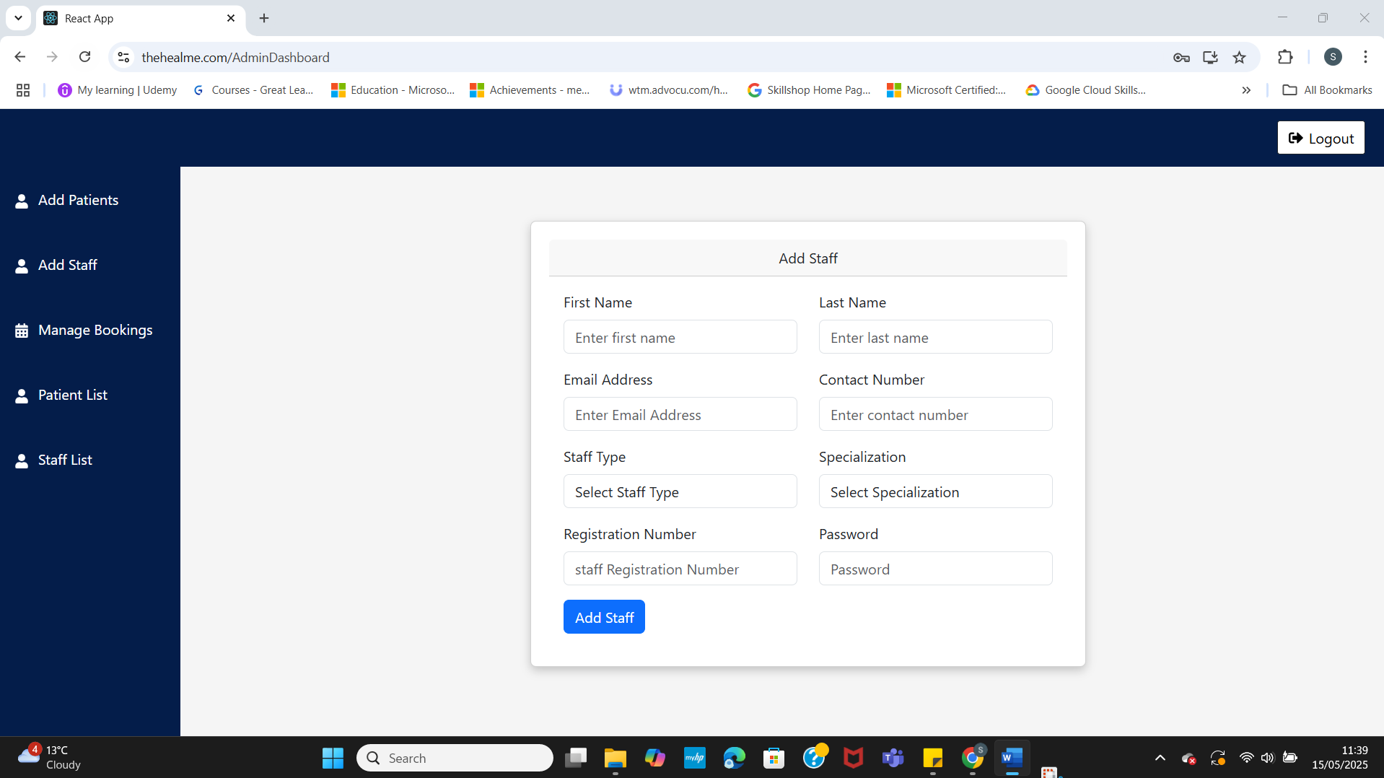

thehealme P.17: Add Staff.

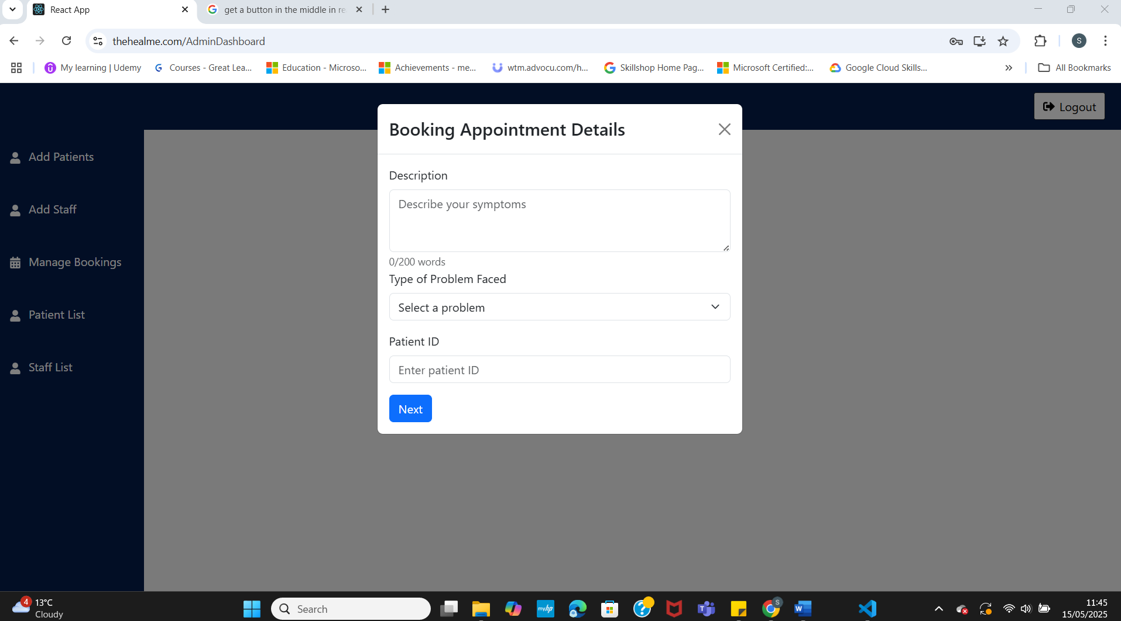

thehealme P.18: Book Appointments.

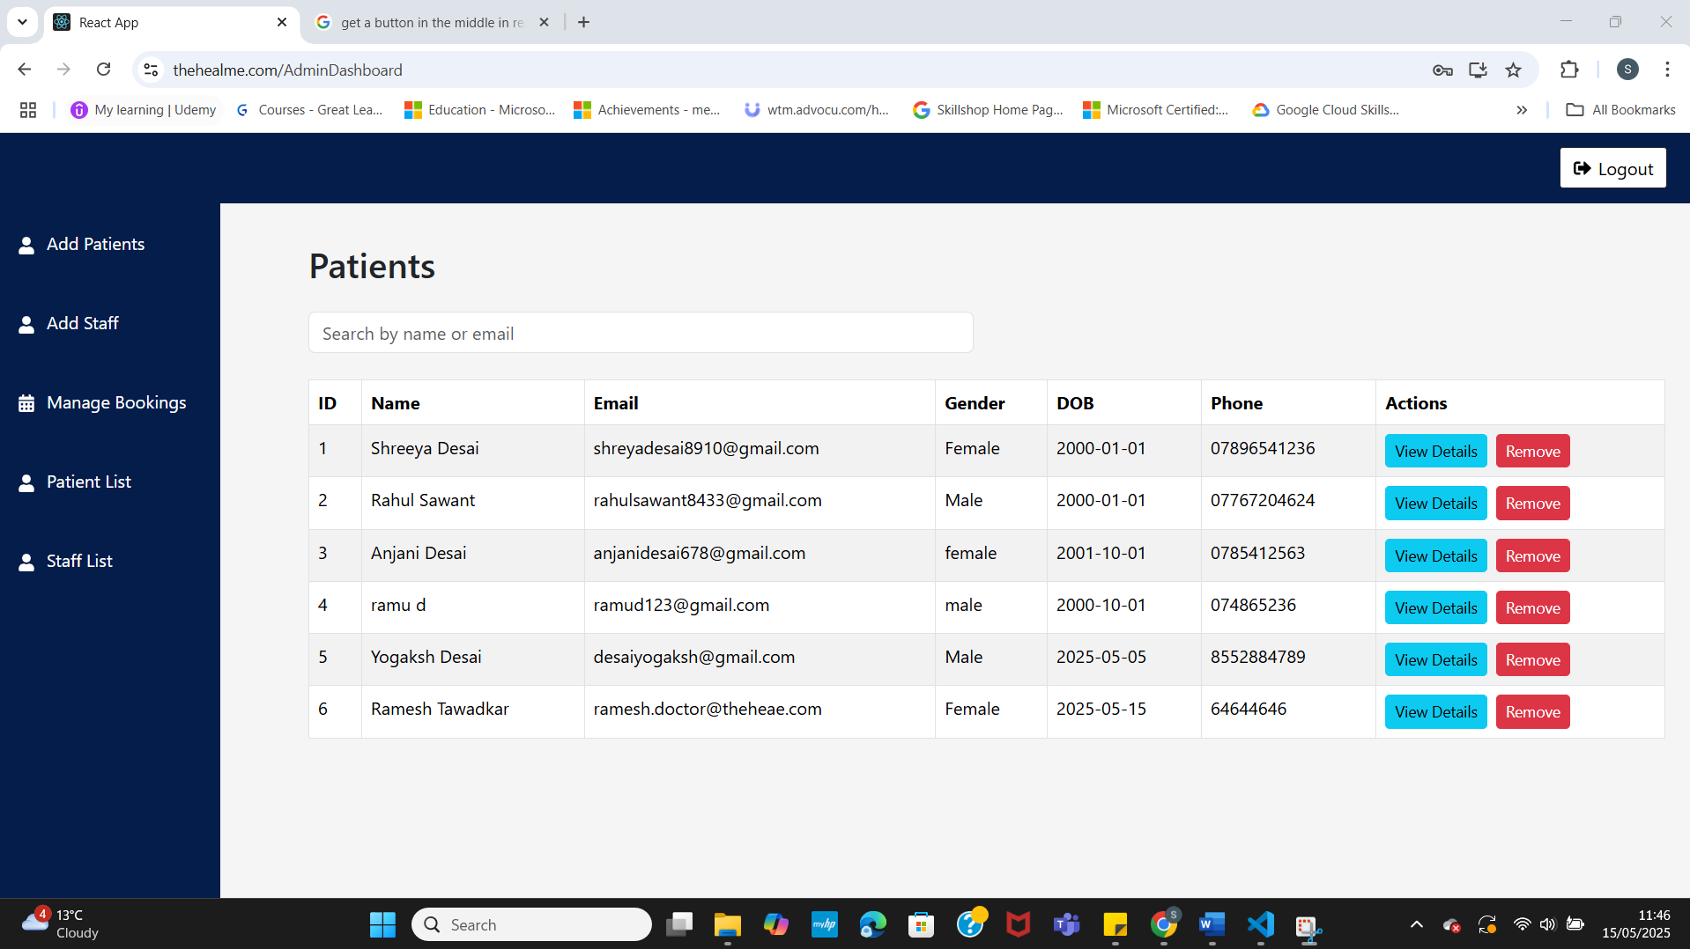

thehealme P.19: Patient List.

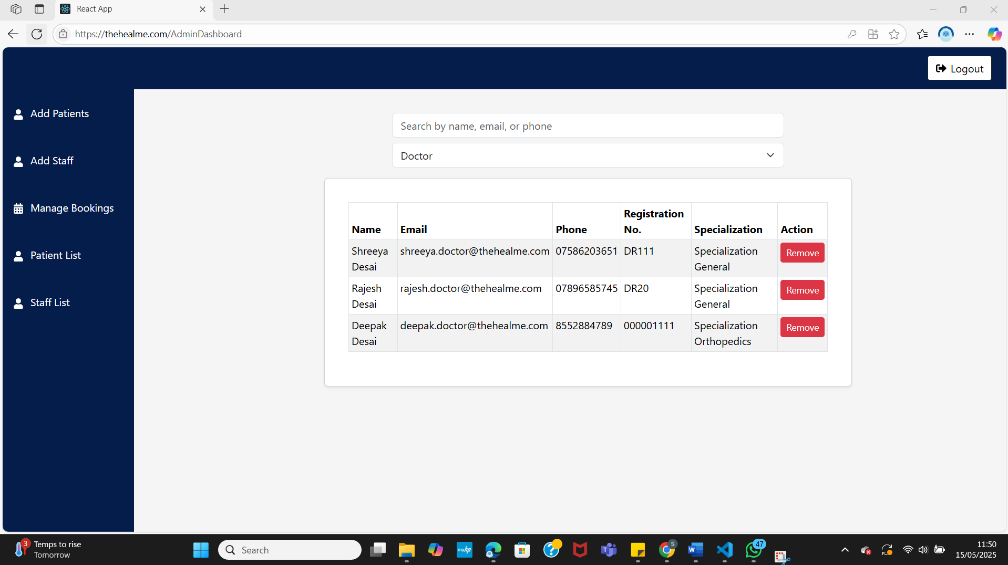

thehealme P.20: Staff List(Doctor)

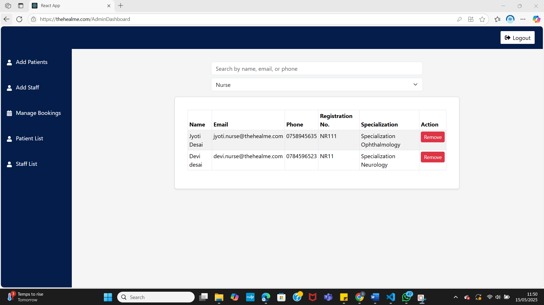

thehealme P.21: Staff List(Nurse)